FUN-raising Ideas: Please note: You must inform the Communications & Advancement Division of your intention to approach Corporate and other donors. The office can assist with available prizes and inform you of approaches to those donors to date. (Knocking on the same doors at the same time is not feasible). An official Give5 approach letter will be provided by Alumni House and all monies to be paid into the Rhodes University bank account for the Give5 project.
Templates and Guidelines for some / many of these can be downloaded on: http://www.ru.ac.za/communicationsandadvancement/alumnirelations/studentradactivities/
Auctions | Organise your own fundraising auction. Why not auction off your talents for the day or donate a percentage of funds raised through Give5.  Have individuals, groups and businesses donate goods and services. Be creative in what you can auction off and make certain that the goods and services are sold at reasonable prices.  Auctions can be conducted in two ways – live or silent. Preparation for each of these is very similar and we recommend holding this type of fundraiser in conjunction with another event. (Check the RU Calendar for existing events and ask permission to join.) The key to hosting a successful auction is securing donations and drawing people to the event. Donations for the auction can vary from clothing to gift certificates to tickets to an athletic event, art works; anything of value basically. Try to secure a wide variety of prizes to appeal to a larger variety of people.  Set a date and time for the event and invite numerous people to attend.  In a silent auction, the items are placed on tables throughout the room with information on the item, sponsor, and estimated value. Individuals bid by placing their name, phone number, and bid on the sheet corresponding to each item. After a designated time, the bids are closed and the highest bidder wins the prize. Bidders may bid as many times as they wish on items.  For a live auction, a captive audience is necessary. Try to secure an auctioneer or someone with a large personality to host the event and add to the atmosphere. People place bids by raising their hand. Prize goes to the highest bidder.
Car Wash | Secure permission to use a location that is water accessible for use. Determine a date for the event. Ideally, try to secure a weekend day from 10am – 2pm in a high traffic area. Do a bit of research in determining the location and date. For example, consider Saturday morning grocery shoppers, youth athletic league practices and competitions, or football games. You want to choose times and places that draw a good number of people. In case of rain, have another day scheduled in advance.  Borrow or purchase a hose, nozzle, buckets, and rags. Purchase soap.  Decide on amount of the donation (R20 per vehicle).  Make flyers to distribute and signs to advertise your event and your club sport.
Tournament/Competition | A prize for the most outrageous face – make sure you get photographic evidence! Each entrant pays to play or residences or halls can decide who their best entrants would be.  Hosting a tournament or competition can raise money and increase awareness of your activities on campus. The first step in hosting an event is to secure permission to host the event, reserve the facilities, and begin staffing the event. Use as many volunteers to staff the event as possible and then hire the personnel (referees, athletic trainer, etc.) that you are not able to provide. After the date and staffing needs have been determined and reserved, contact teams to participate. A team entry fee should be charged to cover tournament expenses (site rental, awards, staffing). Work the numbers in advance to determine the maximum # of teams that can be accommodated and the minimum # of teams necessary to break even on expenses. Once the participating teams have been determined, a tournament game schedule should be distributed to all participants and advertising of the event can occur. Advertising of the event will increase spectators and add to the overall atmosphere of the event. Don’t forget to market the event to local high school or club teams. A gate fee can be charged to those attending to increase revenue, but we recommend making the event free to fellow students. Other revenue possibilities include: a tournament program (sales and/or ad space), concessions, and merchandise (both team and/or tournament specific gear are options). Hosting an event for the public can generate interest and raise money for your club. Think about golf or tennis tournaments or outings, a casino night, or a Texas Hold ‘em tournament, etc.  The first step in this process is to determine the costs involved. Contact the necessary facilities and/or obtain numbers on what rental fees are for your event. The break-even point and registration fees for the event need to be determined by the costs.  Determine a date for the event and then advertise, advertise, advertise! This is especially necessary for a new event. Contact parents, alumni, university faculty/staff, and community members to assist in advertising. It is important to have club members recruit entries to achieve the ideal number of participants.  An event of this type may combine a number of fundraising opportunities including sponsors, selling of merchandise, raffle, etc.
Sales | The two most popular forms of sales are merchandise or concession/bake sales. Merchandise - Sales can include T-shirts, sweatshirts, shorts, hats, water bottles, car decals, etc. To organize a sale of merchandise, decide on what item you would like to sell and design a logo or screen to be placed on the item. Once the item and design has been determined, determine the cost to purchase the item and the target sale price. Keeping the design or logo simple typically keeps costs down.  Consider the option of the screener placing a small logo somewhere on the item in exchange for a lower cost per item to maximize your profit. This option may encompass a variety of different tasks – use your imagination! This is providing a work force for an organization or company during a peak period of time or for an event and being compensated in return. This compensation can be either per individual or at a flat rate for the team. Options for fundraising in this area include:  1. Working in areas such as concessions or program sales at an arena for one or a specified number of games. (Check the Rhodes Calendar as well as the year plan for local activities and events in Grahamstown and Port Alfred)  If working in concessions or program sales, compensation may be offered  in the form of a % of total sales. 2. Providing labour for an event(s) that occurs once or a few times a year. Examples would include residence / hall / house move-in or out, a pool opening or closing, venue cleaning (not just on campus). Research what is in the area, where help is needed and contact the organizers.  3. Assisting with holiday help. There are some businesses that have a rush during a certain time of year. This requires extra help. Think of creating things and helping businesses with specific celebrated days around Valentine’s or Mother’s Day etc.  This fundraiser uses team members as a “labor force for hire.” In exchange for services, a fee is collected.  Determine a date for the event and include a rain date. Usually those who contract team members are looking for assistance with outdoor tasks.  In addition to a date, the length of time must be determined.  - Will the fundraiser last for 1 or 2 days?  - Will you offer ½ and full days of labour?  Then, determine the fee that will be charged and the number of “jobs” your work force will be able to complete successfully.  Advertise work throughout campus and the community. Once the work orders begin to be submitted, a work schedule and driving lan can be determined.  Concession/Bake Sales –For concession sales, supplies must be purchased (shop in bulk to save money), while for bake sales the items are prepared and sold by members.  Set prices in advance and advertise the existence of the sale date.  Seek volunteers to sell items at the given date and time.  Try to coordinate with another larger event to maximize sales.  Examples include: a hosted tournament, a campus event such as a holiday craft or garden show, or a guest lecturer, etc. (check Rhodes Calendar)
Services at Special Events | Give massages for a small fee, rake leaves, market product, advertise brands, take care of a pet. When offering your service, ask the person who benefited from your actions for a donation toward your worthy cause.
"Jellybean" Count | Fill a jar with jellybeans (smarties Rhodent Key Rings etc) and have people pay to guess how many there are in the jar.  Guess-timation  Fill a container with beans, pennies, paper clips, or some other item. Have students guess how many are in the container. They pay a nickel for each guess-timate. The container might be displayed in a local business so the entire community can participate in the guessing. Solicit local businesses for prizes that will be awarded to those who guess closest to the actual number of items in the container.
Dress Up / Down Day | Charge everyone from your Residence, House, Hall etc. who wants to participate. Make certain that you ask permission first.
Band and Choir Concerts | Ask a local / known band to donate their time by performing a benefit concert for your cause. Charge admission for the event. Have a Battle of the Bands: Gather some bands from your local community. Book a venue and advertise with posters, flyers, and radio announcements. Hold a mini concert in which the audience chooses the winning band.
Raffles | Sell tickets and keep ticket stubs. On the date of the draw, have someone close his or her eyes and pick a ticket stub from all the ones that were sold. Do this publicly. The winner receives a prize.  Reverse Raffle – All potential sponsors get a raffle ticket and sell it back for R10 to avoid getting their name drawn to do something embarrassing.
Sell candy, cards, soup etc. | Work with reputable businesses that provide merchandise you can sell. Be sure at least half of the money raised goes to your cause.
Spelling Bee, Trivial Pursuit, Checkers, Scrabble, Twister, Bingo | Have participants and spectators pay to participate and the winner receives a prize. This could be inter-Res. Remember not to violate Gambling Policies (Poker Games etc). Bingo (See Goldrush) can attract community members (traditional Church / Old Age history), so you might want to break it down into various sessions for specific age groups.
Puppet / Theatre Show | Check the Rhodes Calendar and combine with a Social Justice message. Make puppets with socks, felt and other craft materials. Pick out or write a story. Set a date, time, and location. Advertise with flyers and posters. Sell tickets in advance and at the door. Advertise to the local elementary school and day care facilities. Collaborate with Ubom! / First Physical Theatre Companies (RU Drama Dept)
Hold a Theme Party | Decide on a fun theme or combine with Purple Thursday initiatives. Charge an entrance fee, but be sure to explain to people what their cover charge is going towards.
Plant Trees | Ask a nursery for seedling donations and then get people to sponsor a tree. Collaborate with existing Environmental Science Dept project / Environmental Committee Calendar
Piñata Contest | Collaborate with local Crèches and Day Care Centres. Perhaps make this part of your Day Care Service (see idea for Services at Special Events) during school holidays / Festival Periods. You could hold various ones for different age groups (from sweets to more adult treats inside) Charge a fee to have each blindfolded person have one turn at trying to break a candy-filled piñata.
Swim-a-thon | Get people to sponsor you for the number of laps you swim. Collaborate with Sports Administration, Clubs and Societies. Community members invited might need a different / separate event with various age groups.
Beat the Goalie | Pick the best hockey or soccer goalie you know and invite people to try to score a goal for a prize. Check with Sports Admin for collaboration. Every participant has to pay to play.
Come Dine With Me | Collaborate with Oppi's / Community Memembers and local Catering Business Owners. Have people from various ethnic origins cook traditional foods, and then charge admission to an international dinner. Or register (charge small fee) participants to host Xnumber of people every month or 4x per year ending with a Gala Dinner at the end of the year.  Combine these with Purple Thursdays and only serve Purple Food / Drink:  Have a Top / Master Chef competition for the best recipe with:  Eggplants (Aubergines, Brijals), Plums, Sweet Potatoes, Black / Blue / Elder Berries, Grapes  Red Cabbage, Lavendar, Beets, Olives  Perhaps a collaboration with a local restaurant to make a “Purple Pizza”?
Balloon Pop | Before filling a balloon with air or helium, put a note inside. Have a certain number of the notes worth a prize. Have people buy balloons and pop them in the hope of getting the prize. Be sure to pick up the broken balloons afterwards.
Scavenger Hunt | Set a route and make a list of items that the participants need to find in order to win. Advertise your scavenger hunt well and charge everyone a small fee to participate. The winning person/group gets a prize.
Hug-a-gram | Advertise a hug for R???. Have people (including staff members) buy a hug for a friend during trying times (or check the RU Calendar for potentially stressfull times). After a member of your group gives the hug to the designated person, give them a small card with a message from the person who sent the hug. (You could do the same idea per Residence, but have Warden / Sub-Warden give the hugs).
Guess the age of your Lecturer / Warden / Dean | Organize an event in which students pay to guess the age of your teacher. Obtain approval from your Lecturer / Warden / Dean first, however. This could become an inter- Residence / Hall / Faculty / Department annual event.
Hoopla | The competitor throws hoops over prizes. Could be combined with other events (see ideas for Services at Special Events and / or Piñata Contest). The person whose hoop completely lands over the prize gets to keep the award. Make sure you do not spend too much money on prizes.
Duck / Rat Race | Sell numbered plastic rats / ducks. See who can make them (3D Printer?) Set all the ducks afloat in the Grey Dam, Botanical Garden Pond or RU Swimming Pool. The person who bought the duck that wins the race gets a prize. Combine the event with food and beverage sales to be enjoyed while "waiting" for the winning duck / rat.
Comedy Hour / Central | Host a comedy skit at your Residence and charge people to attend.
Purple Thursday | Ugly tie, worst hair-do, best mismatched outfit, best Purple outfit…  Have the students come to an event, dinner, or a sports game where the vote will take place. Provide a price to the winner.  Have a poetry / prose reading event, featuring Purple Writings (charge for entrance or refreshments sold at the event:  - The Man Who Was Thursday (1908).  - Sweet Thursday (1954)  - The Hitchhiker's Guide to the Galaxy by Douglas Adams, the character Arthur Dent says: "This must be Thursday. I never could get the hang of Thursdays". A few minutes later the planet Earth is destroyed. In another "Hitchhiker" book, The Long Dark Tea-time of the Soul (1988), one of the characters says to the character Thor, after whom the day was named: "I'm not used to spending the evening with someone who's got a whole day named after them".  - Thursday's Fictions by Richard James Allen and Karen Pearlman, Thursday is the title character, a woman who tries to cheat the cycle of reincarnation to get a form of eternal life. Thursday's Fictions has been a stage production, a book, a film and an 3D online immersive world in Second Life.  - Thursday Next is the central character in a series of novels by Jasper Fforde.  - In Garth Nix's popular The Keys to the Kingdom series, Thursday is an antagonist who is a personification of the actual day.  - According to Nostradamus' prediction (Century 1, Quatrain 50), a powerful (but otherwise unidentified) leader who will threaten "the East" will be born of three water signs and takes Thursday as his feast day.  Collaborate with RUTV or Que Media and the Rhodes Music Radio. Hold movie nights, showcasing Purple Films (if they are appropriate):  The Color Purple (1985) , The Purple Rose of Cairo (1985), Purple Rain (1984), Purple Hearts (1984), Purple Violets (2007), Their Purple Moment (1928), The Purple Heart (1944), Purple Noon (1960), The Purple Plain (1954), Purple Butterfly (2003), Purple People Eater (1988), Purple Storm (1999), Legend of The Purple Hairpin (1959), The Purple Mask (1955), Purple Sunset (2001), The Purple Taxi (1977), The Purple Monster Strikes (1945), The Purple Vigilantes (1938), Purple Glow (2005), The Purple Cipher (1920)  Combine it with a Purple quiz night with general knowledge facts about the colour Rhodes.  Collaborate with the Music & Musicology Department and RU Chamber Choir to perform modernized versions of the official Rhodes song!
Valentine's Day | Sell Flowers / Cards / Gift Wrapping - It’s a Wrap
Mothers Day | Sell Flowers / Cards / Gift Wrapping - It’s a Wrap
Fathers Day | Sell Flowers / Cards / Gift Wrapping - It’s a Wrap
Christmas Hampers | Buy items in bulk for Male / Female gifts for various age groups. Create gift packs and organise a day / outlet where you will sell these items. Work with reputable local business (outlet and product sponsorship).
Sell 93. Singing Telegrams | Hopefully with someone who has a great voice!
Strike Gold | Participants ask friends and family to donate old jewellery they no longer wear and turn the gold in for cash.
Cook Off | Solicit local celebrities to enter their best dishes and have people pay to vote on the winners.
For the Birds | Deliver a group of fake purple birds (flamingos?) to a donor’s yard and leave a note explaining the cause and asking for a donation to “replant” the flamingos in the yard of the next “victim” the first donor designates.
Bail Me Out | Handcuff (purple of course) two willing fundraisers and let them lose when they raise “bail”.
.Make the Grade | Have students get pledges for “A’s” and “B’s” at the beginning of a term and collect the donations after marks are out.
Egg ‘Em On | Go door to door negotiating with each neighbour for how much they will pay to see you do a crazy stunt with a raw egg (i.e. juggle, crack it on your head, throw it up and catch it). This does not have to be food if you feel that might be offensive. Could work for Oppi’s
Pay it Forward | Give each person in your organization R 10 and a specific amount of time to use the funds to raise as much as they can for the cause.
Spa Night | Offer to have female volunteers give Manis, Pedis and 5 minute massages at a Women’s Night Out for donations. Combine it with Purple Thursday’s right through the year.  Collaborate with local beauty therapists to combine the night with quick “how to” make up workshops (charge a fee). Purple eye shadow is intended to create the illusion of depth and to attract attention to the eyes. Purple was one of the first colors used in prehistoric art and fasion.
Give it Up | Sponsors commit to give up a regular activity for a month and donate the money they save to the designated cause.
X Marks the Spot | Sell golf balls for R10 each and send them all down a hill with the “tosser” blindfolded. The 3 that get closest to the centre of a taped “X” below win prizes.
Matching Gift | Good one for the Winning Resident / House / Hall that won the Give5 Campaign. Ask a corporation or individual to match any donations your organization collects in a specified amount of time. Then, contact potential donors about giving to match the gift.
Coins for Give5 | Collect all those unwanted coins that weigh down your pockets – small change can make a big difference. Offer to “lighten someone’s day”!  OR Set yourselves (as House, Hall, Res) a challenge to see how long you can make your coin collection before you donate it to Give5!
Guess who the baby is (from photos) | Good one for residences / halls and / or homes. Do a twist on the classic baby photo game by collecting some baby photos of wardens, hall secretaries, senior reps and charging your friends to guess who they are.
Guess the weight of Rhodie | Quiz your friends on the weight of the Rhodie. Let everyone see, touch, feel our mascot at a specific time / place and gather all the guesses over a period of time. Closest guess wins a prize as individual or as representative of his / her Hall, Res, House.
Chesa Nyama | Secure permission to use as outlet for your sale or service. Work with existing local business and offer to share a percentage of the profits. What are you selling? Meat (all kinds or just red meat?), Pap, Chakalaka??? Will you promote it as a Chesa Nyama and a braai? Who needs the service you are providing? List them as your target audience.
Games Night | Hold a ??? tournament / competition with ??? number or games and ??? number of participants who each pay ??? registration fee. The winner gets a prize valued at ???. Secure permission to use venue that is suitable for this event. Ensure that entrance fees are sold at reasonable prices and that the prizes are worth singing up and playing for. What equipment will you need for each game to be played? Do you have equipment for the games and the sale of refreshments during these matches? What refreshments will be suitable for this event and how much will you charge for each? How long will it take to complete games, the final rounds and the prize giving? How many games can run at the same time? When will they start and finish? Will you have one or more than one of these events?
Photo / Video Shoot | Do you have Journalism / Photography talent? Ask / organize photo shoots for groups (clubs, committees, res/hall Comms etc) at the beginning of each year and charge a reasonable fee. Proceeds of course going to Give5. Perhaps collaborate with existing Rhodes departments / news- and media rooms who can include welcoming videos for these groups as well? Calculate the % of split beforehand. Does that add up to a feasible amount of money raised for the overall Initiative? When will you do it (once-off only or at the end of the year to welcome incoming faces as well)?
DIY | Make to sell or rent it out during the year.  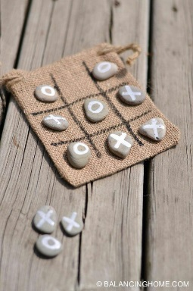  Make to sell at specific events (remember to ask permission!).  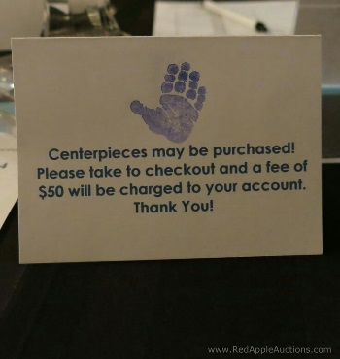
Don’t let me Drown | 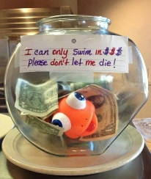 Can you change to a Rat / Rhodent theme instead?  Perhaps “Fishy” can only swim in R5 coins?
Movie Nights | Sell / Raffle this as a complete evening event (perhaps Rhodes Crushes?) or in the form of ongoing “Candy Grams” throughout the year.  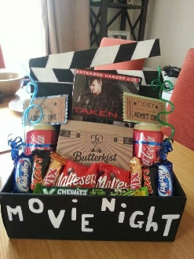
Sweet Gamble / Casino Night | 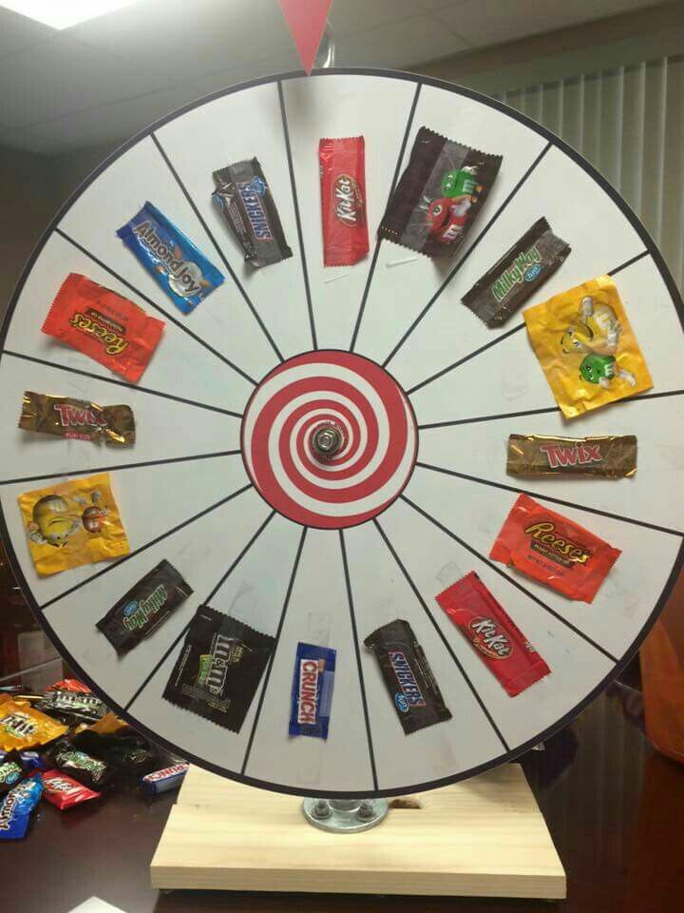 As part of existing Tuck Shops or organise a Casino Event, complete with dress up prizes etc.
Blind / Speed Dates | 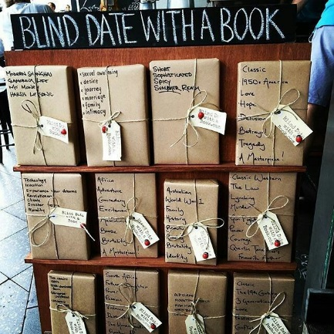 Perhaps by Book Club?  Could be online auctions or through an organized event to include speed dating etc?
Bra Pong / BraNanza | 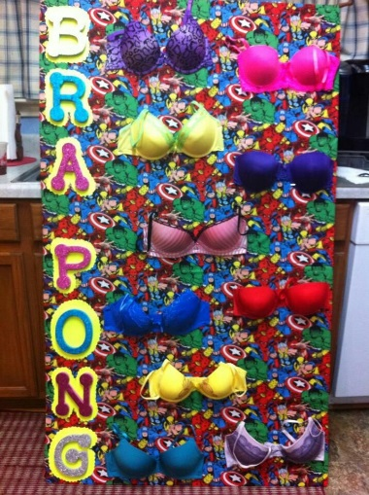 Remember to always be respectful and have good clean fun!

