

**Name**: Roxanne Openshaw (Roxy)

**Course:** Chemistry Honours

**Lab:** S22

**From:** Durban

I Love to travel, dance and chill with friends in my spare time. I am kind, loving, and very loud, love to laugh, outgoing and always speak my mind. I love learning new things especially in chemistry as well as new cultures and religions. I like interacting with different people and always up to make new friends.

**Quote: The Speed of the leader determines the rate of the pack.**

**- Unknown**

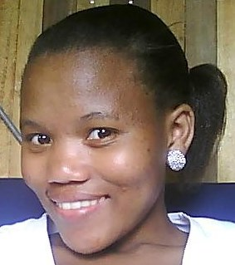

**Name:** Zipporah Madikane (Zippo)

**Course:** Chemistry Honours

**Age:** 21

**From:** Port Alfred

**Quote: Smile well and often, it makes people wonder what you’ve been up to.**

**- Satchel Paige**

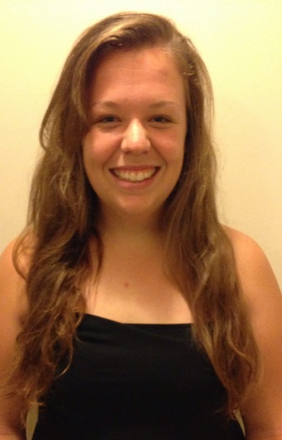

**Name:** Chyanne Abbott

**Age:** 21

**From:** Durban.

I am in fourth year, have a BSc in chemistry and biochemistry and I'm presently studying Chemistry Honours at Rhodes. Apart from academics I also participate in sport (hockey and waterpolo) at Rhodes.

**Quote: Careers, like rockets, don’t always take off on schedule. The key is to keep working the engines.**

**– Gary Sinise**

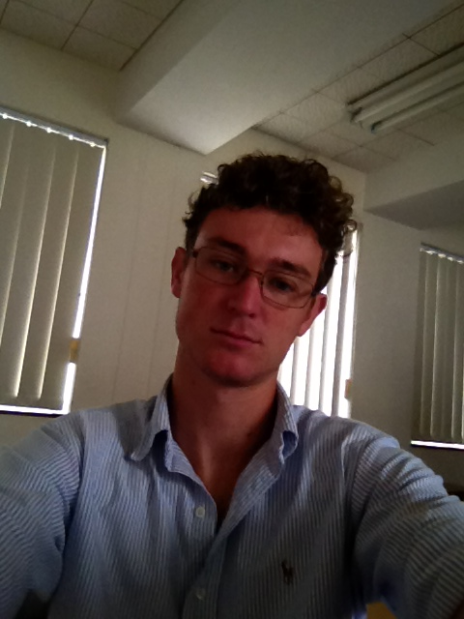**Name:** Charles SJN O’Donoghue (Charlie)

**From:** Zimbabwe

I suffer from intense curiosity and love doing sport. Extremely excited to be doing Honours and look forward to a career in Chemistry. I am from Ireland but live and grew up in Zimbabwe

**Quote: Every Success is built on the ability to do better than good enough.**

**- Unknown**

**Name:** Chelsea Tilbury

**Age:** 20

I'm studying Chemistry Honours. My research is being monitored and supervised by the distinguished Professor T. Nyokong.

I have an undergraduate degree in chemistry and biochemistry and enjoy integrating the two subjects which is why I have chosen a project closely related to photodynamic therapy.

I have lived in South Africa for the past 8 years but I grew up in Zimbabwe.

**Quote: I always view problems as opportunities in work clothes.**

**– Henry Kaiser**

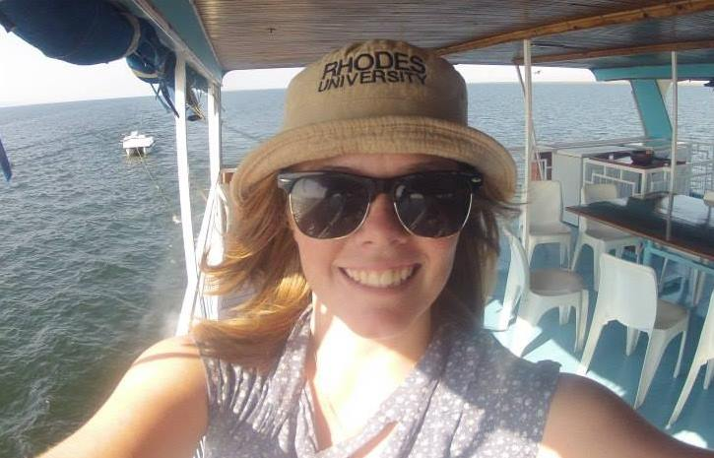**Name:** Rozanne Taylor (Maria)

**Age:** 22

**From:** Harare, Zimbabwe

**Course:** Chemistry Honours (Nanotechnology)

I have pet Rats and Love them.

I HAVE A SOUL!!!

**Quote: Work Hard Play Hard**

**– Wiz Khalifa**

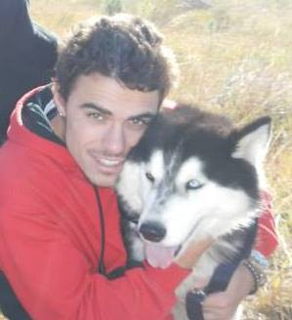**Name:** Kelvin Kelly

**Age:** 22

**From:** Richards Bay

**Course:** Chemistry Honours (Organic Chemistry)

Diploma in Culinary Arts

Life Guard

Sport advocate

I have Pet Tarantulas (15).

**Quote: It’s in your moments of decision that your destiny is shaped.**

- **Anthony Robbins**

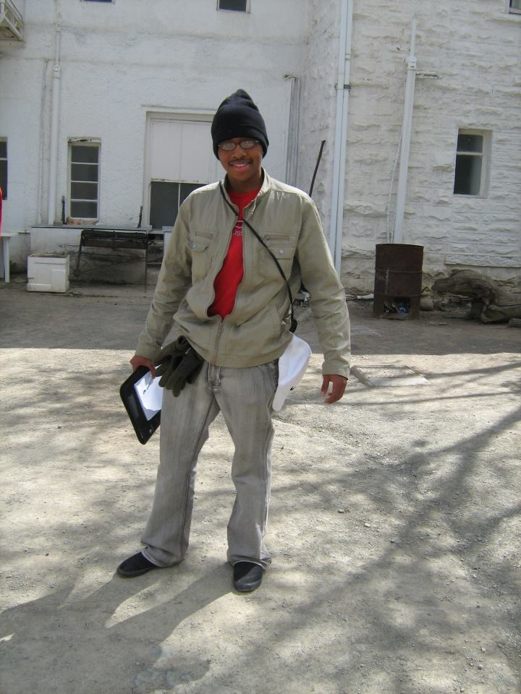**Name:** Ntsika Kota

**From:** Mbabane, Swaziland.

**Course:** Chemistry Honours

I'm a big fan of manga and anime.

I also like cycling.

I'm in Karate and Rifle club.

**Quote: Today knowledge has power. It controls access to opportunity and advancement.**

**– Peter F. Drucker**

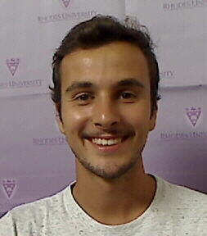**Name:** Bradley Alexander Cormack (Oke)

**From:** Durban

**Course:** Chemistry Honours

**Sport:** Golf, Football, Rugby and Cricket.

Music (Crash Car Burn), Sport and I love going to chill on the beach with mates.

**Quote: To the degree we’re not living our dreams, our comfort zone has more control of us than we have over ourselves.**

**– Peter McWilliams**

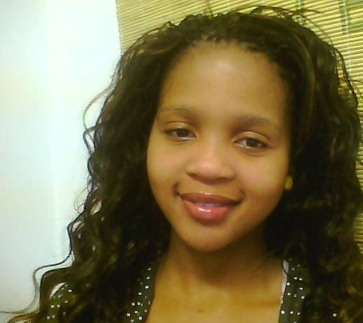**Name:** Sindisiwe Mvango (Sindi)

**From:** East London (Mdantsane)

Graduated with chemistry and geology majors, Honours Project: Enhanced electrochemical signal through the use of hybrid nanostructure materials Biosensors.

**Quote: Just don’t let anyone else set your goals – you do it yourself. Only you know what you want, and only you know what’s realistic.**

**– Yogi Berra**

**Name:** Jessica Harris (Jess)

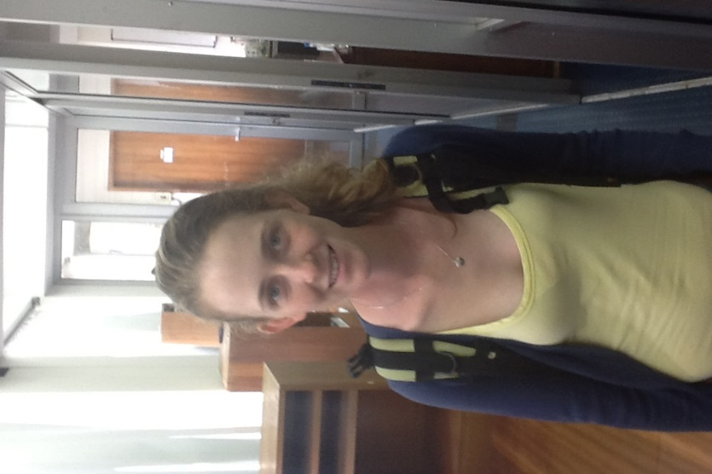**Course:** Chemistry Honours

I'm a local and grew up on a farm on the way to Port Alfred. I am very grateful to the Pearson-Young Memorial Trust for funding my studies this year and providing me with this opportunity.

**Quote: When you’ve got something to prove, there’s nothing greater than a challenge.**

**– Terry Bradshaw**

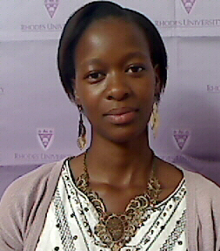 **Name:** Siphokazi Valencia Msengana (Martree)

**Course:** BSc H in Chemistry

**From:** Qumbu, Eastern Cape

**Interests:** Photography, Travel and Reading.

**#Skype_aholic**

**Quote: A ship in harbour is safe, but that is not what ships are built for.**

**– William Shedd**

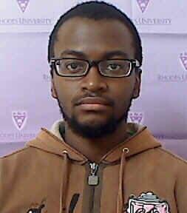**Name:** Gwiba Makalima

**Course:** Chemistry Honours

**From:** Margate, KwaZulu-Natal

**Likes:** Anime and Sport

**Quote: Waste no tears over the grief of yesterday.**

**- Euripides**

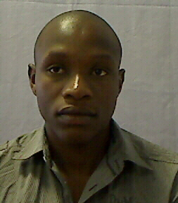**Name:** Mziyanda Mbaba

**Course:** Chemistry Honours

**Likes:** Music

**Age:** 21

**Quote: Make your life a mission – not an intermission.**

**- Glasglow**

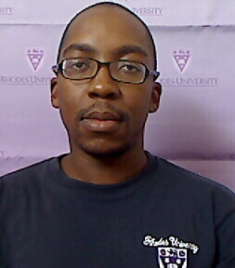**Name:** Joseph Matong

**Course:** Chemistry Honours(Medicinal)

**From:** Bloemfontein

**Hobbies:** Gardening, Singing, Socialising and Cooking

**Interests:** Judo, Soccer, Cricket and Scrabble.

**Quote: A dream is not something you wake up from, but something that wakes you up.**

**– Charlie Hedges**

**Name:** Rachael Magwaza

**Course:** Chemistry Honours

**Age:** 20

**From:** Tongaat (KwaZulu-Natal)

I am a bubbly person that loves life, clothing and friends. I am very determined and I love to travel. I love watching movies.

**Quote: When everything seems to go against you, remember that the airplane takes off against the wind, not with it.**

**– Henry Ford**

**Name:** Nqobile Njoko

**Course:** Chemistry Honours

**Likes: Music, Outdoors and Socializing.**

**Quote: An invincible determination can accomplish almost anything and in this lies the great distinction between great men and little men.**