Ibali lamaMfengu
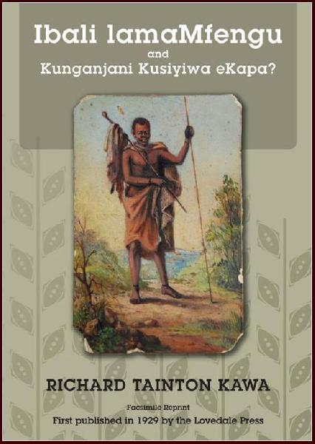

"Eli li Bali kuqala lezizwe ezintsundu, I Bali kwindawo yesibini laba Mbo, le mikwa ne ntlalo yabo beseselu Tukela; ze kwi ndawo yesitatu ibe li Bali lokucitakala kwabo kwelozwe bekongozelwa nogbubele ngoma mpondo, gaba Tembu, nogma Xosa, nangamabandla ase Britani".
In his introduction to I-Bali lama Mfengu (1929) Richard Kawa tells us that he conceived of writing a history of all the black nations and their chiefs while still a student at Healdtown in the 1870s. He travelled far and wide to collect material, and preserved many genealogies and praises that would otherwise have been lost.
Kawa tried to assist Reverend Whiteside in writing the History of the abaMbo (1912) but he fundamentally disagreed with Whiteside’s interpretations more especially on the critical question of how King Hintsa treated the Mfengu refugees and he wanted to set the record straight. Several passages in Ibali lamaMfengu reveal Kawa was one of the very first black nationalist thinkers, and this edition includes his article “Kunganjani kusiyiwe eKapa?” published in Imvo Zabantsundu in 1886.
Many later historians, including DDT Jabavu and KK Ncwana, built on the foundations laid by Richard Kawa, but his book has become almost unobtainable. Cory Library at Rhodes University in Grahamstown has preserved one of the few surviving copies.
We have pleasure in making this facsimile reprint available, which gives you the original text in isiXhosa, just as Kawa wrote it, with an introduction in English by Vathiswa Nhanha and Jeff Peires.
Eastern Cape Reprints is a project of the Cory Library at Rhodes University, Grahamstown. It makes available facsimile reprints of scarce books, long unobtainable but of lasting value and utility. Each book is provided with an expert introduction, which highlights important aspects of the text, contextualises its background, and brings the reader up to date on subsequent relevant research.

