We Can! Black Politics in Cradock, South Africa 1948-1985

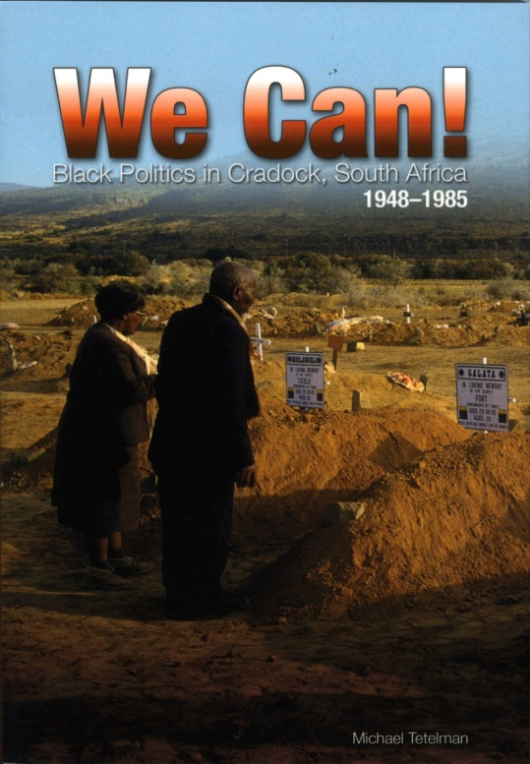
This monograph reflects the broader freedom struggle at the community or grassroots level in South Africa. Homing in on Cradock, We Can! shows our protest history in all its naked horrors, enduring contradictions, and occasional benign nuances.

Michael Tetelman crafts a tapestry wherein both rulers and activists struggle for power and justice in a complex society. In this process we see fear stalking government policy-makers and a combination of boldness and uncertainty exhibited by anti-segregation and anti-apartheid formations up to 1960. After a period of repression, the struggle transitioned to a bolder, even violent, approach that led to the rendezvous of negotiations as of the late 1980s.
Through all of this, Tetelman shows, albeit implicitly, how the “broad church” of the African National Congress (ANC) came into being and played out, especially under the leadership of James Calata of Cradock. More enduringly, the author demonstrates the generational tensions that dogged the ANC from the 1930s through the 19880s; how sport, church, education and beer hall recreation were used for different political outcomes.

He shows how youth incrementally pushed the liberation struggle to higher levels of intensity – from well before university students found their public voice. There is a moment, about 1983-84, in We Can! when charismatic Cradock teacher-activist Matthew Goniwe managed to get African clergy, youth, and elite to transcend their differences. But a complex youth-based grassroots movement, in various community guises, as well as a militarized response from the apartheid regime, set the agenda for a new South Africa by this time.

Tetelman’s book adds significant value to South Africa’s protest literature. It enhances our understanding of the complexity of struggle at local level, and it fleshes out our national narrative.

Eastern Cape Themes. Cory Library at Rhodes University, Grahamstown, reprints out-of print texts and publishes new books. Cory Library, founded in 1931, strives to be the prime custodian of resources and research materials on Eastern Cape history, heritage and culture. It supports inter-and trans-disciplinary research in the humanities and social sciences.

Available from Cory Library @ R195.00 (soft cover) and R395.00 (hard cover) plus postage and packing. Please e-mail us here.

