APPLICATION TO CONDUCT RESEARCH IN THE EASTERN CAPE DEPARTMENT OF EDUCATION
THIS APPLICATION FORM MUST BE COMPLETED AND SUBMITTED IN HARD AND ELECTRONIC COPY TO:
The Director: Corporate Planning, Policy, Monitoring and Research Coordination
Eastern Cape Department of Education
Private Bag X 0032
Bhisho
5605 (Postal address)

OR

Fax to: 086 759 7182

OR
email: shepherd.mutangabende@ecdoe.gov.za
cc: fundiswa.pakade@ecdoe.gov.za/
tanyaradzwa.mazaiwana@ecdoe.gov.za

OR

Deliver to
Steve Vukile Complex
Zone 6
Zwelitsha
5608 (Physical address)

Enquiries: Shepherd Mutangabende
Tel: 040 608 4537/4773
CHECKLIST – Please ensure all documents are attached
Departmental Application Form
Proposal as approved by relevant institution
Research Instruments
Ethical Clearance Certificate
2 slides presentation for the Research Committee
Researcher’s Curriculum Vitae and/or Institution’s Profile
NB.: The Research Committee meets on the last Thursday of each month, complete application documents must reach the office 7 working days before that, otherwise they will be in the agenda of the following month.

EASTERN CAPE DEPARTMENT OF EDUCATION
RESEARCH APPLICATION FORM

SECTION A
TO BE COMPLETED BY RESEARCHER

- PARTICULARS OF THE RESEARCHER

1.1 | Details of Researcher
Surname:
First Name/s:
Title (Prof / Dr / Mrs / Ms / Mr):
Student/Staff Number (if applicable):

1.2 | Contact Details
Institution/Home Address |  | Postal Address (if different)
Postal Code: |  | Postal Code:
Contact No.: |  | Fax No:
Email address:
Preferred method of contact and publication for website: |  |  | Email | Contact No. | Fax

- DETAILS OF THE PROPOSED RESEARCH

2.1 |  | Level of Study (place an “X” in the appropriate column)
Honours |  |  | Masters | Doctorate
Other (specify):
2.2 | Full title of Thesis / Dissertation / Research Project (attach detailed research proposal) Application will not be considered if proposal is not attached
2.3 Brief description of proposed Research
Attach 2 slides PowerPoint presentation to be presented to the Research Committee
The Presentation must include the following:
Name and Surname of the Applicant
- Institution:
- Type and level of Study:
- Field of Study:
- Research Topic:

Summary:
Brief background including the purpose/aim of the study.

Problem Statement:

Objectives of the Study:

Methodology:

Sample:

Ethical consideration:

An example/format of the Presentation:
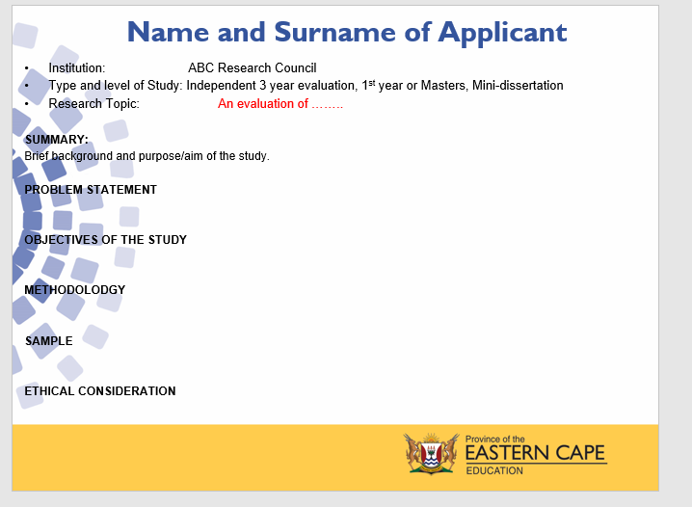
2.4 Value of Research to the Eastern Cape Department of Education

2.5 | Particulars of Affiliated Organisation (if applicable)
Name of Organisation
Position
Head of Organisation/Research Promoter
Contact Number
Email Address

2.6 | Student and Postgraduate Enrolment Particulars (if applicable)
Name of institution where enrolled:
Faculty:
Department:
Name of Supervisor:

- RESEARCH INFORMATION

3.1. District where research will be undertaken:
Institutions where research will be undertaken

Name of Institution | Type of Institution  (primary school, secondary school, technical school, ECD centre, LSEN, FET college) | District

If Head Office/s (Please indicate Chief Directorate/s and Directorates)
3.2. Total number of learners and staff to be involved:
 | Learners | Educators | Principals | Support Staff | Administrative Staff | Lecturers | Other (specify)
Number

3.3. Time of day that you propose to conduct your research. Please mark with an “X”.

School Hours | During Break | After School Hours

3.4. Expected date of commencement of study (DD/MM/YYYY): ……………………………………………..

3.5. Expected date of completion of study (DD/MM/YYYY):……………………………………………..

4. FUNDING INFORMATION

4.1 Did you receive a bursary from the ECDOE? Yes/No
4.2 Details of the bursar/funder/sponsor:

SECTION B
TO BE COMPLETED BY THE UNIVERSITY/INSTITUTION WHERE THE RESEARCHER IS REGISTERED FOR RESEARCH

Application to access Eastern Cape schools
for research purposes
This form is to be completed in any of the following three cases:
- A representative of the Research Body or any institution which commissioned the research
- Student undertaking an Honours, Masters or PhD within Eastern Cape school/s
- Academic undertaking research in Eastern Cape school/s
- Academic applying for group project undertaken by a number of students within a particular programme in Eastern Cape schools (for example for Honours level research project)
- Name of Institution
- Type of application  (See above and indicate one) | - Representative
 | - Student
 | - Academic
 | - Group project
- Name of individual (representative)/student/academic/ group project coordinator
- Student number/ Staff number
- Qualification (where applicable, or indicate if not for qualification purposes)
- Title of research:

- Supervisor/s’ names (where applicable)
- Contact email for (A) Representative, or (B) supervisor, or (C) academic researcher, or (D) programme coordinator (as applicable)
The completion of this form indicates that all the institution’s processes for proposal approval, Ethical clearance or any other processes not mentioned herewith, have been followed.
Reference number and documentary proof of approval of the proposal and Ethical Clearance Certificate must be attached.
Ref number: …………………….
This entailed ensuring that the proposed research meets the criteria of, inter alia:
- Sensitivity - towards participants and institutions, including issues of informed consent and ethical considerations around beneficence and non-maleficence;
- Significance – that the study has merit and meaning and has a contribution to make;
- Accountability – that the researcher understands the responsibilities associated with research in schools and takes issues of validity, reliability and trustworthiness into account;
- Appropriateness – that the research design is aligned to its intentions and to the context of the study.
Date
Institution’s Research Office Details

Institution’s Stamp

Signature of an Authorised person
Title and name of an Authorised Person

- COMMITMENT FORM FOR CONDUCTING RESEARCH IN THE EASTERN CAPE DEPARTMENT OF BASIC EDUCATION

I, (Title, surname and names in full) ……………………………………………………………………………………………………
residing at (Full address) …………………………………………………………………………………………………………………………………………………………….
commit myself to the following 9 items regarding my research:

- To effect no changes with respect to my questionnaire/method of work after having my research application approved by the Department. Any changes I might make shall be submitted to the Department for approval.
- That I am prepared on request of the Department, at my own cost, do a presentation to one preferred audience, once off.
- That, after having obtained permission to continue with my research project from the Department, I shall negotiate with the relevant areas and/or schools regarding final arrangements for visits.
- That I will not to use the Department’s written letter of consent as a means of making unreasonable demands on an office/institution.
- To involve persons in my research project on an absolutely voluntary basis – these persons being all those concerned (including pupils) and all others associated with the Department as well as with all offices/institutions under the control of the Department. Parental/community approval shall be obtained should such a measure be prescribed by the Department.
- Not to remove files/records/documents from the offices and institutions of the Department should information contained in these files/records/documents be needed; to obtain such information under the supervision of a Departmental official assigned by the Department; and to select only information applicable to my research project.
- To present the Department with a copy of my final paper/report/dissertation/thesis free of charge in hard copy and electronic format.
- Not to visit (conduct research or any field work) at institutions (schools) during the fourth school term unless permission has been granted.
- To allow the research to be published on the Departmental website.

SIGNATURE OF APPLICANT: ……………………………………………………………………………………………………………..

PRINT NAME IN FULL: ………………………………………………………………………………………………………………………..

DATE: ………………………………………………………………………………………………………………………………………………

PLACE: ……………………………………………………………………………………………………………………………………………

Tel no (h): ………………………………………. Tel no (w): …………………………….

Cell no: ……………………………………………. Fax no.: …………………………………

FOR THE DEPARTMENTAL COMMITTEE ONLY

APPROVED/ NOT APPROVED

SIGNATURE (Department of Education): ……………………………………………………………………….

S. MUTANGABENDE
CHAIRPERSON: DEPARTMENTAL RESEARCH COMMITTEE

DATE: …………………………………….

END OF DOCUMENT

