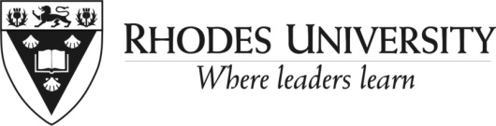
Notice to Appeal
Outcome of a Disciplinary Hearing

Note: this only applies to level 1 and Level 2 internal hearings.
Level 3 hearings appeals must be lodged with the CCMA)

STAFF MEMBER’s DETAILS
Surname |  |  |  |  |  | First name
Preferred name |  |  |  |  |  | Employee no
Job title |  |  |  |  |  | Department
Grade/post level

Your representative in the disciplinary process
DETAILS OF OUTCOME OF HEARING
Date on which you received notification of the outcome of the hearing

REASONS FOR APPEAL
There are two broad categories under which you can appeal:

- Substantive fairness: for example
- the penalty was not appropriate to the charges
- the penalty was not consistent relative to other similar cases of discipline in your work area
- mitigating circumstances were not considered

- Procedural fairness: for example
- your rights were not observed
- the disciplinary process was not followed

If you need help with this, please approach your HR generalist.

This document is available on the HR website on:
http://www.ru.ac.za/humanresources/academicstaff/disciplinarymatters/appeal
http://www.ru.ac.za/humanresources/supportstaff/disciplinarymatters/appeal
Please state your reasons for requesting an appeal (tick the appropriate block/s)

 | Substantive fairness |  |  |  |  |  |  |  | Procedural fairness
Please provide evidence of your claims:
(e.g. if you think the disciplinary hearing was unfair on substantive fairness grounds, give specific examples of this).

SIGNATURES

Signature of employee |  |  |  |  |  |  |  |  |  |  | Date
TO BE SENT TO THE HR GENERALIST FOR OUR WORK AREA

Name of HR generalist
Date received by HR Generalist |  |  |  |  |  |  |  | Signature

