Tasks 1, 5, 6, 7: Number identification, number word before and after
4 | 6 | 9 | 11
20 | 50 | 99
1 | 2 | 3 | 4
5 | 6 | 7 | 8
9 | 10 | 11 | 19
20 | 25 | 32 | 46
47 | 48 | 49 | 50
51 | 52 | 53 | 54
55 | 99 | 100 | 101
208 | 300 | 1025 | ½
¼ | 0 | 30 | 70

Task 2 – Number Line

Task 12: Equal grouping of visible items – Multiplication

3 × 7
7 × 3

9 × 7
32 ÷ 4
8 × 4

8 × 7 = 56

Task 26 cont.
÷
=
8
7
56
8
÷
=
0
0
8

Task 17: Visible items arranged in arrays

Task 15: Non-count-by-ones – Relational thinking
9 + 3 =
9 + 4 =

9 + 5 =
6 + 6 =

7 + 5 =
8 + 4 =

27 – 5 =
7 – 5 =

47 – 5 =

Task 12: Horizontal sentences – Relational thinking
16 + 10 =

16 + 9 =

42 + 23 =
43 – 15 =

56 – 23 =

Task 9: Counting with incrementing tens - Four and ten strips

Task 24
Task 24
Task 24
Task 24
Task 24

Task 2 – Number Line
Task 2 – Number Line
Task 2 – Number Line
Task 2 – Number Line
Task 2 – Number Line

Task 14
28 + 43 | 28 ÷ 43
28 x 43 | 28 - 43
Task 14
28 + 43 | 28 ÷ 43
28 x 43 | 28 - 43
Task 14
28 + 43 | 28 ÷ 43
28 x 43 | 28 - 43
Task 14
28 + 43 | 28 ÷ 43
28 x 43 | 28 - 43
Task 14
28 + 43 | 28 ÷ 43
28 x 43 | 28 - 43

Task 18
Natasha bought | Rajesh bought
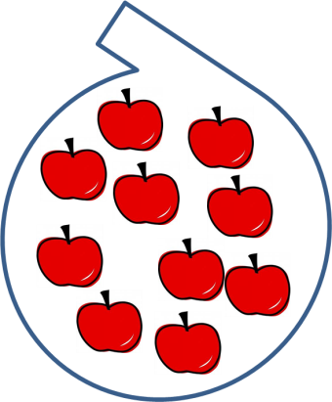  Dawn bought  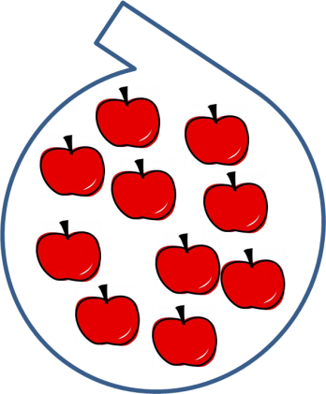 | Gary bought  