A message from the President of the SRC
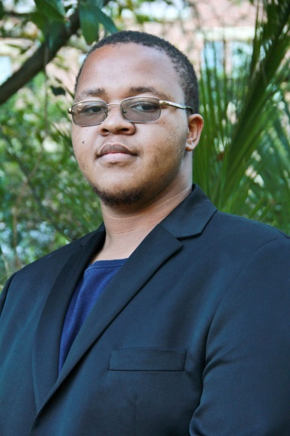
Sisesakhe Ntlabezo

To you, the first year class of 2016, it is my sincerest and humblest pleasure to welcome you to what will become one of the most challenging and most rewarding journeys you will ever take. As new students, you all arrive with varying histories and memories, which form and inform your experience. Ours as the Student Representative Council is to provide you with an invigorating, conducive and supported stay here at the institution currently known as Rhodes University. You have entered university at a time in which institutions of higher learning across the country are embarking on an important process of transformation. As the incoming class, I sincerely hope that by the end of your journey here you will have played a part in ensuring institutions of higher learning reflect the wider realities of South Africa and continually address the pervasive inequalities that exist.

However, it is also crucial that you dedicate time, care and attention to the academic project. After all, it is one of the core reasons you have come to be at Rhodes. The academic project requires patience, humility, and a keen desire to learn. When in doubt, ask questions. Interrogate the material you are provided in your courses, and take advantage of the fact lecturers are easily accessible – more often than not, they are no more than 5 minutes away! Added to that, this stage will require you to exercise great responsibility over your actions and yourself.
At this stage, you are granted much independence. You have to actively remember to submit your work in time, to prepare adequately for tests and to ensure that you are up to date with all you have to do. No one will force you to go to the library or the labs, no one will remind you to prepare for class or for a laboratory session. You have reached a stage where your success depends largely on your own effort and sacrifice. You need to embrace your responsibilities. The only limitation to what you want to achieve in life is how much you want it. However, one thing must be stated - you are not on your own.

There are many resources available to assist: from intern counsellors, sisters in our Health Care Center, Academic support staff and your Representative Council, a plethora of elected leaders equipped to offer guidance and assistance

In the Residence Structure, the Residence Councillor, Oppidan Councillor, House Committees, Hall Senior Students and SRC Hall Representatives are there to offer representation and support.

The Academic Councillor with Class Representatives and Faculty Representatives are there to offer Academic Support when needed.

The Secretary General with Student Defense Councilors are all tasked with assisting you with legal matters or matters concerned with the university rules.

The Treasurer and Student Benefits and Sponsorship Councillor are there to assist you when in financial need or need advice with fees and financial matters

Societies, Environmental, Community Engagement, and Projects Manager are tasked to offer a suitable, enjoyable, oriented, engaging and balanced experienced.

For International students, the International Councillor is available to open platforms and forums for you to voice your concerns, comments and thoughts on how the SRC can ensure you are always represented and your stay at Rhodes is well enjoyed.

The Activism and Transformation and Media Councilor’s are tasked with advancing student-driven activism and ensuring the student body is well informed on matters of transformation that not only affect them, but require their active presence and participation. After all, we co-create the world around – so help us build it.

I, along with the Vice President, are mandated to ensure that the SRC keeps to its vision(s) and missions(s) of representing the student body and being the platform for student driven action. Your SRC strives to work with you, to serve you and to remain exactly what it aims to be – yours.

This is a powerful moment in history, a moment in which your voice can change the world. A moment in which the time you put in now will come out as so much more. So I encourage you to give of your best wherever possible. You have nothing to lose, so give it your all. And remember, at all times – we will be there.

Here’s to you, and your future successes. Stay woke.

