C/S-BOR-AWEBB-2004.05
RHODES UNIVERSITY
ALLAN WEBB HALL COMMITTEE
MINUTES OF A MEETING HELD ON TUESDAY, 28 September
AT 19:00 IN THE HALL WARDENS FLAT.

J. McNeill JM/lk
Allan Webb Hall Warden 29 September 2004

MINUTES

PRESENT
Messrs John McNeill (Hall Warden, Chair) and Luke Brown (Winchester House Sub-Warden), Sr Rosemary Büchner (Associate Hall Fellow), Messrs Matthew Charlesworth (Salisbury House Warden) and Ms Natalie Grunewald (Truro House Senior Student), Prof Roger Jacob (Hall Fellow), Ms Nicola Kane (Hall Senior Student), Mr Zwangendaba Ludidi (Winchester House Sub-Warden), Ms Mpumi Mathibela (Canterbury House Sub-Warden), Mr Trevor Mushowe (Salisbury House Sub-Warden), Ms Monica Ramsunder (Canterbury House Sub-Warden), Mr Stuart Thackray (Hall SRC Rep 2005), Mesdames Anne Warring (Truro House Warden) and Desiree Wicks (Canterbury House Warden)
Secretariat: Ms Larissa Klazinga (Allan-Webb Hall Secretary)

LEAVE OF ABSENCE
Prof. Lilla Stack (Hall Fellow), Mr Garth Francis (Winchester House Senior Student), Mr Glenn Guiseb (Salisbury House Senior Student), Graeme Saggers (Salisbury House Sub-Warden) and Oliviér Serrao (Allan Webb Hall SRC Rep) and Ms Lerato Thulo (Canterbury House Senior Student) were absent.

OTHER MATTERS FOR THE AGENDA
There were no other matters for the agenda.

CONFIRMATION OF MINUTES
The minutes of the previous meeting were confirmed by Mr Charlesworth and seconded by Ms Warring.

WELCOME
Mr McNeill welcomed the Committee to the final Hall Committee meeting of the year.

HALL WARDEN’S FORUM
  - Dining Hall Refurbishments
Mr McNeill informed the Committee that the Dining Hall will be refurbished. The upgrade was scheduled to begin in December and this would most likely continue into the new year.

MATTERS ARISING
7.1 Allan Webb Adventure
Mr Brown thanked the Hall Committee and all helpers and participants for the role they played on the day. Despite the rain it was agreed that the event was a success.

Mr McNeill thanked Mr Brown and the AWA committee for their hard work and enthusiasm. It was suggested that a Chair and Vice-Chair be appointed for the AWA to ensure continuity.
7.2 Canterbury Karaoke
Ms Kane informed the Committee the Canterbury would be hosting a Karaoke evening to raise house funds.
7.3 Sub-Warden Appointments
Mr McNeill thanked the committee members who served on the Sub-Warden selection committees for their contribution to the successful outcome of the process..
  - Hall Bar
Mr Francis proposed the name “Bishop & Nun” for the Hall Bar. After some discussion the name “The Nun & Bishop” was adopted as the official name.
  - Quality of Residence Life Survey
Mr McNeill reminded the Committee that a staff performance survey would be conducted throughout the Hall. He encouraged everyone to ensure a high turn-out.

ALLAN WEBB ADVENTURE BUDGET REPORT BACK
Mr Charlesworth informed the Committee that the AWA was in the process of finalising its books. He assured the Committee that the Hall would recoup its loan.

SRC ELECTION RESULTS
Mr McNeill congratulated Mr Thackray on his election as Allan Webb Hall SRC Representative for 2005 and welcomed him on behalf of the Hall.

HALL SENIOR STUDENT ELECTIONS & HOUSE COMMITTEE ELECTIONS
Mr McNeill informed the Committee that the Hall Senior Student election was complete and the results will be announced at the Leavers’ Dinner. He reminded the Committee that House Committee elections should be complete within the fortnight.

2nd DRAFT EXAM TIMETABLE
Mr McNeill informed the Committee that the 2nd draft exam timetable is available.

SOCIAL FUNCTIONS CUT OFF PERIOD
Mr McNeill reminded the Committee that the cut-off date for social functions is three weeks prior to the November exams and it should be strictly adhered to.

FOOD REP MEETINGS WITH CATERING – SHOULD THEY CONTINUE?
The Committee noted that there were few positive outcomes from Food Rep meetings. It was suggested that complaints should be emailed directly to Mrs Jay Pillay in order to resolve issues quickly. It was decided that the matter should be held over until 2005.

MERIT SCHOLARSHIP AWARDS
Mr McNeill informed the Committee that nominations for Merit Scholarships are open and forms are available from the Hall Secretary.

HALL FELLOW
The item was deferred until the first meeting of 2005.

SECURITY ON CAMPUS
The Committee noted the proposed locations for the Panic Buttons and Emergency Communicators, as well as the Allan Webb Hall submission on the issue of improved safety on campus to the Vice-Principal.

AMENDMENT TO THE STUDENT DISCIPLINARY CODE – ALCOHOL
Mr Charlesworth drew the Committees attention to the Vice-Chancellor’s amendment to the Student Disciplinary Code relating to alcohol consumption.

Members of the Committee noted that alcohol is a legal substance and “intoxication” both varies from person to person and is very subjective. The definition of drunk was questioned, would it be 0.05 blood alcohol level as is relates to drunk driving, or would there be some other measurement. It was felt that the amendment was too broad and subjective to be effective.
The Committee supported the spirit of the amendment, which it identified as discouraging over-indulgence.

HALL & HOUSE FINANCES AND REVISED HALL BUDGET
Mr McNeill drew the Committee’s attention to revisions in the House and Hall Budget for 2004.

RESNET REP & RESNET TECHNICIAN PORTFOLIOS
Mr McNeill noted the JP Buchanan would be reappointed as ResNet Technician if the Committee felt that his job performance warranted it. The Committee was satisfied with Mr Buchanan’s performance and recommended his reappointment..

ANY OTHER BUSINESS
There was no other business.

LK/28 July 20264
Proposed Locations of Panic Buttons and Emergency Communicators (St Peter’s Campus enlarged) Document A
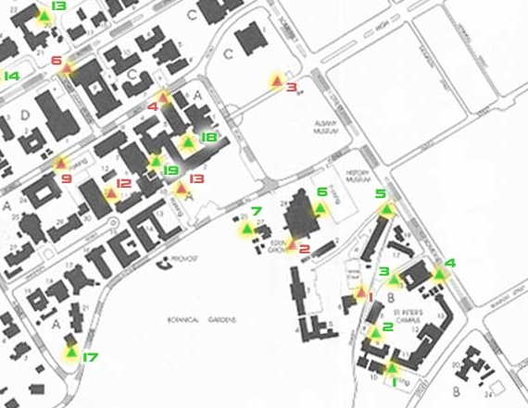
The green triangles represent panic buttons and the red ones emergency communicators.
Proposed Locations of Panic Buttons and Emergency Communicators 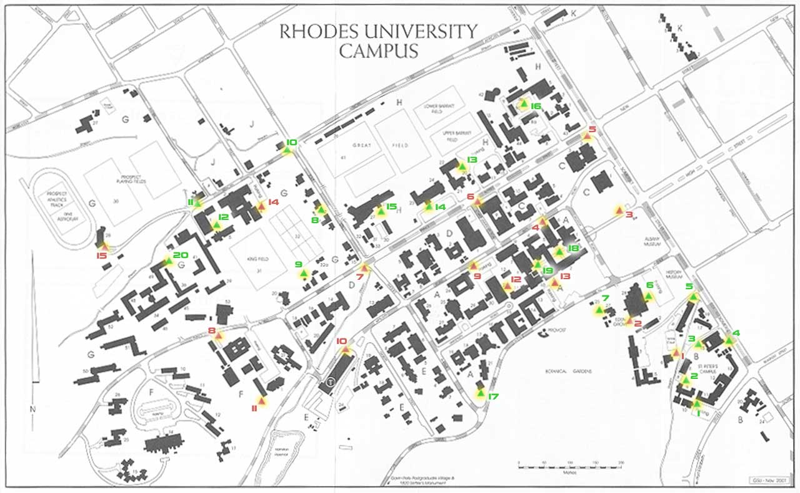
The green triangles represent panic buttons and the red ones emergency communicators.
Proposed Locations of Panic Buttons and Emergency Communicators
The map below shows the proposed locations of panic buttons and emergency communicators on campus. The locations were chosen based on two main criteria: frequency of traffic and reported incidents. Comments and constructive criticism concerning the location of these devices is welcomed. Please direct such input to D.Charteris@ru.ac.za.

Panic Buttons §
- Education department car park
- Law department
- Music department (St Peters side)
- Music department (Somerset Street side)
- Fine art (graphic design)
- Eden Grove car park
- Photo Journalism
- Estates Division
- Tennis Courts
- Corner South Street/African Street
- Transit Housing office
- Alec Mullins quad
- Red square car park
- Great Hall
- Union
- Ichthyology car park
- Rhodes Crèche
- Fountain Quad (Quad one)
- Quad two
- Helen Joseph house
Emergency Communicators
- St Peters bridge
- Eden Grove computer lab
- Drostdy Arch
- Jacaranda Lab
- Prince Alfred Street (Rhodes Theatre)
- Prince Alfred Street (Chemistry)
- Prince Alfred Street (South Street)
- Prince Alfred Street (LIRI)
- Library car park
- Electrical/Transport office
- Fine Art/path to Kimberley
- Library Quad (Quad three)
- Botany car park
- Sports suite/HKE car park
- Sports admin
§ It should be noted that the panic buttons make use of standard alarm radio telemetry. The University already makes use of this technology to monitor fire and building alarms throughout campus (they sound remotely at the Campus Protection Unit offices). Unfortunately, the technology currently in use is somewhat dated and difficult to source parts for. This means that when the current stock of radio transmitters is used up, the University will have to look for newer alternatives. This will likely require that the University applies to ICASA for a frequency licence (our current frequency is deprecated and no longer available). This is a process that will likely take six months or more. As a result, we can install the first few panic alarms in fairly short order using the transmitters we have in stock. There will be a significant delay, however, in getting the full roll out completed. This is why the prioritization of these installations is important.

Panic Button: Emergency Communicator:
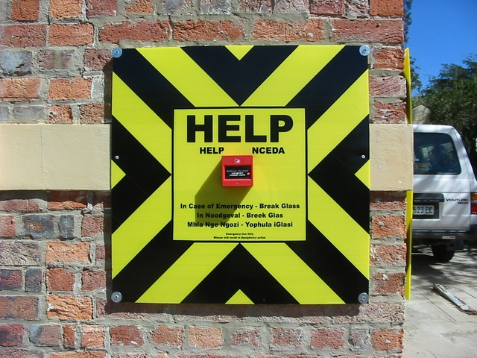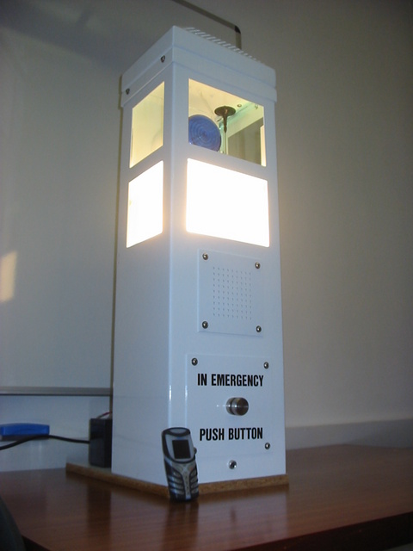
DOCUMENT B
AMENDMENT TO THE STUDENT DISCIPLINARY CODE

"Acting in my capacity of Chief Disciplinary Authority of the University, I deem it necessary and desirable that student disciplinary hearings should be conducted in accordance with the following interim amendments to the Student Disciplinary Code with immediate effect:

1. By insertion of the following definition of 'under the influence of alcohol':

'Under the influence of alcohol means that the skill or judgement normally required in the conducting of a student's everyday life is obviously diminished or impaired as a result of the consumption of alcohol.'

2. By the substitution of Rule 20.5.1.2.3 with the following rule:

'being under the influence of alcohol'

3. By the deletion of the words 'in residence' from Rule 12

4. By the deletion of the words 'living in residence' from Rule 12.1

5. By the insertion of the following rule:

Rule 13.5 The lawful instruction referred to in 13.2 shall include the right to request a student who, on reasonable grounds, is suspected of being under the influence of alcohol to take a breathalyser test or any other reasonable, relevant tests, for example the ability to stand on one foot or the ability to walk in a straight line."

