Transport

PE airport - 120km from Grahamstown (1hr 30 min travel time)

East London airport - 200km from Grahamstown (2hrs travel time)

Shuttle contacts :

Blunden 041 451 4803 or 041 581 4566 odette@blunden.co.za

JC Shuttle 083 590 2169 or 083 444 8226 jcshuttle@vodacom.co.za

Leslie Kortrooi 083 762 9164

Mark Bridger 083 721 2296

Grahamstown accommodation

Rhodes Univeristy on campus Bed and Breakfast

Contact : conferencing@ru.ac.za or n.adriaan@ru.ac.zaor or s.ponoshe@ru.ac.za

Accommodation off-campus

Hotels
Bushman Sands Golf Lodge  e: reservations@myriver.com  p: +27 861 748 374  w: www.riverhotels.com  Contact Person: Reservations  Set in the Bushman's River Gorge, in the heart of the Greater Addo in the Eastern Cape of South Africa, Bushman Sands Golf Lodge features an 18 Hole Golf Course and Luxury Lodge Accommodation. The Lodge boasts 13 tastefully decorated rooms, all marked by welcoming warmth, a hint of intimacy and stunning views of the golf course and hills beyond. The Luxurious rooms are all en-suite, featuring spacious bath rooms with a bath, shower, twin vanity and toilet. Each room has its own private patio, opening onto the pristine landscapes and picturesque golf course. All rooms are fully air conditioned and offers limited DSTV channels. The complimentary use of the onsite gymnasium, coupled with a scenic swimming pool, will add that special touch to your getaway. Also, being ideally situated (with a travelling time of less than 15 minutes) guests have the option of visiting the world renowned Born Free Foundation: The Centre where battered and bruised animals (e.g. Lion and Leopard) are being rehabilitated to be released back into the wild. | 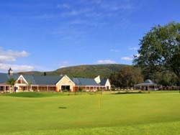

The Graham Hotel  e: centralres@afritemba.com  p: 0861 at eRes (283 737)  w: www.afritemba.com  Contact Person: Reservations  The Graham Hotel situated on High Street in the city centre amidst the peaceful ambience of historic Grahamstown. Recently refurbished bedrooms offer warm Eastern Cape hospitality, while on site the Calabash Restaurant offers truly South African wining and dining. Near cinemas, Museums, Rhodes University, Private Schools. Three conference rooms. | 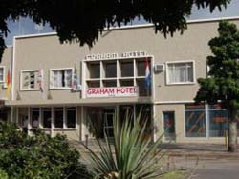

Halyards Hotel and Spa - Port Alfred  e: reservations@myriver.com  p: +27 861 748 374  w: www.riverhotels.com  Contact Person: Reservations  The Halyards Hotel lies in the heart of the Sunshine Coast, set along the waterfront of the stunning Royal Alfred Marina and surrounded by majestic coastline. Boasting a refined nautical inspired style and with classic and cool interiors, the luxurious en-suite rooms and suits and unparalleled views of the marina. The versatile meeting and event spaces offer, the perfect venues for a lasting impression making the Halyards Hotel the ideal location for social events, weddings, meetings and conferences. With plenty to offer the Halyards Hotel is the ideal destination...so come and discover this exclusive and exquisite place! | 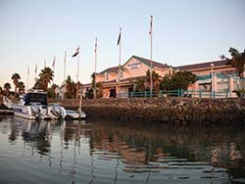

"Hotel Victoria"  e: hotelvictoria@imaginet.co.za  p: +27 46 622 7208 or +27 46 622 7261  w: www.hotelvictoriamews.com  Contact Person: Reservations  Mr. O' Donnel, an Irishman, built the hotel 1849, trading as an Inn, Canteen and Boarding house. In 1860, Archibald Lappan took over the Hotel; in 1901 the new owner (still unknown) renamed it "Hotel Victoria". "The Vic", was for many years, the most popular Student Party Spot in Grahamstown. It was changed back into a Hotel in 1998. We have re-decorated the 15 rooms and created a homely, warm atmosphere. The swimming pool, is the perfect place to cool off. Gino's, "Grahamstown's favourite pizza place" and Henry Ate Restaurant are all on the same premises. | 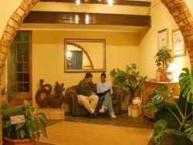

Summerhill Inn  e: centralres@afritemba.com  p: 0861 at eRes (283 737)  w: www.afritemba.com  Contact Person: Reservations  Summerhill Inn a charming Country Inn just outside historicBathurst is nestled amongst pineapple plantations and offers Colonial-Style accommodation. The Packshed Restaurant offers an al la Carte menu for lunch and dinner, light snacks and refreshments, and great atmosphere in the Porcupine Bar with Friday night live entertainment. Conference facilities, a swimming pool, fun kiddies' playground and enjoyable tractor tours are on offer. | 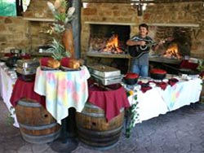

Backpackers
Blue Skies Backpackers  e: blueskiesbackpackers@gmail.com  c: +27 84 278 3193  Contact Person: Sean  3,5km from the Cathedral on the Craddock rd, Blue Skies Backpackers is the idyllic rest area for your Grahamstown visit. Set at the aerodrome,home of EP Skydivers, recharge in a tranquil quiet environment and enjoy the expansive views and stunning sunsets. Dorm space and Private cabins available, let your experienced hosts tend to your needs. Family orientated, children welcome. | 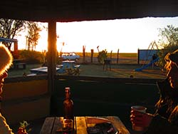

Bon Tempo  e: bontempofarm@gmail.com  c: +27 83 281 0257  w: www.bontempo.co.za  Contact Person: Claudia  Our little farm is on top of a small hill in the beautiful Manley Flats valley just 20 km from Grahamstown. We are farming with honey bees and keep a group of zebras and donkeys. The grassland with acacia, aloe, euphorbia, trees, shrubs and herbs slopes down to dense riverside thickets and many wild animals and birds are living here. We have two cottages for our guests, where minimalism pairs with eco-art and thousands of glass bottles found a new use as features in walls and windows. Phall♂s, an exhibition of visual art, was premiering at the National Arts Festival 2012. Today it is a permanent gallery of erotic art with mainly phallic artworks for sale including pottery, photography, paintings and graphics. A priapic garden is surrounding our buildings and the number of phalli and other artworks is growing steadily. | 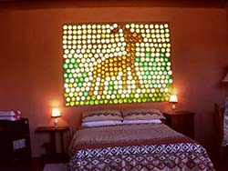

Chappy's Cushion  e: info@chappyscushion.co.za  p: +27 43 722 3990 | c: +27 72 585 4860 / +27 82 494 3025  w: www.chappyscushion.co.za  Contact Person: Gerald  The vision for Chappys Cushion is to give everyone the opportunity to experience the outdoors, relax, refresh and enjoy the beautiful Savannah bush veld surroundings. With the lodge situated about 28Km from Grahamstown and Port Alfred, we offer 3 star En-suited accommodation in our main-lodge and 4 star Backpacker accommodation in the bunk-house. | 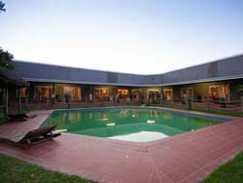

Conservation Academy on Craig Doone  e: info@conservationacademy.co.za  p: +27 46 622 3505 (unreliable) | c: +27 73 566 2809  w: www.conservationacademy.co.za  Contact Person: Trelss McGregor  Basic self-catering farm accommodation 10 km from Grahamstown 800m off N2 to Port Elizabeth. Cost R180 pp sharing unit. 4 units. 2 x self-catering units sleep 2-7. Bedrooms sleeps 2-5, living/eating room (2 extra beds), small equipped kitchen (fridge with freezer, stove/hotplate, microwave etc.), bathroom (toilet, shower) and outside braai. 2 x separate units rooms sleep 2-6 with own bathrooms (toilet, shower), self-catering facilities (fridge, kettle, microwave, 2 plate hotplate etc.) in room. Bedding and linen provided, no towels, NO TV, no shop, no consumables, no frills. Accommodation within electric fenced area, uncovered parking. Suitable for families, school and student groups, contractors... Right of admission reserved. Veld, forest and stream walks. Conservation courses! | 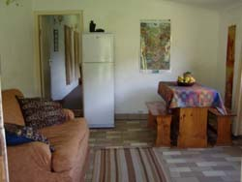

Bed & Breakfast
18 Henry Street  e: info@henry18.co.za  c: +27 72 882 9692  w: www.henry18.co.za  Contact Person: Stuart and Anne  Offers friendly and affordable accommodation for up to 10 people. A double-storey period house with large rooms and high ceilings, guests have the use of the entire top floor. Accommodation consists of 3 bedrooms, a lounge and bathroom. A second bathroom is provided downstairs. The garden apartment has 2 rooms, both en-suite, and full self catering facilities. Situated in a quiet area, 1km from the centre of town, guests are assured of peace and convenience. Equipped for self-catering, breakfast can be provided on request. | 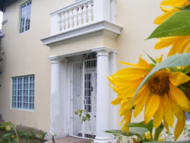

47 Strelitzia Street  e: w.wrench@ru.ac.za  c: +27 82 365 4444  Contact Person: Wendy  This secure, self-catering unit welcomes visitors to Grahamstown and is situated in a tranquil, residential area. The spacious, modern unit offers a comfortable home-away-from-home experience. An open-plan area consists of a double bed and a lounge with two sleeper couches (sleeps 4). The en-suite bathroom has a glass shower and attractive built-in hand basin and vanity area. A fully equipped kitchenette is available for those opting for self-catering. Sliding doors open onto a patio with a pool. Breakfast is an optional extra. | 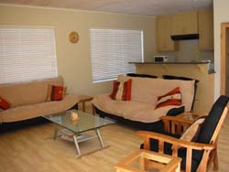

Aloe and Elephant Lodge  e: info@aloeandelephantlodge.co.za  c: +27 82 890 2633  w: www.aloeandelephantlodge.co.za  Contact Person: Marianna  An exclusive game lodge situated in pristine Eastern Cape bush only 10 minutes from Grahamstown. One hour drive from PE airport. Well appointed thatch chalets, each room ensuite & serviced daily. Mini bar, safe, electric blankets, heater, kettle, tea and coffee in each room. Bed & breakfast includes wholesome farm cooking. | 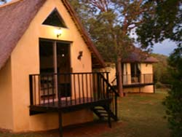

Amberleigh  e: paulhobson@telkomsa.net  p: +27 46 622 4724 | c: +27 82 773 3983  w: www.grahamstown.co.za/amberleigh  Contact Person: Rose  Comfortable, spacious accommodation in quiet neighbourhood within easy reach of schools, town and Rhodes University. 2 Units with king beds en-suite (one can be made into twins and has self-catering nook) and 1 fully equipped self-catering flat. Each unit has off-street parking behind remote controlled gate / an alarm / wifi / and a lock-up garage is available on request | 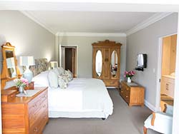

Amblewood B & B  e: amblewood@imaginet.co.za  c: +27 83 283 0682  w: www.amblewoodbnb.co.za  Contact Person: Yvette  Conveniently situated between Kingswood College and Graeme College. We offer comfortable, spacious accommodation, a home away from home. A braai facility and sparkling swimming pool within a large private garden, for those hot summer months. Consisting of a family/conference unit sleeping up to 6 people. Choose from either king size or single beds and enjoy the fresh percale linen. We offer a self service continental breakfast or self catering. Pets welcome by prior arrangement. | 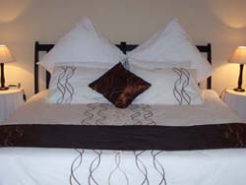

Antique Silk  e: marion@antiquesilk.co.za  p: +27 46 622 3816 (a/h) | c: +27 83 731 9732  w: www.antiquesilk.co.za  Contact Person: Marion  A stylish two bedroom flat (interleading room) with twin beds in both rooms. An en-suite bathroom with shower in main bedroom, and a fully equipped kitchenette. We also have a delightful log cabin which sleeps 2 and is also self-catering. Situated on the sunny side of town, with a lovely garden filled with Antique Silk and other white roses. A few minutes drive to town, university and schools. Secure off street parking and separate entrance. We offer continental breakfasts or self catering. Facilities include TV with M-Net, hairdryer, fans, heaters, radio, braai and tea/coffee. Affordable rates. A warm Eastern Cape welcome awaits you! | 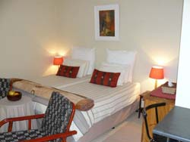

Apple Bee Guest Cottage  e: jeannine@formstar.net  p: + 27 46 622 2651 | c: +27 83 680 3111 | f: +27 86 551 4310  Contact Person: Jeannine  Clean, fresh country decor gives AppleBee its unique warmth and charm. There is only one cottage on the property with its own private garden area. The accommodation offers a queen-size bedroom with plenty of cupboard space and bathroom with shower and bath. Quality linen, towels and hospitality items are supplied. The living room has a well-equipped kitchenette with full sized fridge/freezer, microwave, gas/electric stove, kettle and toaster. There is a dining area and comfortable lounge seating with a ¾ sleeper couch. Teas, coffee, hot chocolate, cereals, milk, fruit and rusks are provided. Continental breakfast is available on request. Full bouquet DSTV is available. The cottage is serviced daily. Secure off-street parking with remote access is provided. Complimentary internet Wi-Fi access. Safe. Laundry service. Fans & heaters. AppleBee is conveniently situated 100m from St Andrew's Prep, 700m from St Andrew's College and DSG and 1.2km from Rhodes University. | 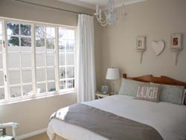

A Stone's Throw B&B  e: info@astonesthrow.co.za  p: +27 46 622 3294 | c: +27 83 651 9244  w: www.astonesthrow.co.za  Contact Person: Suzanne  Offers country living only 4km's from the city centre of Grahamstown, the heart of Frontier Country. A warm welcome awaits you at A Stone's Throw, the perfect travellers stopover in Grahamstown, Africa's Festival Capital and City of Saints. A Stone's Throw B&B accommodation is situated in a tranquil country setting with the advantage of accessibility to the main centre of Grahamstown, as well as Thomas Baines Nature Reserve. | 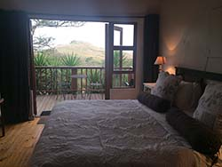

Autumn Leaves  e: autumnleaves@insightnet.co.za  p: +27 46 622 9328 | c: +27 83 377 2101  Contact Person: Michelle  Autumn Leaves offers quality double and single B&B or self-catering accommodation in the lovely suburb of Westhill and is within walking distance of Rhodes, St Andrews, Prep, DSG and Aquaculture Innovations. Unit 1 has twin beds (or king size on request) with en-suite bathroom and a fully equipped kitchen, lounge and dining area combined. Unit 2 has twin beds (or king size on request) with en-suite bathroom, kitchenette and desk area. Enjoy the beautiful view of Rhodes University and the surrounding hills from the verandah of the Units 1 and 2. Unit 3 is a small, but comfortable bedroom (three-quarter bed) with en-suite bathroom for the single guest and for shorter stays. All units are linked to a back-up water supply in the event of a municipal outage. DSTV Hospitality Bouquet available in all units. Wireless internet available in all units. | 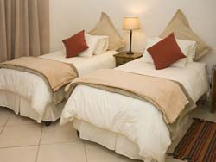

Bartholomew's Loft  e: justine@bartholomewsloft.co.za  c: +27 82 448 2971  w: www.bartholomewsloft.co.za  Contact Person: Justine  Bartholomew's Loft is affordable, centrally situated, self catering accommodation, ideally suited to families or friends travelling together in the Eastern Cape. We offer a self serve continental breakfast if required. This lovely old building with its double volume living space has been converted into very comfortable self catering accommodation for a group of up to six people. Bartholomew's Loft offers 3 bedrooms; one king size upstairs and two smaller twin rooms downstairs, a spacious open plan lounge/dining room/kitchen area. There is only has ONE bathroom which is not en-suite to any of the bedrooms. The loo is separate. | 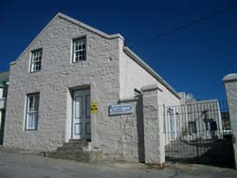

Belvedere B & B  e: grahamstownphy@imaginet.co.za  p: +27 46 622 4486 (h)/+27 46 622 7116 (w) | c: +27 83 279 7969  w: www.grahamstown-accommodation.co.za/belvederepage.html  Contact Person: Annalise  Belvedere B&B offers luxurious accommodation and is set in a lovely private garden. Guests have their own entrance through remote controlled gates to safe parking. The centre of town is only a 4min drive away, and also approximately 4 mins drive to the private schools, St Andrew's, DSG and Kingswood College. Graeme College is within easy walking distance and we are a 6min drive to PJ Olivier. | 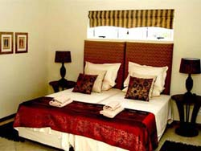

Bezali Lodge  e: info@bezalilodge.co.za  c: +27 82 465 2780 or +27 82 890 9612  w: www.bezalilodge.co.za  Contact Person: Mari  Bezali Lodge is a great country getaway nestled in the mountains just outside Grahamstown. The lodge is situated 7 km out of Grahamstown on the Port Alfred road. Wake up to the spectacular mountain views and the gentle sounds of birdlife. The lodge sleeps up to 12 guests. The loft in LAPA is perfect for students and back packers sleeping 8 to 10 people. A private braai, jaccuzzi and bar area are available in the LAPA. A swimming pool to cool off in on those hot summer days and nights. Arranged barbeques at night! | 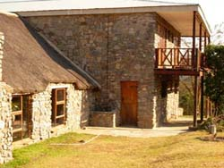

B's B & B  e: baartjeanine@gmail.com  p: +27 46 622 6063 | c: +27 82 785 9363  Contact Person: Jeanine  B's B & B offers asunny, spacious garden flat in a pretty secluded flower-scented garden. Situated in a quiet area near Kingswood College, it has a private entrance and off-street parking. The flat has vibrant colourful decor, with some lovely original artwork and personal touches. There are twin beds with good, comfortable mattresses and these can be put together to form a kingsize bed. A third bed or mattresses for 2 small children can be added if necessary. The flat is fully carpeted, has 2 comfortable chairs, a quality TV with MNET, video machine with DVD player, music system, heater, fan, electric blankets and hairdryer. | 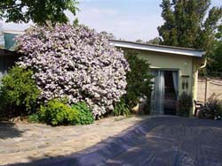

Cottage-in-the-Garden  e: mary@cottageinthegarden.co.za  p: +27 46 636 2793 | c: +27 83 651 0067  Contact Person: Mary  The cottage has a large bedroom with double bed, couch, TV (full DSTV) and heater and fan available. Top quality cotton bedding is used for the comfort of our guests. An electric blanket will keep you warm on those cold winter nights! The en-suite bathroom has a shower, but no bath. A well equipped, separate kitchen has a table and chairs that can double up as a desk for guests who need space to work. Complimentary WIFI is available. The cooking facilities are microwave and two-plate stove with mini oven. The cottage is let on a self catering basis, with basic breakfast supplies provided. A more substantial self-serve breakfast can be delivered to the cottage by arrangement. | 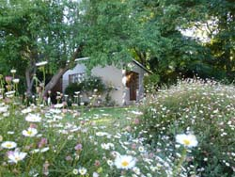

Courtlands  e: courtlands@imaginet.co.za  p: +27 46 622 3247 | c: +27 83 376 2250  w: www.courtlands.co.za  Contact Person: Jo  Situated in historic New Street, Grahamstown and a few meters from an entrance to Rhodes University Campus and Peppergrove Shopping Center, Courtland's has 2 self-contained, neat and comfortable garden cottages. Convenient for conferences, studies, business or relaxation, we provide secure under cover parking, your own entrance, and offer B&B or self catering accommodation in the heart of Grahamstown. Children very welcome. | 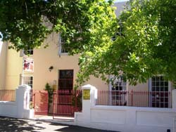

Durham Cottage B & B  e: durhamcottage@albanynet.co.za  p: +27 46 622 4453 | c: +27 82 730 7330  Contact Person: Maureen  Durham Cottage is situated in the beautiful garden of our renovated 1820 Settler Cottage. Close to Kingswood College and walking distance from the centre of Grahamstown. Guests have their own remote controlled garage and private entrance. The accommodation comprises; an en-suite double bedroom, double bed, top quality linen is used for the comfort of our guests. TV (full DSTV), wall heater, fan and hairdryer are available. The en-suite bathroom has a shower, but no bath. Top quality towels plus a selection of toiletries are provided. The modern kitchenette is full equipped for basic self-catering. Teas, coffee, plus filter coffee, a choice of cereals and biscuits are available. Fresh milk and fruit is provided on arrival. The accommodation is serviced daily and laundry can be done for a nominal fee. Additional large double bedroom with modern private bathroom in main house, if required. | 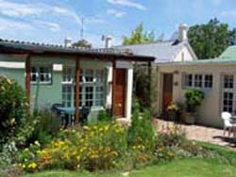

Eagles Nest B & B  e: eaglesnestgtown@gmail.com  p: +27 46 622 7189 | c: +27 82 657 0359  w: www.eaglesnestbnb.co.za  Contact Person: Sheryl-Anne  Eagle's Nest B&B is on the sunny side of Grahamstown. Ideally situated near schools, city centre and in walking distance to shops, museums, Rhodes University and restaurants. Three reasonably priced self-contained garden flats each with their own private entrance. One of the flats sleeps 4 and the other 2 flats sleep 2 people in each. The braai facility near the sparkling pool on your doorstep often comes in handy on this sunny side of town. Children welcome. Pets welcome by arrangement. Choice of self-catering or B&B accommodation. Secure parking where guests bring their car into our yard with remote control/electric fence. Facilities include TV, hairdryers, fans, heaters, radio, complimentary WIFI / internet and tea/coffee facility, small kitchenette with stove/microwave/fridge. | 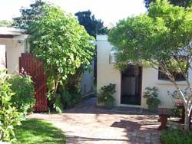

Elgon B & B  e: info@elgon.co.za  p: +27 46 622 7702 | c: +27 82 655 6733  w: www.elgon.co.za  Contact Person: Morny  Elgon B&B is a two-roomed separate unit, with queen-sized bed, en suite shower and self-catering facilities, offering the discerning traveller a comfortable home away from home while doing business or exploring frontier country in the Eastern Cape. Elgon is situated in a tranquil, residential area, and is conveniently positioned a couple of minutes drive from the city center allowing easy access to Rhodes, schools, the cathedral and museums. Your stay at Elgon includes a refreshing continental breakfast, if required, as well as daily servicing of the unit. Other features include: Private entrance, secure parking, wireless hotspot. | 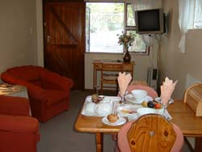

Guinea-Fowl B & B  e: cheryth@lantic.net  p: +27 46 636 2887 | c: +27 73 444 3012  Contact Person: Cheryth  Situated in the quiet Westhill neighbourhood, close to St Andrews & DSG, and 900m from Rhodes University, Guinea-Fowl B&B offers 2 en-suite units - 'The Cottage' & 'The Guest Room'. Both units have private entrances, off-street parking, complimentary wireless internet access, TV, tea/coffee-making facilities and a fridge. In addition, the Cottage has self-catering facilities. The Cottage has 1 queen-sized bed and the Guest Room, 1 Queen & 1 Single bed. Choose between our Full English Breakfast or our Room Only option. Breakfasts are prepared by your host and are served in the Breakfast Room. STRICTLY NON SMOKING | 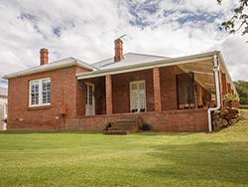

Henri House B & B  e: henrihouse@telkomsa.net  p: +27 46 622 8845 | c: +27 72 431 5625  www.henrihouse.co.za  Contact Person: Andrew  Henri House B & B offers luxury holiday accommodation in the heart of Grahamstown. Henri House is situated in a quiet residential area. It is believed that 16 on Henri was originally built for a Rector of Christ Church, which is situated just around the corner. The main house was built in 1856. Henri House offers 5 rooms all en-suite plus 2 rooms sharing a private bathroom. | 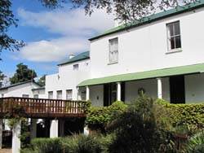

The Highlander  e: highlander@sacschool.com  p: +27 46 622 3564  Contact Person: Dale and Ros  The Highlander is situated next to the famous St Andrews College Lower field and in close proximity to DSG, St. Andrews' Prep, Rhodes University and the city centre. The Highlander is well placed for the visitor to Grahamstown. With a welcoming atmosphere The Highlander offers you a home from home feel where you can relax and enjoy real Eastern Cape hospitality. | 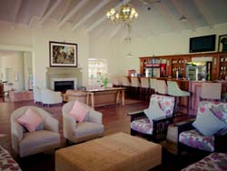

Hilton House  e: hiltonhouse@hiltonfarm.co.za  p: +27 87 802 0807 | c: +27 83 673 2434  Contact Person: Janet  Hilton House is a B&B or self catering house on the farm Hilton, 20km (15 min.) out of Grahamstown on the R350 to Bedford. Consisting of 2 comfortable units, each with a double room, a twin room, a full bathroom, and dining room/lounge area with fire place for those cold winter nights. A well equipped kitchen & private braai area overlook the oxbow lake & surrounding hills. Enjoy the beautiful sunsets & wild sounds over high tea or sundowners, before lighting a braai fire or weber. A farmstay is a great week-end getaway for locals, or something different for visiting parents, Orientation, Graduation, Festival or whatever your reason to visit Grahamstown. | 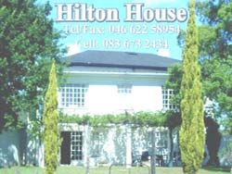

Historic Cottages  e: historic@imaginet.co.za  p: +27 46 622 8936 | c: +27 83 630 8696  w: www.historiccottages.co.za  Contact Person: Roswitha  Historic Cottages, quaint and comfortable in the heart of town. Within walking distance to Rhodes, shops, restaurants and CBD. Offering old world charm, such as down duvets, homemade biscuits and modern conveniences. En suite bathrooms, private entrances, secure parking, lounges with books and TV. A generous breakfast is served under an old avocado tree in the shady courtyard or in the adjoining breakfast room. | 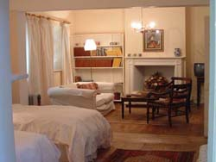

Isiqalo B & B  e: nomfiepura@telkomsa.net  p: +27 46 622 8100 | c: +27 84 4436236/+27 81 4882744  Contact Person: Nomfundo  At Isiqalo b&b we are striving to give our guests an excellent service and warm hospitality as we are their home away from home. | 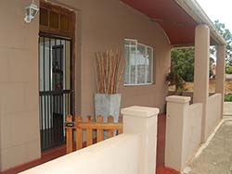

"Kaiser's"  e: rkaiser@albanynet.co.za  p: +27 46 622 2781 | c: +27 82 655 6696  w: www.grahamstown.co.za/kaiser  Contact Person: Rodger and Colette  We offer B&B (continental) & self-catering accommodation in 7 self-contained suites. Each suite has a full bathroom, a well equipped kitchenette and TV with DSTV. We have electric blankets, wall heaters and fans. Within walking distance to town and a five minute drive to Rhodes University and Grahamstown's excellent schools. We have braai facilities and you can enjoy a swim in the pool. We are happy to welcome children - a number of our suites have a sleeper couch. Our pets will welcome yours! Your vehicle will be parked off the street behind electronic gates. Our rates are affordable and we offer special discounts for groups or long stays. | 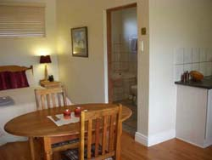

Kingston Farm  e: kingstonfarm@mac.com  p: +27 46 625 0129 | c: +27 83 2624813  w: www.kingstonfarm.co.za  Contact Person: Fred and Carla  Kingston Farm is situated just outside of the village of Bathurst and offers guests the opportunity to relax in rural and comfortable surroundings. There is a wealth of historical sites in the vicinity and is within easy reach of both Port Alfred and Grahamstown. The farm, originally established in 1828, now functions as an appaloosa horse stud and the farmhouse hosts a restaurant and tea garden serving cuisine in keeping with the style and age of the buildings. The atmospheric restaurant offers a stylish and romantic experience that combines many of the nation's and world's best traditions using outstanding local produce. There are dams to view the abundant birdlife, golf courses nearby and several game reserves offering day-trips. Three self-catering apartments, with fully equipped kitchens, en-suite baths and showers. One of the apartments sleeps four guests, while the other units sleep two adults each. | 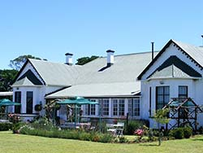

Lanherne House  e: info@lanherne.co.za  p: +27 46 622 2466 | c: +27 74 765 9752  w: www.lanherne.co.za  Contact Person: Adriana  Lanherne House is a classic early 1900s Grahamstown home located at 7 Harrismith Street in the Westhill suburb which provides easy access to all Private Schools and Rhodes University. Lanherne Guest House consists of a 7 Room Bed and Breakfast with four star standards. It has 1 full self-catering Loft to accommodate 4 persons with balcony and seperate entrance. 2 semi-self catering rooms with separate entrances. In the main house it has 3 private en-suite rooms and 1 Honeymoon/Executive full en-suite with Victorian Bath. | 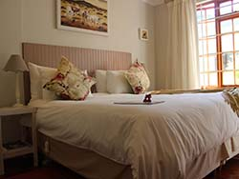

Leicester  e: ashleabrunette@telkomsa.net  p: +27 46 622 8902 | c: +27 82 826 3409 | f: +27 86 636 8020  Contact Person: Ashlea  Situated in a quiet, leafy, upmarket suburb of Grahamstown,2km from the university and less than 1km from DSG and St Andrews, Leicester B&B offers comfortable amenities in a safe, private environment. | 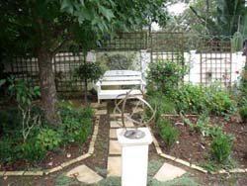

Makana Resort & Conference Centre  e: Reservations@makanaresort.co.za  w: www.makanaresort.co.za  Contact Person: Lolly and Cwenga  Makana Resort & Conference Centre offers 20 Self Catering / B&B units that are fully equipped with furnishings / crockery / cutlery / bedding / towels / DSTV etc. 16 Units sleep a maximum of 4 people and 4 units sleep a maximum of 6 people. The resort also have two swimming pools, a undercover lapa braai area, a jungle gym (for the little ones) & conference fascilities that cater for all needs and specifications. Walking distance from all ammenities and yet you'll feel like you're way out in the country. | 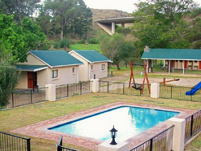

Mariya uMama weThemba Monastery  e: guesthouse@umaria.co.za  p: +27 46 622 8111  w: www.umaria.co.za  Contact Person: Guest Master  Benedictine monasteries are never without guests, and the guesthouse at Mariya uMama weThemba Monasterycontinues a Benedictine tradition centuries old of offering hospitality to both individuals and groups. We can sleep 24 people in 17 rooms contained in three different guesthouse buildings. We invite individuals and groups of all faiths to come for retreat or bed and breakfast. | 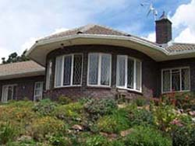

Mimosa B & B  e: sashamartin@imaginet.co.za  p: +27 46 622 4888 | c: +27 83 357 8232  w: www.stayatmimosa.co.za  Contact Person: Sasha  Enjoy the charm and elegance of a bygone era in one of Grahamstown's beautiful old Victorian homes, commissioned by A.N. White in the heyday of Grahamstown's trading era. Mimosa Bed & Breakfast or Self Catering is a maximum of a 3 minute drive to schools, town and the university, and provides secure off-street parking. Mimosa B & B sleeps 4 people in a self contained private unit, with own entrance, fully equipped kitchen and private veranda with access to a beautiful garden and swimming pool. | 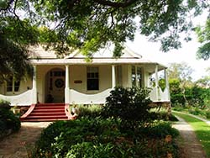

Mooimeisies Guest House  e: cary@imaginet.co.za  p: +27 46 622 2797 | c: 074 618 8747  w: www.riebeeckeast.co.za  Contact Person: Cary and Neil  Escape to the rural hamlet of Riebeeck East just 39kms from Grahamstown. Peace, tranquility, nature ,cycle and hiking trails makes this a special place to unwind and revive your soul. Rooms are beautifully appointed and heated. Home made meals available on request. Workshops offered are Photographic, Mosaic, Art and Sculpture and Music and dinner evenings are also on the itinerary of things to do in Riebeeck East. Please enquire about our rates which are for two people sharing and this includes a continental breakfast. Courses and music evening details are available on request. | 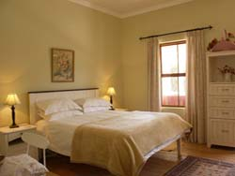

'Park Off'  e: ann@imaginet.co.za  p: +27 46 622 5263 | c: +27 83 632 6350  w: www.grahamstown-accommodation.co.za/parkoff  Contact Person: Ann  'Park Off' is a free standing large spacious suite situated in a lush garden. Close to both Kingswood College (1 min) and Graeme College (1 min) and a 5 minute drive to the centre of town or Rhodes University. The light, open-plan room includes a compact kitchenette and an attractive lounge with DSTV as well as a separate bedroom area with a double bed. Sliding doors lead out onto an attractive spacious private sundeck over looking the pool. A single bed can be incorporated if twin beds are required or a bed is needed for a child or third person. Parking is off-street and is secure and alarmed. Although primarily a self catering unit, help-yourself continental breakfasts can be made available. | 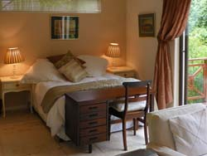

Table Farm B & B  e: watty1@telkomsa.net  p: +27 46 622 3512 | c: +27 082 770 8572  w: www.tablefarm.co.za  Contact Person: Robert  Table Farm B & B is located 14km (10 mins) on the Bedford Road (R350). Enjoy a relaxing time in idyllic surroundings on a Settler Farm which has been in the family since 1828. Two spacious double bedrooms en-suite with separate entrances and kitchen facilities for self-catering if required. Special farm breakfast and dinner is available on request. Enjoy excellent bird-watching, walks on the working livestock farm with numerous game species, a game of tennis or a braai under the oak trees overlooking the lake. Regret no credit cards. | 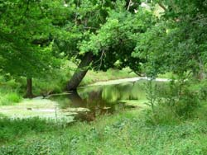

Tipuana B & B  e: tipuanabb@telkomsa.net  p: +27 46 622 3105 | c: +27 83 312 3716  w: www.grahamstown.co.za/tipuana  Contact Person: Dorothy  Tipuana B & B offers 2 accommodation options. Flat 1: Two-Bedroomed flat with TV in each room, four single beds, kitchen, braai & swimming pool facilities, secure parking with security lights, private entrance and continental breakfast supplied. Flat 2: Small two-bedroomed flat with TV in each room, double bed & coloured TV, two single beds, kitchenett, access to braai & swimming pool when available, secure parking with security lights, private entrance and continental breakfast supplied. | 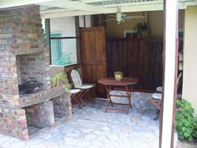

- backpackers

- bed & breakfast

- camping

- ekasi homestays

- game lodges

- guest farms

- guest houses

- hotels

- self catering

- add establishment

Self Catering
7 Oatlands Guest Cottage  e: emscoops@telkomsa.net  c: +27 79 515 1120  Contact Person: Emma and Rob  7 Oatlands is a beautifully decorated newly renovated garden guest cottage. We are ideally situated at the corner of Speke Street and Oatlands Road for Grahamstown's three private schools, Rhodes University and are close to town for business and festival visitors. The cottage officially sleeps two but there is a single bed available for a third person or a child which doubles as a daybed when not in use. All beds have white cotton linen and there are fresh white towels in the brand new shower room. There is a comfortable sitting area with a flat screen TV, a fully equiped eat-in kitchen, plenty of cupboard space, a pretty private courtyard with outdoor furniture for guest use , excellent security and off-street parking. Coffee, tea, fresh milk and rusks are provided. | 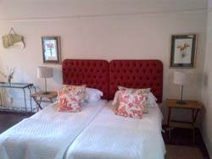

11 Worcester-on-Durban  e: sally@11worcesterondurban.co.za  p: +27 46 636 1165 | c: +27 79 4928254  w: www.11worcesterondurban.co.za  Contact Person: Sally  11 Worcester-on-Durban is situated directly opposite Diocesan School for Girls (DSG), on Worcester St. It is 400m from St. Andrew's College and a kilometer from the Rhodes University campus and the Peppergrove shopping and restaurant mall. Accommodation consists of a stylish and comfortable cottage with a queen bedroom, which overlooks the garden and swimming pool. The kitchen is fully equipped. There is a braai facility on the patio. There are 2 additional, well appointed rooms. The Blue room is a twin room with en-suite shower and the Stable consists of 2 interleading twin rooms with a shared bathroom. | 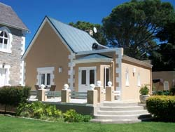

18 Henry Street
e: info@henry18.co.za
c: +27 72 882 9692
w: www.henry18.co.za
Contact Person: Stuart and Anne
Offers friendly and affordable accommodation for up to 10 people. A double-storey period house with large rooms and high ceilings, guests have the use of the entire top floor. Accommodation consists of 3 bedrooms, a lounge and bathroom. A second bathroom is provided downstairs. The garden apartment has 2 rooms, both en-suite, and full self catering facilities. Situated in a quiet area, 1km from the centre of town, guests are assured of peace and convenience. Equipped for self-catering, breakfast can be provided on request.

47 Strelitzia Street
e: w.wrench@ru.ac.za
p: +27 46 622 3351 | c: +27 82 365 4444
Contact Person: Wendy
This secure, self-catering unit welcomes visitors to Grahamstown and is situated in a tranquil, residential area. The spacious, modern unit offers a comfortable home-away-from-home experience. An open-plan area consists of a double bed and a lounge with two sleeper couches (sleeps 4). The en-suite bathroom has a glass shower and attractive built-in hand basin and vanity area. A fully equipped kitchenette is available for those opting for self-catering.

Acacia Guest Cottages  e: acaciamo@mweb.co.za  c: +27 82 522 7884  w: acaciaguestcottage.wix.com/grahamstown  Contact Person: Acacia  Two luxurious, comfortable & affordable self-catering units in a quiet location in the heart of Grahamstown. Within easy walking distance of city centre, Rhodes University, leading schools, Pepper Grove Mall, coffee shops, restaurants & festival venues. Units offer double bedroom, en-suite bathroom, fully equipped kitchen (fridge, microwave, induction plate, kettle, toaster), complimentary tea/coffee, heater, DSTV, free Wifi, office desk, private patio & garden, secure off-street parking, security system & independent access. Reduced rates for long stays. Regret no credit card facility, no smoking indoors and no pets | 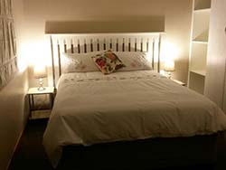

Aloe Cottage  e: sonja@alugutters.co.za  p: +27 46 622 9516 | c: +27 72 965 3196  Contact Person: Sonja  Situated 500m from Kingswood College, Aloe Cottage is a cosy secure cottage set in a tranquil, residential area. This affordable cottage offers full DSTV & Wi-fi with comfortable home-away-from-home living. It is open-plan and consists of a double and single bed with fresh percale linen. The en-suite bathroom has a shower and built-in hand basin area. A fully equipped kitchenette is available for those opting for self-catering. Secure off street parking is situated on premises behind electric gates. | 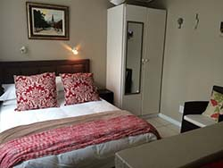

Amazing Grace  e: jaxhickey@gmail.com  c: +27 82 900 0066  Contact Person: Jacqueline  A newly renovated & stylish home in Oatlands with 4 bedrooms and 3 bathrooms (2 MES), oozing old charm, sleeping 8 guests comfortably. Secure & conveniently situated within walking distance to Rhodes, University, St Andrews, DSG, Prep, Highlander, Peppergrove /restaurants Mall and the late night Spar with ample on -site parking and automated gate . Amazing Grace offers a spacious and sunny ,open plan kitchen with dishwasher and washing machine ,gas hob and electric oven, a cosy fire place in front of the 10 seater dining room table .The separate lounge with its comfy couches is just what you need to watch TV, or your favourite DVD or just curl up under a throw and read your latest book...A games room will entertain the children with Air hockey .Tea, Bodum coffee, most condiments & cleaning products are supplied. A home away from home...come and relax a little... | 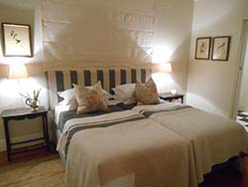

Amberleigh  e: paulhobson@telkomsa.net  p: +27 46 622 4724 | c: +27 82 773 3983  w: www.grahamstown.co.za/amberleigh  Contact Person: Rose  Comfortable, spacious accommodation in quiet neighbourhood within easy reach of schools, town and Rhodes University. 2 Units with king beds en-suite (one can be made into twins and has self-catering nook) and 1 fully equipped self-catering flat. Each unit has off-street parking behind remote controlled gate / an alarm / wifi / and a lock-up garage is available on request | 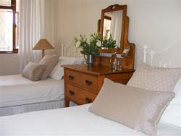

Amblewood B & B
e: amblewood@imaginet.co.za
c: +27 83 283 0682
w: www.amblewoodbnb.co.za
Contact Person: Yvette
Conveniently situated between Kingswood College and Graeme College. We offer comfortable, spacious accommodation, a home away from home. A braai facility and sparkling swimming pool within a large private garden, for those hot summer months. Consisting of a family/conference unit sleeping up to 6 people. Choose from either king size or single beds and enjoy the fresh percale linen. We offer a self service continental breakfast or self catering. Pets welcome by prior arrangement.

Antique Silk
e: marion@antiquesilk.co.za
p: +27 46 622 3816 (a/h) | c: +27 83 731 9732
w: www.antiquesilk.co.za
Contact Person: Marion
A stylish two bedroom flat (interleading room) with twin beds in both rooms. An en-suite bathroom with shower in main bedroom, and a fully equipped kitchenette. We also have a delightful log cabin which sleeps 2 and is also self-catering. Situated on the sunny side of town, with a lovely garden filled with Antique Silk and other white roses. A few minutes drive to town, university and schools. Secure off street parking and separate entrance. We offer continental breakfasts or self catering. Facilities include TV with M-Net, hairdryer, fans, heaters, radio, braai and tea/coffee. Affordable rates. A warm Eastern Cape welcome awaits you!

Apple Bee Guest Cottage
e: jeannine@formstar.net
p: + 27 46 622 2651 | c: +27 83 680 3111 | f: +27 86 551 4310
Contact Person: Jeannine
Clean, fresh country decor gives AppleBee its unique warmth and charm. There is only one cottage on the property with its own private garden area. The accommodation offers a queen-size bedroom with plenty of cupboard space and bathroom with shower and bath. Quality linen, towels and hospitality items are supplied. The living room has a well-equipped kitchenette with full sized fridge/freezer, microwave, gas/electric stove, kettle and toaster. There is a dining area and comfortable lounge seating with a ¾ sleeper couch. Teas, coffee, hot chocolate, cereals, milk, fruit and rusks are provided. Continental breakfast is available on request. Full bouquet DSTV is available. The cottage is serviced daily. Secure off-street parking with remote access is provided. Complimentary internet Wi-Fi access. Safe. Laundry service. Fans & heaters. Electric blanket. AppleBee is conveniently situated 100m from St Andrew's Prep, 700m from St Andrew's College and DSG and 1.2km from Rhodes University.

Assegaai Trails
e: assegaaitrails@imaginet.co.za
p: +27 46 622 8619 | c: +27 82 445 1042 | f: +27 46 622 8619
w: www.assegaaitrails.co.za
Contact Person: Ray and Sheila
Assegaai Trails boasts accommodation to suit every requirement, from rustic overnight stops to upmarket self-catering units, and includes an ideal venue for weddings and conferences, team building and leadership courses. Assegaai Trails offers 2-day or 3-day hikes, several day walks of varying distances, as well as mountain bike trails.

Autumn Leaves
e: autumnleaves@insightnet.co.za
p: +27 46 622 9328 | c: +27 83 377 2101
Contact Person: Michelle
Autumn Leaves offers quality double and single B&B or self-catering accommodation in the lovely suburb of Westhill and is within walking distance of Rhodes, St Andrews, Prep, DSG and Aquaculture Innovations. Unit 1 has twin beds (or king size on request) with en-suite bathroom and a fully equipped kitchen, lounge and dining area combined. Unit 2 has twin beds (or king size on request) with en-suite bathroom, kitchenette and desk area. Enjoy the beautiful view of Rhodes University and the surrounding hills from the verandah of the Units 1 and 2. Unit 3 is a small, but comfortable bedroom (three-quarter bed) with en-suite bathroom for the single guest and for shorter stays. Unit 3 has an air-conditioner for your comfort. All units are linked to a back-up water supply in the event of a municipal outage. DSTV Hospitality Bouquet available in all units. Wireless internet available in all units.

Bartholomew's Loft
e: justine@bartholomewsloft.co.za
c: +27 82 448 2971
w: www.bartholomewsloft.co.za
Contact Person: Justine
Bartholomew's Loft is affordable, centrally situated, self catering accommodation, ideally suited to families or friends travelling together in the Eastern Cape. We offer a self serve continental breakfast if required. This lovely old building with its double volume living space has been converted into very comfortable self catering accommodation for a group of up to six people. Bartholomew's Loft offers 3 bedrooms; one king size upstairs and two smaller twin rooms downstairs, a spacious open plan lounge/dining room/kitchen area. There is only has ONE bathroom which is not en-suite to any of the bedrooms. The loo is separate.

Belvedere B & B
e: grahamstownphy@imaginet.co.za
p: +27 46 622 4486 (h)/+27 46 622 7116 (w) | c: +27 83 279 7969
w: www.grahamstown-accommodation.co.za/belvederepage.html
Contact Person: Annalise
Belvedere B&B offers luxurious accommodation and is set in a lovely private garden. Guests have their own entrance through remote controlled gates to safe parking. The centre of town is only a 4min drive away, and also approximately 4 mins drive to the private schools, St Andrew's, DSG and Kingswood College. Graeme College is within easy walking distance and we are a 6min drive to PJ Olivier.

Belton Accommodation  e: belton@intekom.co.za  p: +27 46 622 8395 | c: 082 808 6139  w: www.belton.co.za  Contact Person: Peter and Ali  Belton Accommodation is situated on a working pineapple farm, centrally located 40kms out of Grahamstown and 10mins from Kenton on Sea. The Milking Parlour Cottage sleeps 6 and is more comfortable having 3 bedrooms and 2 bathrooms. We offer hiking trails,great birding, and wonderful peace and quiet! | 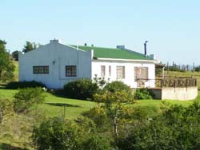

Brackkloof Farm & Guest House  e: Brackkloof@imaginet.co.za  c: 072 822 5687 / 083 429 9116  w: www.brackkloof.co.za  Contact Person: Aletta  Whether you are looking for a quite stay on a farm or an interactive stay on a working farm, Brackkloof Farm can offer this to you. We are pet friendly and family focused. Brackkloof Farm is situated 18km from the city of Grahamstown and is easily accessible. Our rustic but comfortable self - catering guest house consists of a 3 bedroom cottage and 2 hunters rooms that are serviced daily. Take a walk in the veld and discover all the small creatures living on the hills including kudu, steenbok, duiker, warthog, impala and many more, or take part in the many activities we have to offer. Come and relax with the beautiful sounds of the native Eastern Cape bird life. | 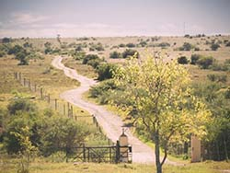

B's B & B
e: baartjeanine@gmail.com
p: +27 46 622 6063 | c: +27 82 785 9363
Contact Person: Jeanine
B's B & B offers asunny, spacious garden flat in a pretty secluded flower-scented garden. Situated in a quiet area near Kingswood College, it has a private entrance and off-street parking. The flat has vibrant colourful decor, with some lovely original artwork and personal touches. There are twin beds with good, comfortable mattresses and these can be put together to form a kingsize bed. A third bed or mattresses for 2 small children can be added if necessary. The flat is fully carpeted, has 2 comfortable chairs, a quality TV with MNET, video machine with DVD player, music system, heater, fan, electric blankets and hairdryer.

Conservation Academy on Craig Doone
e: info@conservationacademy.co.za
p: +27 46 622 3505 (unreliable) | c: +27 73 566 2809
w: www.conservationacademy.co.za
Contact Person: Trelss McGregor
Basic self-catering farm accommodation 10 km from Grahamstown 800m off N2 to Port Elizabeth. Cost R180 pp sharing unit. 4 units. 2 x self-catering units sleep 2-7. Bedrooms sleeps 2-5, living/eating room (2 extra beds), small equipped kitchen (fridge with freezer, stove/hotplate, microwave etc.), bathroom (toilet, shower) and outside braai. 2 x separate units rooms sleep 2-6 with own bathrooms (toilet, shower), self-catering facilities (fridge, kettle, microwave, 2 plate hotplate etc.) in room. Bedding and linen provided, no towels, NO TV, no shop, no consumables, no frills. Accommodation within electric fenced area, uncovered parking. Suitable for families, school and student groups, contractors...

Cottage-in-the-Garden
e: mary@cottageinthegarden.co.za
p: +27 46 636 2793 | c: +27 83 651 0067
Contact Person: Mary
The cottage has a large bedroom with double bed, couch, TV (full DSTV) and heater and fan available. Top quality cotton bedding is used for the comfort of our guests. An electric blanket will keep you warm on those cold winter nights! The en-suite bathroom has a shower, but no bath. A well equipped, separate kitchen has a table and chairs that can double up as a desk for guests who need space to work. Complimentary WIFI is available. The cooking facilities are microwave and two-plate stove with mini oven. The cottage is let on a self catering basis, with basic breakfast supplies provided. A more substantial self-serve breakfast can be delivered.

Courtlands
e: courtlands@imaginet.co.za
p: +27 46 622 3247 | c: +27 83 376 2250
w: www.courtlands.co.za
Contact Person: Jo
Situated in historic New Street, Grahamstown and a few meters from an entrance to Rhodes University Campus and Peppergrove Shopping Center, Courtland's has 2 self-contained, neat and comfortable garden cottages. Convenient for conferences, studies, business or relaxation, we provide secure under cover parking, your own entrance, and offer B&B or self catering accommodation in the heart of Grahamstown. Children very welcome.

Crown River Safari and Wildlife Reserve  e: info@crownriversafari.co.za  c: +27 82 672 9814  w: www.crownriversafari.com  Contact Person: Anneke  Crown River Safari is situated on a private game reserve 22 km outside of Grahamstown. The lodge is perched 20 meters above the high water mark on the Settlers dam with breathtaking views up river. Animal and bird sightings along the river banks are a guaranteed occurrence from the spacious viewing porch. The lodge can be booked in its entirety or per person depending on the need. The lodge sleeps 7, and is made up of three bedrooms, a large double volume lounge, dining room and bar is available with a separate kitchen. Male and female restrooms are available to aid further entertainment and further accommodation can be arranged if required. Sun downer cruisers and game drives can be arranged on request. | 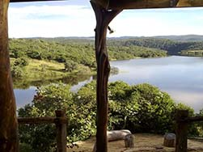

Deja View Guesthouse  e: info@festivalaccommodation.co.za  p: +27 46 636 2455 | f: +27 46 636 2473 | c: +27 82 573 3679  w: www.festivalaccommodation.co.za  Contact Person: SJ Dold Festival Accommodation  Deja View Guesthouse is situated at 25 Kings Gardens, Kings Crecent, Grahamstown. We offer a stylish two bedroom duplex apartment, two bathrooms and a sleeper couch for extra guests and can accommodate up to 6 guests. The apartment is fully fitted and has dstv. This apartment is in a secure complex with a communal pool for guests to enjoy. | 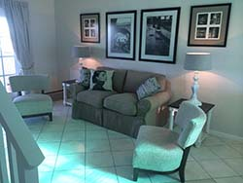

Durham Cottage B & B
e: durhamcottage@albanynet.co.za
p: +27 46 622 4453 | c: +27 82 730 7330
Contact Person: Maureen
Durham Cottage is situated in the beautiful garden of our renovated 1820 Settler Cottage. Close to Kingswood College and walking distance from the centre of Grahamstown. Guests have their own remote controlled garage and private entrance. The accommodation comprises; an en-suite double bedroom, double bed, top quality linen is used for the comfort of our guests. TV (full DSTV), wall heater, fan and hairdryer are available. The en-suite bathroom has a shower, but no bath. Top quality towels plus a selection of toiletries are provided. The modern kitchenette is full equipped for basic self-catering. Teas, coffee, plus filter coffee, a choice of cereals and biscuits are available. Fresh milk and fruit is provided on arrival. The accommodation is serviced daily and laundry can be done for a nominal fee. Additional large double bedroom with modern private bathroom in main house, if required. Pets are welcome. Dutch spoken.

Eagles Nest B & B
e: eaglesnestgtown@gmail.com
p: +27 46 622 7189 | c: +27 82 657 0359
w: http://www.eaglesnestbnb.co.za
Contact Person: Sheryl-Anne
Eagle's Nest B&B is on the sunny side of Grahamstown. Ideally situated near schools, city centre and in walking distance to shops, museums, Rhodes University and restaurants. Three reasonably priced self-contained garden flats each with their own private entrance. One of the flats sleeps 4 and the other 2 flats sleep 2 people in each. The braai facility near the sparkling pool on your doorstep often comes in handy on this sunny side of town. Children welcome. Pets welcome by arrangement. Choice of self-catering or B&B accommodation. Secure parking where guests bring their car into our yard with remote control/electric fence. Facilities include TV, hairdryers, fans, heaters, radio, complimentary WIFI / internet and tea/coffee facility, small kitchenette with stove/microwave/fridge.

Elgon B & B
e: info@elgon.co.za
p: +27 46 622 7702 | c: +27 82 655 6733
www.elgon.co.za
Contact Person: Morny
Elgon B&B is a two-roomed separate unit, with queen-sized bed, en suite shower and self-catering facilities, offering the discerning traveller a comfortable home away from home while doing business or exploring frontier country in the Eastern Cape. Elgon is situated in a tranquil, residential area, and is conveniently positioned a couple of minutes drive from the city center allowing easy access to Rhodes, schools, the cathedral and museums. Your stay at Elgon includes a refreshing continental breakfast, if required, as well as daily servicing of the unit. Other features include: Private entrance, secure parking, wireless hotspot.

English Lavender B&B  e: englishlavender@telkomsa.net  c: +27 84 771 0105  Contact Person: Denise  This quaint and comfortable accommodation can be found on the sunny side of Grahamstown in Lawrence Street. English Lavender is close to town which makes it a well-suited choice for those wanting to explore Grahamstown. It is also close to Rhodes University and a popular choice among postgraduate seeking short-term accommodation, such as those working towards completing their MBAs. The units are inviting, affordable and offer a familial warmth - creating a feeling of being at home, away from home. Each self-catering unit has its own private entrance with a kitchenette and en-suite bathroom. | 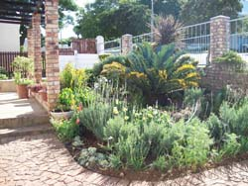

Henri House B & B
e: henrihouse@telkomsa.net
p: +27 46 622 8845 | c: +27 72 431 5625
www.henrihouse.co.za
Contact Person: Andrew
Henri House B & B offers luxury holiday accommodation in the heart of Grahamstown. Henri House is situated in a quiet residential area. It is believed that 16 on Henri was originally built for a Rector of Christ Church, which is situated just around the corner. The main house was built in 1856. Henri House offers 5 rooms all en-suite plus 2 rooms sharing a private bathroom. Plunge pool is available for residents. Secure off road parking is provided.

Hilton House
e: hiltonhouse@hiltonfarm.co.za
p: +27 87 802 0807 | c: +27 83 673 2434
Contact Person: Janet
Hilton House is a B&B or self catering house on the farm Hilton, 20km (15 min.) out of Grahamstown on the R350 to Bedford. Consisting of 2 comfortable units, each with a double room, a twin room, a full bathroom, and dining room/lounge area with fire place for those cold winter nights. A well equipped kitchen & private braai area overlook the oxbow lake & surrounding hills. Enjoy the beautiful sunsets & wild sounds over high tea or sundowners, before lighting a braai fire or weber. A farmstay is a great week-end getaway for locals, or something different for visiting parents, Orientation, Graduation, Festival or whatever your reason to visit Grahamstown.

Holly Lane  e: jandm@imaginet.co.za  p: +27 46 622 7572 | c: +27 82 643 7050 / +27 72 118 1146  Contact Person: Jeanie and Mike  The cosy cottage is tucked away from noise and traffic. It is situated 50 metres from Rhodes University, the Albany Museum and from Victoria Girls High School. The holly-bordered lane is a comfortable 500 metres from major shops, restaurants, St Andrews College, the Diocesan School for Girls, and the Law Courts. Privacy and secure off-road parking are offered. A spacious living area, with fan and heater, complements the fully equipped kitchenette and bedroom en-suite. Access to full DSTV. | 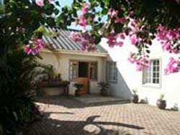

Isiqalo B & B
e: nomfiepura@telkomsa.net
p: +27 46 622 8100 | c: +27 84 4436236/+27 81 4882744
Contact Person: Nomfundo
At Isiqalo b&b we are striving to give our guests an excellent service and warm hospitality as we are their home away from home.

"Kaiser's"
e: rkaiser@albanynet.co.za
p: +27 46 622 2781 | c: +27 82 655 6696
w: www.grahamstown.co.za/kaiser
Contact Person: Rodger and Colette
We offer B&B (continental) & self-catering accommodation in 7 self-contained suites. Each suite has a full bathroom, a well equipped kitchenette and TV with DSTV. We have electric blankets, wall heaters and fans. Within walking distance to town and a five minute drive to Rhodes University and Grahamstown's excellent schools. We have braai facilities and you can enjoy a swim in the pool. We are happy to welcome children - a number of our suites have a sleeper couch. Our pets will welcome yours! Your vehicle will be parked off the street behind electronic gates. Our rates are affordable and we offer special discounts for groups or long stays.

Kingston Farm
e: kingstonfarm@mac.com
p: +27 46 625 0129 | c: +27 83 2624813
w: www.kingstonfarm.co.za
Contact Person: Fred and Carla
Kingston Farm is situated just outside of the village of Bathurst and offers guests the opportunity to relax in rural and comfortable surroundings. There is a wealth of historical sites in the vicinity and is within easy reach of both Port Alfred and Grahamstown. The farm, originally established in 1828, now functions as an appaloosa horse stud and the farmhouse hosts a restaurant and tea garden serving cuisine in keeping with the style and age of the buildings. The atmospheric restaurant offers a stylish and romantic experience that combines many of the nation's and world's best traditions using outstanding local produce. There are dams to view the abundant birdlife, golf courses nearby and several game reserves offering day-trips. Three self-catering apartments, with fully equipped kitchens, en-suite baths and showers. One of the apartments sleeps four guests, while the other units sleep two adults each.

Langholm Farm B & B  e: info@langholm.co.za  p: +27 46 622 8338 | c: +27 83 325 4835  Contact Person: Kathy  Self-catering cottage in the restored managers offices built in the 1930's. Featuring a facade of red clay bricks, and unique reed ceilings made on the farm. The 2 bedrooms are comfortable with percale linen, fluffy towels, heaters, and electric blankets; 1 double bed and twin single beds, sharing a shower bathroom. A comfortable lounge with a TV, and a kitchenette neatly fitted in, opens onto the garden with big trees, interesting bird life, African sunsets with Guinea Fowls calling and quiet starlit nights. B&B on request. All this on a busy pineapple farm, where midweek visitors are bound to see freshly harvested pineapples being loaded onto the trucks for transport to the processing factory in East London. Only 30kms from Grahamstown on R67 to Port Alfred(30mins). Centrally situated for anyone visiting Grahamstown, Bathurst or Port Alfred. | 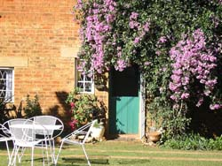

Lanherne House
e: info@lanherne.co.za
p: +27 46 622 2466 | c: +27 74 765 9752
w: www.lanherne.co.za
Contact Person: Adriana
Lanherne House is a classic early 1900s Grahamstown home located at 7 Harrismith Street in the Westhill suburb which provides easy access to all Private Schools and Rhodes University. Lanherne Guest House consists of a 7 Room Bed and Breakfast with four star standards. It has 1 full self-catering Loft to accommodate 4 persons with balcony and seperate entrance. 2 semi-self catering rooms with separate entrances. In the main house it has 3 private en-suite rooms and 1 Honeymoon/Executive full en-suite with Victorian Bath.

Leicester
e: ashleabrunette@telkomsa.net
p: +27 46 622 8902 | c: +27 82 826 3409 | f: +27 86 636 8020
Contact Person: Ashlea
Situated in a quiet, leafy, upmarket suburb of Grahamstown,2km from the university and less than 1km from DSG and St Andrews, Leicester B&B offers comfortable amenities in a safe, private environment.

Makana Resort & Conference Centre
e: management@makanaresort.co.za
p: +27 46 622 2159 | c: +27 71 167 3042
w: www.makanaresort.co.za
Contact Person: Lolly and Cwenga
Makana Resort & Conference Centre offers 20 Self Catering / B&B units that are fully equipped with furnishings / crockery / cutlery / bedding / towels / DSTV etc. 16 Units sleep a maximum of 4 people and 4 units sleep a maximum of 6 people. The resort also have two swimming pools, a undercover lapa braai area, a jungle gym (for the little ones) & conference fascilities that cater for all needs and specifications. Walking distance from all ammenities and yet you'll feel like you're way out in the country.

Mimosa B & B
e: sashamartin@imaginet.co.za
p: +27 46 622 4888 | c: +27 83 357 8232
w: www.stayatmimosa.co.za
Contact Person: Sasha
Enjoy the charm and elegance of a bygone era in one of Grahamstown's beautiful old Victorian homes, commissioned by A.N. White in the heyday of Grahamstown's trading era. Mimosa Bed & Breakfast or Self Catering is a maximum of a 3 minute drive to schools, town and the university, and provides secure off-street parking. Mimosa B & B sleeps 4 people in a self contained private unit, with own entrance, fully equipped kitchen and private veranda with access to a beautiful garden and swimming pool.

Mountain View Manor  e: info@mountainvmanor.co.za  c: +27 83 495 8731  w: www.mountainvmanor.co.za  Contact Person: Sharon  Mountain View Manor warmly welcomes you to a peaceful and relaxing stay in a beautiful mountainous setting. The property overlooks Grahamstown, as well as the surrounding mountains, and is secure with an electric fence surrounding the property. 2-Self-catering flats fully equipped for self-catering purposes, tea and coffee amenities provided as well as bedding and towels. Full DSTV is supplied to each flat. Mountain View Manor guesthouse has 9 en-suite rooms - see website. Plenty of nature reserves and game farms surrounding Grahamstown, well known for magnificent game viewing as well as exquisite scenery. | 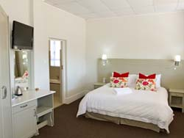

'Park Off'
e: ann@imaginet.co.za
p: +27 46 622 5263 | c: +27 83 632 6350
w: www.grahamstown-accommodation.co.za/parkoff
Contact Person: Ann
'Park Off' is a free standing large spacious suite situated in a lush garden. Close to both Kingswood College (1 min) and Graeme College (1 min) and a 5 minute drive to the centre of town or Rhodes University. The light, open-plan room includes a compact kitchenette and an attractive lounge with DSTV as well as a separate bedroom area with a double bed. Sliding doors lead out onto an attractive spacious private sundeck over looking the pool. A single bed can be incorporated if twin beds are required or a bed is needed for a child or third person. Parking is off-street and is secure and alarmed. Although primarily a self catering unit, help-yourself continental breakfasts can be made available.

Seabush Cottage  e: bookings@seabush.com  c: +27 83 273 7826  w: www.seabush.com  Contact Person: Geoff  Situated in the heart of Sibuya Game Reserve through which the Kariega River estuary flows, Seabush Cottage is a mere 5km away from the pristine beaches of the seaside village of Kenton-on-Sea in the malaria free Eastern Cape Province of South Africa. Grahamstown is only a 35 minute drive away making it an ideal break for those looking for unique escape where the sea and the bush meet. Seabush Cottage is offered on a fully serviced self-catering basis. Accommodation includes three spacious bedrooms (a 4th bedroom can be made-up on request), a well appointed kitchen and an open plan lounge and dining room supplied with DSTV, a fireplace and a music system for your comfort. | 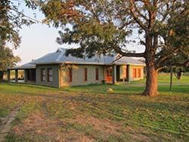

Shaleky's Cottage  e: info@shalekyscottage.co.za  p: +27 46 622 7502 | c: +27 83 495 8731  w: www.shalekyscottage.co.za  Contact Person: Sharon  Shaleky's Cottage is a comfortable 2-bedroomed garden cottage, situated in a quiet neighbourhood, where sweet birdsong provides the morning wake-up call. A short 5 minute drive takes you to the heart of Grahamstown, for easy laidback shopping or movie viewing at Peppergrove Mall. Upon your return to the cottage, you can park your car securely behind a remote controlled gate, right in front of the cottage. A warm Eastern Cape welcome awaits you at Shaleky's Cottage. | 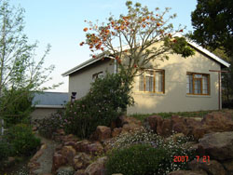

Studio 19 New Holland  e: lea@bosberg.co.za  p: +27 46 684 0522 | c: +27 82 520 6874  Contact Person: Lea  Studio 19 New Holland, Holland street is a stylish , fully furnished apartment that can comfortably accommodate 4 people. It is centrally located to Rhodes ,St Andrews College& DSG as well as the Pepper Grove Mall( All within walking distance ). The Apartment has 2 bathrooms, a luxurious fully equipped kitchen and living area. It is in a secure building on the second floor. Has undercover parking which is also secure. DSTV available on request. There is heating and air-conditioning for the changing seasons. The location although central is quiet and peaceful. | 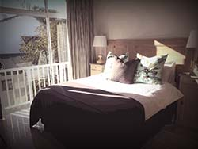

Table Farm B & B
e: watty1@telkomsa.net
p: +27 46 622 3512 | c: +27 82 770 8572
w: www.tablefarm.co.za
Contact Person: Robert
Table Farm B & B is located 14km (10 mins) on the Bedford Road (R350). Enjoy a relaxing time in idyllic surroundings on a Settler Farm which has been in the family since 1828. Two spacious double bedrooms en-suite with separate entrances and kitchen facilities for self-catering if required. Special farm breakfast and dinner is available on request. Enjoy excellent bird-watching, walks on the working livestock farm with numerous game species, a game of tennis or a braai under the oak trees overlooking the lake. Regret no credit cards.

Tipuana B & B
e: tipuanabb@telkomsa.net
p: +27 46 622 3105 | c: +27 83 312 3716
w: www.grahamstown.co.za/tipuana
Contact Person: Dorothy
Tipuana B & B offers 2 accommodation options. Flat 1: Two-Bedroomed flat with TV in each room, four single beds, kitchen, braai & swimming pool facilities, secure parking with security lights, private entrance and continental breakfast supplied. Flat 2: Small two-bedroomed flat with TV in each room, double bed & coloured TV, two single beds, kitchenett, access to braai & swimming pool when available, secure parking with security lights, private entrance and continental breakfast supplied.

Wylies Farm Stay "1 on the N2"  e: gwylie@vodamail.co.za  p: +27 46 637 2941 | c: +27 82 832 5839  Contact Person: Gillian  Wylies Farm Stay "1 on the N2" has a fully equipped, self-catering cottage which sleeps 4-5 people. Hostess trays are available. Baby cot and high chair available. There is also a charming rondavel with a double bed. Extra bed available on request. The bathroom is adjoining. The rondavel is attached to our home, but has it's own separate entrance. In addition there is a 4 bedroom old stone cottage with only one bathroom. Parking is secure. Scenary is picturesque and there are plenty of interesting walks. Gillian is Satour registered guide. | 