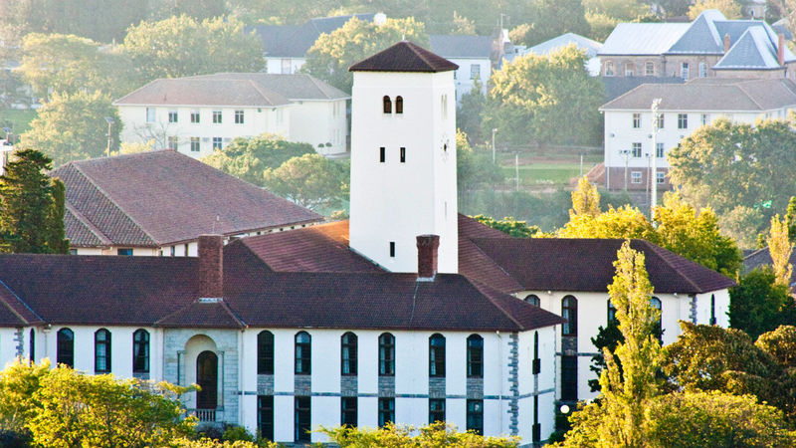

***Graduation Newsletter***

**2020**

**DEPARTMENT OF CHEMISTRY**

RHODES UNIVERSITY *Where leaders learn*





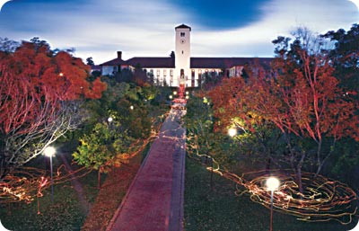

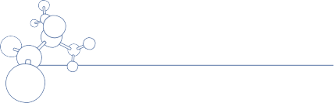

**Message from the HOD**

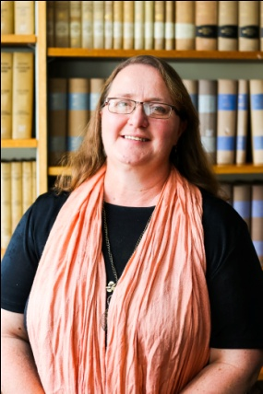

***Welcome to 2020 with the Department of Chemistry,***

***As*** I stand here at the beginning of my tenure as Head of Department, i want to take a moment to look back at the leaders who have gone before me. The first Head of Department I encountered at Rhodes University - back in 1997 - was Professor Perry Kaye: his time as Head was decades long and his legacy in the department is diverse and deep. We are now on the verge of a major institutional audit of our undergraduate programme, and we are still benefiting from the thorough work that Prof Kaye did as part of the previous audit in 2005. In fact, the format of our course outlines and course themes and outcomes are still as they were designed by Prof Kaye and Dr Ron Cosser (Overall course coordinator) at that time.

Prof Kaye also oversaw the purchase and installation of our first Fourier transform NMR.

***After*** Prof Kaye retired, in 2008 Prof Mike Davies-Coleman was appointed to lead "Team Chemistry". His first major departmental project was the total reorganization of the Chemical Stores and a revival of our safety protocols. We still have regular safety tests and the stores has an excellent safety record and very good organization - as well as managing chemical waste for the whole faculty!

***Prof*** Davies-Coleman moved on to be Dean of Science at UWC, and was succeeded by Prof Nelson Torto who oversaw the development of our first Departmental Strategy Document. We have managed to accomplish

many of the research goals he laid out in this document.

***Prof*** Torto moved North to the country of his birth, Professor Rui Krause stepped up to lead. Under his guidance we have revived Industrial visits for third year chemistry students and chemistry magic shows for kids. In fact, our Community engagement activities have diversified and grown under his leadership so that we are now making an ever greater impact outside of the classroom and laboratory.

***As*** Prof Krause takes up some exciting research challenges, I have been asked to take up the enormous privilege of leading this Department. We are diverse, strong-willed and talented individuals, each with something great to offer. When our staff - technical, research, teaching, and administrative staff - pull together, we have the potential to make a significant impact on the world of science in research, teaching, and public service.

***The*** challenges we face are big enough that none of us can afford to work alone. When I am done serving as head of department I hope that my legacy is that more of our staff and students will have reached significant goals, especially through supporting each other. There is nowhere else in South African Higher Education where the strengths of your fellow academics are so necessary or so accessible. We talk together, share our successes, support each other. Together, we can do more.

**Professor Rosalyn Klein**



**STANDING REPUTATION FOR TEACHING AND RESEARCH**

**Introduction**

“In order to succeed you have to do well and perform well. Don’t do less and accept less. Put in the time and complete the task. You want to be a contributing member to every group you are part of.” (Jeanette Epps, Astronaut and Aerospace engineer).

***Year*** after year the Department of Chemistry makes a strong contribution to the University and to the Chemical community in research (and in teaching). It is not enough to be part of a productive group, but each member of our collective makes a contribution to the productivity that we have enjoyed. A quick scan of the publication record reveals multiple collaborations across the department, between academics and students, across disciplines within the faculty, and across regional and national boundaries. In every one of these collaborations the members of our department have made a strong, considered, and valuable contribution. The standards are set high, and we have put in the time to finish what we start.

Research in the Department of Chemistry enjoys the support of a large support staff contingent, including two able storemen, two instrument technicians, a glassblower, and a carpenter. In addition to maintenance of the impressive suite of instruments housed in the Institute for Nanotechnology Innovation and the Department of Chemistry (ranging from Mass Spectrometers all the way to hot plates), our technicians enable us to modify and develop small electronic devices for innovative analytical and synthetic applications. The availability of an expert scientific glassblower has similarly enabled our students to modify procedures and processes and gain access to techniques otherwise beyond reach. Creative collaborations like this are priceless, and make an invaluable, although often unrecognized, contribution to our research achievements.

During the course of 2019 the chemistry department was pleased to welcome upgrades to two instruments: Time of Flight –Secondary Ion Mass Spectrometer and an addition to our local file server for Computational Chemistry. Dr Mashazi (Deputy Director of INI) was awarded an NRF NEP grant for R3.5M to upgrade TOF-SIMS to allow for soft material analysis. The upgrade was for an additional Argon gas cluster gun which was commissioned in January 2020. The upgrade was successful and the backlog of samples are being analysed with this soft ionization gun. The Departmental grant for capital equipment was used to upgrade our bank of servers in the Computational Chemistry Laboratory, enhancing our computational capacity (allowing larger calculations and/or more simultaneous) and facilitating remote management of our NMR suite. These two additions have already added to our research outputs in Nanotechnology and Computational Chemistry and Bioinformatics.

In June Distinguished Prof Tebello Nyokong was awarded Degree Of Doctor Of Science, Honoris Causa from Western University, London, Ontario, Canada (11-15 June 2019). This is an outstanding achievement, and is added to a long list of accolades for the innovative scientist and accomplished mentor and leader. Dr Philani Mashazi, currently Senior Lecturer in the Chemistry Department, and Deputy Director of the Institute for Nanotechnology Innovation, was selected by the Department of Higher Education and Training to be part of the Future Professors Programme which is aimed at young academics with a “strong research trajectory."

**Postgraduates / Graduations**

***We*** were proud to see 16 post graduates graduate in 2019, including eight PhD students, and eight Masters students (five of whom graduated with distinction). Graduation is an important milestone for our students (obviously) but also for their supervisors. We recognize and celebrate their achievements, and the contributions they have made to scientific community as a whole.

Some of our post graduate students have been singled out for particular achievements. Ms Lindokuhle Nene was recognized by the South African Women in Science Awards with a DST-Albertina Sisulu Fellowship (August 2019); and Ms Sixolile Centane (also supervised by Dist. Prof. Nyokong) received First Prize in the Senior Section at the South African Chemical Institute (SACI), Eastern Cape Postgraduate Seminars, held at Nelson Mandela University, Port Elizabeth, on the 25th October 2019.

**Distinguished Visitors / International Visits**

***The*** INI enjoyed visitors from Canada (as part of the NRF South Africa/Canada Research Collaboration) and Mintek over the course of the year. Other distinguished visitors included several post graduates and fellows who have become collaborators.

In a similar vein, various members of the INI pursued collaborations abroad, notably visits by Professor John Mack and his students to the United States International University, Nairobi, Kenya as part of an NRF South Africa/Kenya Research Collaboration. Students also travelled to University of Ottawa and Ecole Nationale Supérieure de Chimie de Paris on exchange.

Distinguished Professor Nyokong visited Paris in March for the L’Oreal UNESCO for Women in Science Week, and in June travelled to Canada where she was awarded an honorary doctorate from Western University.

**Significant Research Aligned Events**

***The*** annual Barker Lecturer was Professor Leonard Barbour. Professor Barbour delighted and inspired us with three lectures on crystallographic investigations into novel materials. By the end of the lecture series both staff and students were considering applications of his methods in our own research.

**Professor Rosalyn Klein**

**Head of Department**

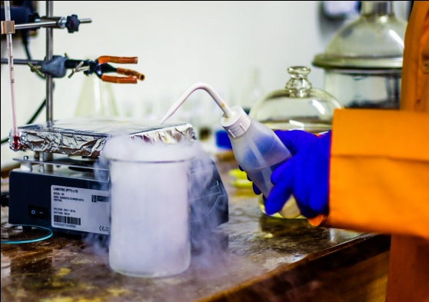

**Congratulations 2020 Postgraduate Graduates**

|  |  |  |  |
| --- | --- | --- | --- |
| **PhD DEGREE** | | | |
| 1 | **Mr Khethobole Sekgota** | **PhD** | **F22** |
| 2 | **Mr Meloddy Manyeruke** | **PhD** | **F22** |
| 3 | **Mr Arthur Sarron** | **PhD** | **S4/S36** |
| 4 | **Mrs Abiola Adesina** | **PhD** | **F3** |
| 5 | **Mr Omotayo Adeniyi** | **PhD** | **F3** |
| 6 | **Mr K Denuga** | **PhD** | **S36** |
| 7 | **Mr Mziyanda Mbaba** | **PhD** | **F22** |
| 8 | **Ms Gugu Kubheka** | **PhD** | **S22** |
| 9 | **Mr Gold Matlou** | **PhD** | **S22** |

|  |  |  |  |
| --- | --- | --- | --- |
| **MSc DEGREE** | | | |
| 1 | **Ms Reitumetse Nkhahle** | **MSc (with distinction)** | **S22** |
| 2 | **Ms Lindokuhle Nene** | **MSc (with distinction)** | **S22** |
| 3 | **Mr Aviwe Magadla** | **MSc (with distinction)** | **S22** |
| 4 | **Mr Kelechi Lebechi** | **MSc (with distinction)** | **S22** |
| 5 | **Mr Thanduxolo Mtshare** | **MSc** | **F22** |
| 6 | **Mr Fostino Bokosi** | **MSc (with distinction)** | **F22** |
| 7 | **Ms Tayna Carlilse** | **MSc** | **S4** |
| 8 | **Mr Washington Dendera** | **MSc** | **S4** |
| 9 | **Ms Kate Cobbing** | **MSc** | **S36** |
| 10 | **Ms Akhona Ngqinambi** | **MSc** | **S36** |
| 11 | **Mr Benjamin Jones** | **MSc (with distinction)** | **S22** |
| 12 | **Mr Banele Motloung** | **MSc** | **S22** |
| 13 | **Ms Nadine Dubazane** | **MSc (with distinction)** | **S22** |
| 14 | **Mr Samuel Shabangu** | **MSc (with distinction)** | **S22** |
| 15 | **Mr Francis Chindeka** | **MSc (with dinstinction)** | **S22** |
| 16 | **Mr Xolani Mayana** | **MSc** | **S36** |
| 17 | **Sino Zama** | **MSc** | **F22** |
| 18 | **Alain Bapolisi** | **MSc(with distinction)** | **F22** |
| 19 | **Judy Webber** | **MSc(with distinction)** | **F22** |
| 20 | **Nnamdi Okafor** | **MSc** | **F22** |



**Welcome to New Staff Dr Theodor Geswindt**

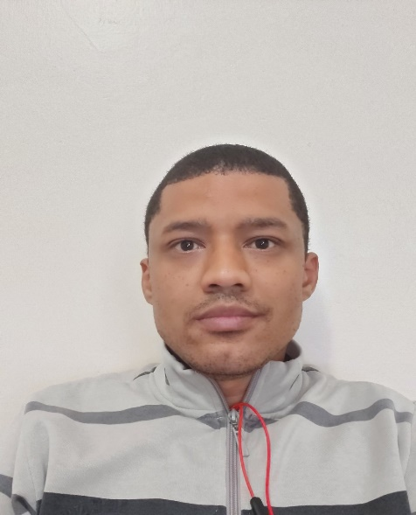

**BSc (Hons) (NMU), MSc (NMU), PhD (US); Post-doctoral fellowship (US)**

***After*** completing my PhD (analytical/inorganic chemistry), I worked at Heraeus chemicals GmBH (Hanau, Germany) as a research scientist involved in the optimization of platinum group metal separation and recovery from various sources such as spent automotive catalysts and electronic waste. Thereafter, I entered academia as a lecturer (2015-2018) at the Cape Peninsula University of Technology, teaching various undergraduate and post-graduate courses in analytical, inorganic and physical chemistry.

***My*** research interests centre on thermodynamic and kinetic modelling of chemical processes in mainly aqueous solutions. In general, my interest in chemical kinetics stems from the fascinating scope of the macroscopic physical properties that chemical systems exhibit in the non-equilibrium state. These range in complexity from ligand exchange under well controlled experimental conditions, oscillating chemical reactions, pattern or structure formation and bifurcation. It is an exciting time in the field of chemical kinetics considering that, in principle, with modern computers and a fair knowledge of programming numerical algorithms, even the most complex system of differential equations can be solved. The role that chemical kinetics fulfils in nature is a testament to the importance of a detailed understanding of kinetics. Thermodynamic and kinetic modelling requires accurate and precise analytical work in order to obtain high quality data. It is therefore part of my research interest to continually develop existing and learn new analytical instrumentation and techniques.

***As*** for hobbies – Everything nerds do! But mostly reading non-fictional books/articles (chemistry, physics, computer/robotics programming etc.), playing/studying chess, and attempting to learn a new language (currently Japanese). Generally, I just try to stay mentally and physically fit.

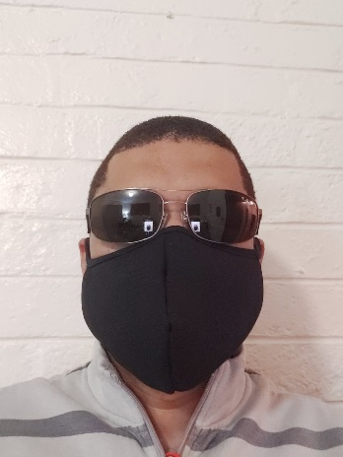 Theodor Geswindt



**Rhodes University leads an international research collaboration to discover and accelerate the development of new antibiotics**

***Rhodes University*** will lead an international research collaboration that seeks to discover and accelerate the development of new antibiotics. The three-year, £1.5 million project, funded by the Newton Fund through the Antibiotic Accelerator Initiative of the United Kingdom (UK) Medical Research Council (MRC) and South African (SA) MRC, aims to discover novel compounds from natural sources that have the potential to be developed into new antimicrobial compounds to combat drug-resistant bacterial pathogens.

The project will bring together scientists from 12 higher education and research institutions in SA and five from the UK. All the universities of the Eastern Cape and the South African Institute for Aquatic Biodiversity are part of this research consortium that seeks to establish an Antibiotic Accelerator Hub to significantly boost capacity for the discovery of new antibiotics. The focus will be on unexplored, biodiversity-rich habitats, including deep sea and polar environments, offering real potential for new ‘natural product’-derived drugs.

Antimicrobial resistance (AMR) is widely regarded as one of the greatest threats to global public health, the impact of which is particularly severe in developing countries. In addition to the growing list of bacterial pathogens known to be resistant to treatment, there is increasing concern over sexually-transmitted infections caused by resistant *Neisseria gonorrhoea*. There is, clearly, an urgent need for the discovery of new antibiotic therapeutics to counter the danger posed. Moreover, alongside medical benefits, this project aims to support future growth in the bio-economies of both countries, ensuring fair and equitable sharing of the benefits of any new drugs arising from the research.

Rhodes University’s SARChI

Professor, Rosemary Dorrington, said she is hoping that the partnership will establish a regional centre for drug discovery within the Eastern Cape Province and profile Rhodes University as a drug discovery hub.

“This initiative will lay the foundation for a multi-disciplinary drug discovery platform in a region known to be a terrestrial and marine biodiversity hotspot. The establishment of a Natural Products Research Network representing twelve South African partner institutions, will provide unprecedented access to the chemical diversity of our extraordinarily rich natural resources,” she said.

Professor in Medical Microbiology at the University of Plymouth, Mat Upton, who is leading the project from the UK, said: “We know there is an urgent global need to accelerate the discovery of new antimicrobial drugs and bring them to market, and this project brings together expertise from the UK and South Africa to create the infrastructure for that to happen. Natural products and their synthetic analogues are the basis for most antibiotics in clinical use today, and the hope is that this collaboration will go some way towards unlocking the potential resources contained in marine and terrestrial biota in South Africa, one of the world’s most biodiverse places.”

Read more about the project, Harnessing natural product diversity to combat multidrug-resistant pathogens, on the UKRI Gateway to Research: <https://gtr.ukri.org/projects?ref=MC_PC_MR%2FT029579%2F1>.

***ISSUED BY THE RU COMMUNICATIONS AND ADVANCEMENT DIVISION***

**2020 Teaching Challenges**

***They***say there is never a dull time in SA, but 2020 has outperformed any other year when it comes to challenges in teaching and learning. Lecturers and teachers who intended to start some online work “sometime in the future” were forced very quickly into multi-modal teaching – and this was achieved by a microscopic unicellular organism, the coronavirus (SARS-CoV-2) which changed the world in a matter of days.

Suddenly lecturers and students were doing everything remotely, and it was different, and difficult. Lecturers were putting slides on RUConnected and then recording lectures, as well as preparing printed notes for students who did not have access or connectivity to the internet. We had to find different resources, and try to keep the students engaged. Many of us also had to contend with assisting their own children with their schoolwork or keeping them occupied, since there was no childcare or playgroups.

On the other hand, students were at home, trying to study under difficult circumstances. Some students did not get their printed packs for many weeks, and thus fell further behind. It must be borne in mind that first year students had only had 5 weeks of being at University, and were then expected to learn without face-to-face lectures, and without their tutors at hand. And there was no way of science students doing practical work. After much negotiation, a new academic calendar was sent out.

Then came assessment, and new terms were coined, “continuous assessment” and “alternative summative assessment”, each with very specific contextual meanings. Again, we listened and we acted, and we put our assessments online and in printed form. And the students responded accordingly. The Chemistry 101 results were exceptionally good.

The second semester has been easier – not easy though. Many students have returned to campus, including all students who were receiving printed packs. And lecturers and students are all familiar with online teaching and learning. Some classes (e.g. Chemistry 3) are back on campus and doing pracs, although teaching is still online. Chemistry 3 will also be writing sit-down exams at the end of the year.

We are extremely proud of our staff (including the tutors) and our students. They have engaged in their studies under very trying circumstances, and we wish them well for the remainder of the academic year. We are grateful for our health and the welfare of our loved ones and think of those who were not so fortunate.

We also have to think and plan for 2021. What implications do the teaching and learning arrangements of 2020 have for 2021? How do we structure the curriculum in such a way that we can fill the gaps (e.g. all the practical skills) and yet also give our students the necessary skill set that they can be proud graduates of Rhodes University, and that they can make their mark in society?

This will take an innovative curriculum and some brave decisions.

***Mrs Joyce Sewry – Deputy Dean of Science***



**Congratulations to our Top 202o students**

Best 1st Year:    Mr AM Sibanda

Best 2nd Year:   Ms KP Burgess

Best 3rd Year:   Ms TA Matlapeng

 Best Honours Student :  Ms NN Mfamela

Douglas Rivett prize :  Mr Nogqala Simnikiwe



**Post Graduate News**

“***A*** unique mixture of promise and despair,” is a very fitting description of 2020 for a postgraduate student in Chemistry. Especially one whose thesis is dependent on lab experiments. The year started off like most others, with energised students keen to delve into their chosen research topic or deep in their last push to submit the final draft of thesis in time for April graduation. Many were successful in this and for that we are incredibly happy. To those for whom it took a bit longer, we say well done for the grit to stay in it and finish. We draw motivation from you and your journey. Congratulations!

The way in which the year panned out was in no way ideal for anyone and for postgraduates the uncertainty was the main source of worry. Many students weren’t able to return home due to border closures, the threat of contracting the virus while travelling home (which could be very dangerous for older family members) and struggles with the lack of resources to continue working from home. Here the department was incredibly helpful in assisting where possible, so that students could still continue remotely with work. The efforts in working towards the eventual opening of the laboratories did not go unnoticed. Many thanks go to the Academic and Support Staff for the sacrifices made to adjust to a completely new way of life. Lab work and research is continuing despite the challenges we face with Covid-19. This was not easy, but we have managed as best we can. This can only bode well for 2021. In closing, I’d like to add a quote from my favourite childhood cartoon;

*“You must never give into despair. Allow yourself to slip down that road, and you surrender to your lowest instincts. In the darkest times, hope is something you give yourself. That is the meaning of inner strength.” – Uncle Iroh.*

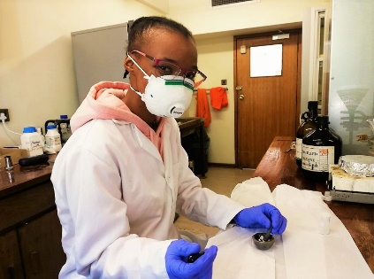

Miss Obakeng Setsome (MSc1) working on making

co-crystals for TB-HIV treatment



**CovidCollaborations**

***Two*** eminent Rhodes University academics, Professors Rosemary Dorrington and Rod Walker have joined a team of experts assembled by Premier Lubabalo Oscar Mabuyane and assigned by the Minister of Health, Dr Zweli Mkhize, to shore up efforts to curb Covid-19 in the Eastern Cape Province.

As part of the expert panel, Professors Dorrington and Walker will provide clinical advice to the OR Tambo, Sarah Baartman and Nelson Mandela Bay Metro Joint Operations Centres, to best inform governmental response strategies.

Prof Dorrington, who holds a SARChI in Marine Natural Products Research, has been the consulting virologist to Rhodes University’s Coronavirus Response Task Team (CVRTT) since the start of the outbreak. Under her expert guidance, the CVRTT has been able to make informed decisions regarding the Covid-19 outbreak and the effect it may have on the University and the city of Makhanda.

Prof Walker, who is a Professor of Pharmaceutics and was the first-ever academic to receive a South African Pharmacy Council Pioneer Pharmacy Award, has been at the helm of the University’s World Health Organisation-accredited sanitiser manufacturing project since early March of 2020. What started out as a small initiative to produce sanitiser for the University and Makhanda when this much-needed commodity became scarce, quickly turned into a collaboration with the Eastern Cape Provincial Health Department that has produced in excess of 5000 litres to date. Furthermore, world-class training is now being rolled out by the Pharmacy Faculty, also at no cost to government, to rural communities in sanitiser manufacturing under the auspices of the Department of Rural Development and Agrarian Reform.

“All of these efforts speak to the drive Rhodes University academics have to serve their community and their country. Rhodes University wishes Professors Dorrington and Walker all the best in their new significant roles. We take pride in their expertise, professionalism and commitment to serve,” said Dr Sizwe Mabizela, Vice-Chancellor for Rhodes University.

ISSUED BY THE COMMUNICATIONS AND ADVANCEMENT DIVISION ON BEHALF OF RHODES UNIVERSITY

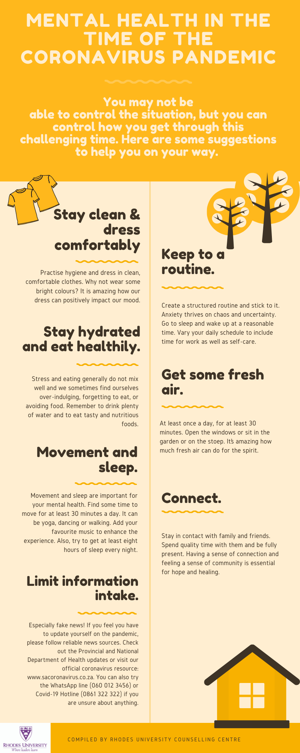

**thank you from chemistry**

***To*** our ***suppliers*** we would like to express our sincere appreciation for your service in 2020. You have provided quality products and good customer services to our department. We wish you and your loved ones a happy festive season and we look forward to working with your company in 2021.

***To*** our ***student***s the year is coming to an end and some of you will be moving up a year and others leaving the University. We have enjoyed getting to know each of you, take what you have learnt and build on it. Thank you for everything, enjoy the festive season.

***To*** our ***staff*** thank you for everything you did to make this a successful year, thank-you for your commitment to the Department. We wish you a very restful, safe and peaceful holiday season.

**Chemistry 2020 Photo**

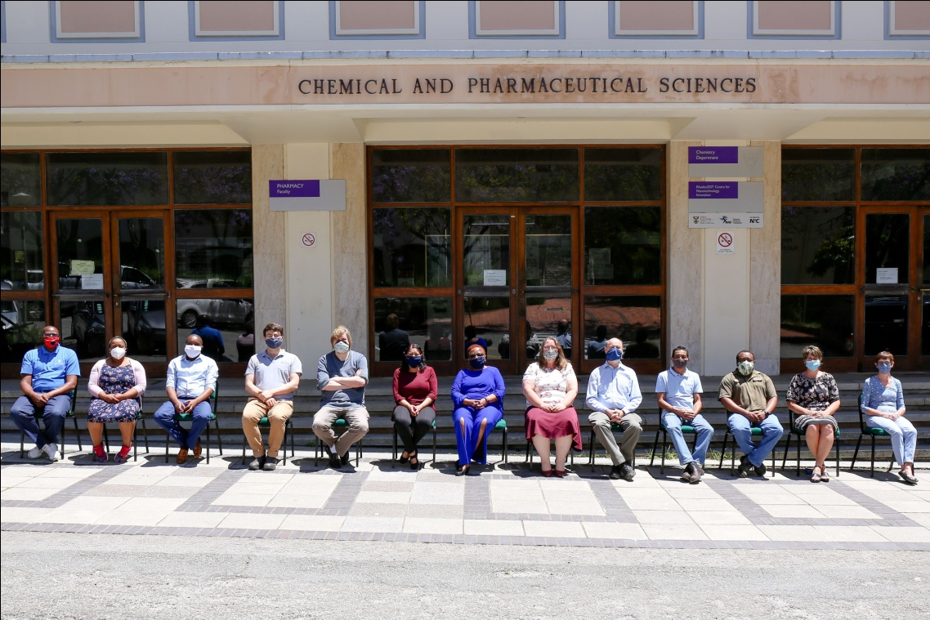

|  |  |
| --- | --- |
| F22.jpeg | ryd-BWCg.jpeg |

