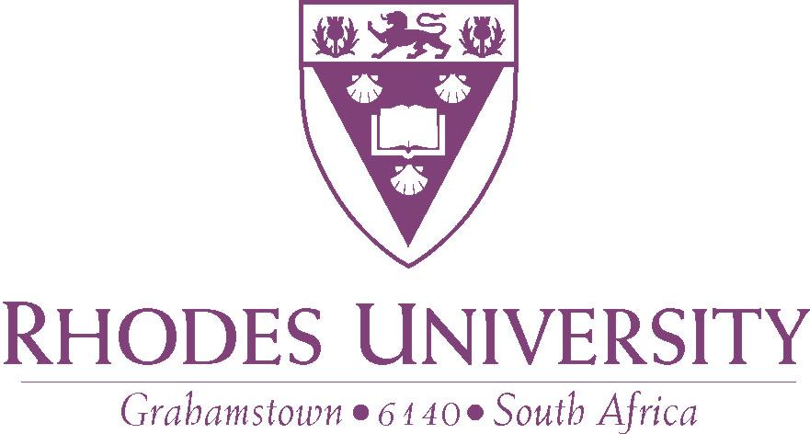

OFFICE OF VICE-CHANCELLOR
Tel: (046) 603 8149  Fax: (046) 603 7561

19 July 2016

Dear Alumni, Parents, Donors and Funders of Rhodes University

Over the past two weeks print and electronic media have reported on what has been characterised as a ‘financial crisis at Rhodes’. I thought it would be appropriate that I contextualise the recent reportage on Rhodes University. Some of it has sought to sensationalise rather than inform and educate our public on the challenges faced by our higher education institutions.
Let me state from the outset that Rhodes University is a going concern. It is not about to close down. The financial strain currently experienced by Rhodes University is experienced by all public universities in South Africa. Given its smallness, Rhodes University is particularly vulnerable and sensitive to changes in its funding streams that are a result of a fiscally strained national environment in which we find ourselves.
Below I will briefly sketch the national and the higher education contexts that have placed considerable financial pressure on our higher education institutions. It is in locating our higher education system in the broader national context that one is able to understand the challenges faced by our universities and what their future might look like.

National context
- South Africa has the highest percentage of highly indebted citizens of any other country. According to the World Bank Report (2015), 86% of adults in the country took out loans during that year (2015). The biggest debt owed by the majority of South Africans is consumption debt.
“In March, it was reported that half of 19 million credit-active South Africans had impaired credit records, three months plus in arrears, while 15% are described as debt stressed, one to two months in arrears. As a result, more than 11 million of South Africa’s credit active consumers are described as over-indebted.”
- We are amongst the most unequal society in the whole world.
- Almost a third of South Africans receive a State social grant.
“The number of social grants recipients in South Africa has increased exponentially over the past twenty years: from an estimated 4-million in 1994 to 16.9-million by 30 September 2015. In recent years, a growing chorus of voices has warned that the numbers are not sustainable.”
- The official unemployment rate is estimated to be 26.7%.
- The number of assessed taxpayers in the 2014 tax year was 4 941 390.
- According to the latest figures, our current economic growth rate is about 0.2%.

Higher Education context
- Our higher education system is chronically underfunded. This has been acknowledged by a number of Reports, including the Ramaphosa Report of 2013. Government subsidy dropped from 50% in 1994 to 40% in 2014, while the student proportion of higher education funding grew from 20% in 1994 to 31% in 2014. This decline in State subsidy has forced universities to increase the student fee income in order to maintain the quality of the educational experience of students. The student protests (#FeesMustFall campaign) of October last year were sparked off by the student fee increases which had reached unsustainable levels.
- Between 1994 and 2016, our higher education system enrolments have grown from about 500 000 to about 1 million. The number of fee-paying students, as a proportion of the entire public higher education enrolment, has dropped significantly.
- The National Student Financial Aid Scheme (NSFAS) is available for students who come from families whose income is less than R122 000 per annum, a very low threshold indeed. Currently over 405 000 students are being funded by NSFAS for the 2016 academic year. The level and extent of NSFAS funding remain inadequate. The funding is not adequate to cover all costs for books, transport, accommodation, tuition, etc. The demand for NSFAS Funding far outstrips the available resources.
- At the moment there is no funding mechanism for students whose family income is above the NSFAS threshold, but not enough to afford university education. These students are generally referred to as the ‘missing middle’. Given the levels of indebtedness mentioned above, parents of these students are unable to secure bank loans to fund their education. The only ray of hope in so far as assisting these students is concerned is in the work led by Mr Sizwe Nxasana who may come up with a viable funding mechanism that can address the plight of the ‘missing middle’.
- Following the student protests of October last year, government placed a moratorium on fee increases for 2016. Government provided some R1.9 billion towards a shortfall of R2.3 billion. Universities were asked to find the balance from their operations.
- The October 2015 student protests against unaffordable fee increases morphed into a demand for zero-fee increase and then to a new demand for universal fee-free higher education.
- Following the October 2015 student protests, universities entered into a number of agreements with students regarding fee payments for 2016.
- As a response to the student protests, the government appointed a Presidential Judicial Commission of Inquiry, chaired by the Honourable Justice Jonathan Heher, to investigate and make recommendations, inter alia, on the feasibility of fee-free higher education in South Africa. This Commission will report in 2017.
- The Council in Higher Education (CHE) has been asked by the Minister of Higher Education & Training to provide him with advice on fee increases for 2017.
- All public universities are experiencing considerable financial hardships. Some have embarked on austerity measures and others have offered their staff voluntary severance packages.

Rhodes context
- As noted above, following the protests of 2015, Rhodes University entered into a number of agreements with the students regarding fee payment arrangements for 2016.
- Among these, we agreed that we would do away with the 50% Minimum Initial Payment (MIP). Students would pay 10% of their fees (tuition and residence) as Registration Fee. Students would make payment arrangements for the balance of 90% of their fees.
- Some students paid the 10% Registration Fee in February and have not paid anything since then. Others who had made payment arrangements have not honoured them. By the beginning of June, some 1616 had either paid very little or nothing more than the 10% Registration Fee. This has placed our cash-flow which was previously covered by the MIP under severe strain.
- In June 2016, the University took a decision to withhold the first semester results of the 1616 students who had made very little progress in paying or had made no arrangements for the payment of their fees. This is what was picked up on by the media but was out-of-date within days.
- As at 15 July 2016, 818 of the 1616 students had either paid or made appropriate payment arrangements with the University. Their results were released immediately. The payments made since July 06, 2016 have totalled R12 million.

What does the future hold at national level?
We are eagerly awaiting the advice of the CHE regarding fee increases for 2017. Another year of zero fee increase in 2017 will place our higher education system further in a precarious position, unless the State can provide shortfall funding again. Indications from the budget Vote Speech of the Minister of Finance earlier this year are that government will provide the same level of shortfall funding for 2017 and 2018 as in 2016, only adjusted for inflation. If the student fees are left at the 2015 level, this will leave a significant financial gap for the universities.
The findings and recommendations of the Heher Judicial Commission will have a significant impact on the future of funding of our higher education system. Rhodes University has made a submission to the Commission appealing for increased funding of our higher education system.
Our nation, and by extension our higher education system, is experiencing unprecedented fiscal strain.

What does the future hold for Rhodes University?
When I was inaugurated as the Vice-Chancellor and Principal of this fine university I noted that
“[a]s always, challenges present new opportunities to do things differently. And so I have been very clear in my conversations with the University community that we cannot and will not continue with business as usual. We must do things differently”.
I further committed that
“[h]owever, my promise is that I will use my leadership to further our shared objective of strengthening our University’s position as a distinct and distinctive institution providing outstanding education to young people of our country and beyond, generating and disseminating knowledge of high quality which advances human understanding and wisdom; knowledge that helps us build and sustain a better society and a better world”.

Our University has a well-entrenched tradition and long legacy of academic excellence. Whatever the challenges, we must ensure that it remains a pre-eminent centre of academic excellence and that we defend its enviable academic reputation as we continue to transform it to ensure our responsiveness to the contemporary challenges facing our society and humankind.
Over the past number of months our University leadership has been developing a financial sustainability plan for our University. Among other things, we are
- carefully interrogating our operations with a view to realising efficiencies where possible;
- embarking on aggressive cost containment efforts which has become a central theme in our decision-making processes;
- exploring possible new sources of income;
- investing in improving our throughput and graduation rates;
- engaging our academics with a view to improving our scholarly outputs;
- complementing NSFAS funding with R45m of our own funding to assist academically deserving students who are in financial need. In the next few months we will be launching a student financial aid campaign, Isivivane Fund, to ensure that no academically deserving student is turned away from Rhodes University simply because he/she cannot pay the university fees.
In all our efforts to respond to the challenges we face, we are determined not only to protect and safeguard the quality of the educational experience of our students and the reputation of our University, but also to enhance them to the extent that resources permit us to.
As alumni, parents, donors and funders of Rhodes University, we welcome and appreciate your support in terms of ideas, partnerships and financial support in ensuring that we maintain the quality education that is synonymous with this great university.
Thank you so much for your continued support.

Yours sincerely,
Sizwe Mabizela, Vice-Chancellor.

World Bank Indicators of income distribution http://www.tradingeconomics.com/south-africa/gini-index-wb-data.html
Source: https://africacheck.org/factsheets/separating-myth-from-reality-a-guide-to-social-grants-in-south-africa/
Source: http://www.tradingeconomics.com/south-africa/unemployment-rate
Mr Sizwe Nxasana, former CEO of FirstRand Ltd and Chairman of NSFAS Board.
S Mabizela, Inaugural address as Vice-Chancellor and Principal of Rhodes University, 27 February 2015.
ibid

