Wise Buying Series: Produced in collaboration with the Rhodes University Environmental Education & Sustainability Unit
Welcome to our Wise Buying Series! This is the first of several short and informative pieces that will help you think about the choices you can make when shopping. Each series is accompanied by an entertaining Basil Mills illustration (originally produced for the 2003 Sasol SciFest). Enjoy!

Which eggs would you buy?

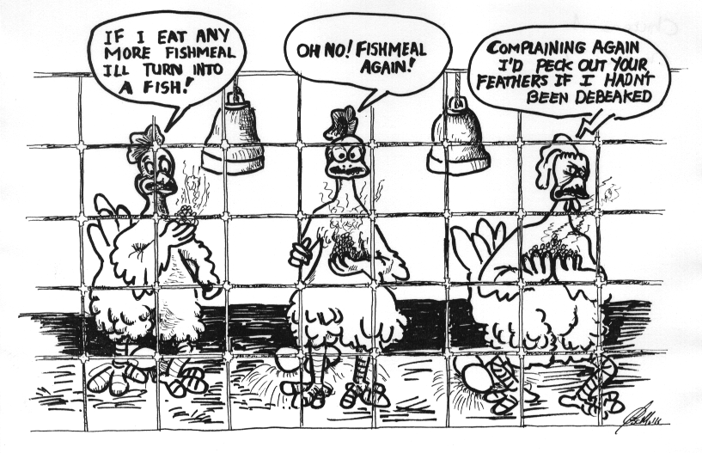
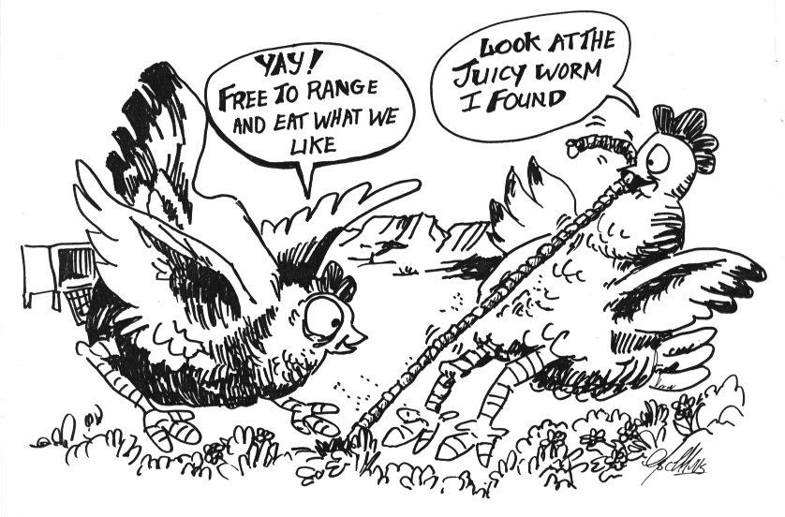
1
2

Drawings by Basil Mills

1. Think about: Battery chickens live in cramped spaces with no access to healthy green feeds. Battery chickens often have their beaks chopped off, so that they can’t peck each other. They are also often exposed to antibiotics and chemicals, to keep them alive or make them grow faster – this can’t be good for us. The waste that leaches out from battery chicken houses can also affect our environment.
Would you buy eggs from farmers who treat chickens, and our environment, badly?
2. Think about: Free-range chickens enjoy a healthy lifestyle. They have access to the open air and sunlight, and can roam freely. They can scratch for seeds, insects, and fresh green feeds. They can also roll in the dust to keep their feathers healthy. And their beaks are not chopped off!
Wouldn’t you like to buy healthy eggs from happy chickens?

For more info: Visit the websites http://www.uncc.edu/pjleonar/EGG.htm & http://www.organicconsumers.org/

