Wise Buying Series: Produced in collaboration with the Rhodes University Environmental Education & Sustainability Unit
Welcome to our Wise Buying Series! This is the second of several short and informative pieces that will help you think about the choices you can make when shopping. Each series is accompanied by an entertaining Basil Mills illustration (originally produced for the 2003 Sasol SciFest). Enjoy!

Which nappies for your baby?
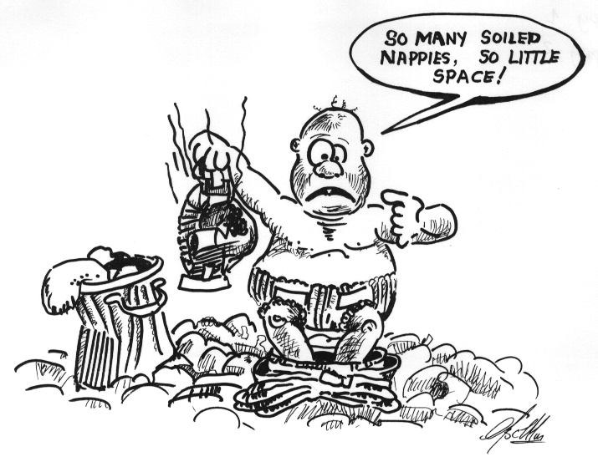
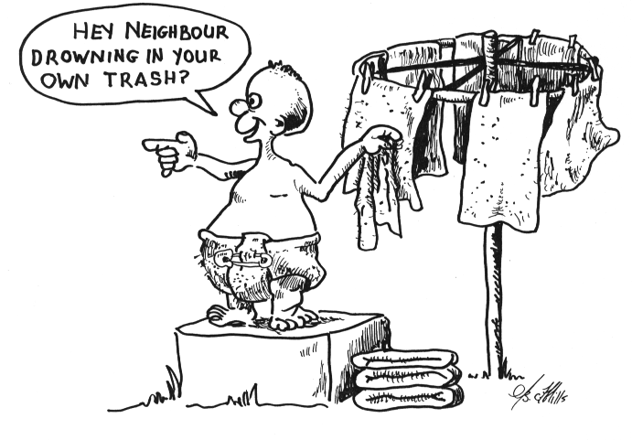
3
4

Drawings by Basil Mills

1. Think about: Disposable nappies cost a lot of money; as we use them, we need to buy more nappies. Disposable nappies are made of super-absorbent chemicals, paper pulp and plastics. The chemicals are bad for the environment. And it can take many decades for the plastic part to break down, which means that disposable nappies tend to fill up our rubbish dumps.
Do we want to pollute our country and fill it with rubbish dumps?
2. Think about: Cloth nappies cost a lot less money (than disposable nappies); we can use them again and again. While washing cloth nappies uses chemicals that affect the environment, this is less than half the damage caused by disposable nappies. And cloth nappies do not fill up our rubbish dumps.
Don’t we want to keep our country clean and beautiful?

For more info: Visit the websites http://www.beezhouse.co.uk/why.html and http://www.wen.org.uk/nappies/Nappy_facts.htm

