Wise Buying Series: Produced in collaboration with the Rhodes University Environmental Education & Sustainability Unit
Welcome to our Wise Buying Series! This is the third of several short and informative pieces that will help you think about the choices you can make when shopping. Each series is accompanied by an entertaining Basil Mills illustration (originally produced for the 2003 Sasol SciFest). Enjoy!

Whose business would you support?
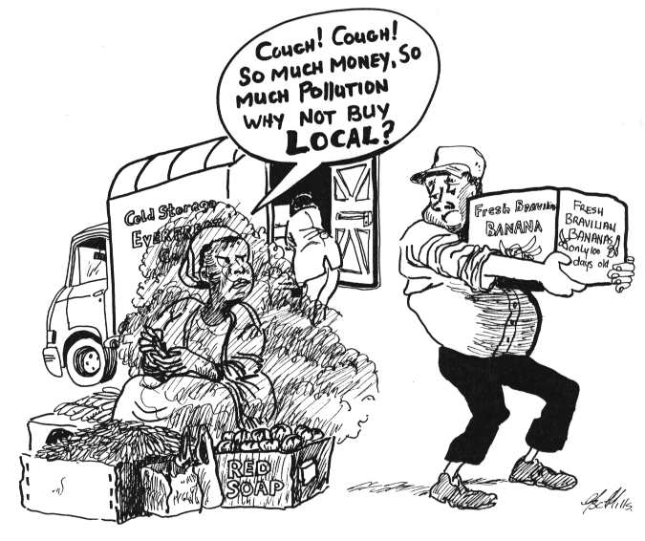

5
6

Drawings by Basil Mills

1. Think about: Food that is imported to our area needs to be packaged, stored and transported. This costs money and uses up energy, including fossil fuel – which contributes to global warming. Also, imported food loses more and more vitamins as time passes (during cold storage and transport). This cannot be good for our health! Our local producers often struggle to compete with the big food importing businesses, and can end up closing down.
Do we want to harm our environment, our health and our local economy?
2. Think about: Food that is grown locally does not need to be stored or transported very far. This means lowers costs, and less energy usage. Freshly picked food is also full of vitamins, which is better for our health – and means fewer medical expenses! And our local producers and businesses need to make a living.
Don’t we want to look after our health and our local economy?

For more info: Talk to local businesses. Or visit the websites http://pw1.netcom.com/~symbios/buylocal.html , http://www.consciouschoice.com/issues/cc1301/localvscheap1301.html & http://www.proudlysa.co.za/

