Wise Buying Series: Produced in collaboration with the Rhodes University Environmental Education & Sustainability Unit
Welcome to our Wise Buying Series! This is the fourth of several short and informative pieces that will help you think about the choices you can make when shopping. Each series is accompanied by an entertaining Basil Mills illustration (originally produced for the 2003 Sasol SciFest). Enjoy!

How would you control insects?
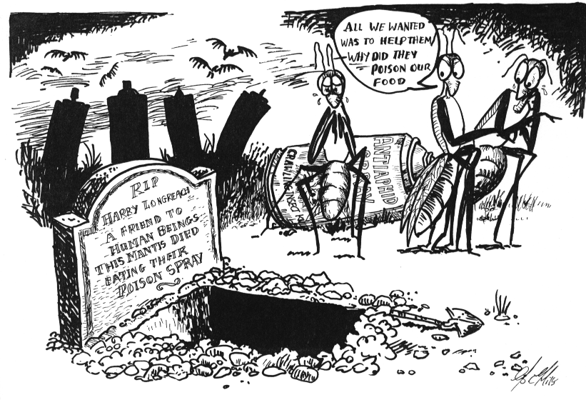
7

8

Drawings by Basil Mills

1. Think about: Pesticides contain many long-lasting poisonous chemicals. These poisons can damage our health, and also kill useful insects (e.g. the praying mantis) that eat pests (e.g. aphids, which attack our flowers and vegetables).
Do we want to harm our environment and our health?
2. Think about: There are many good insects (e.g. the praying mantis) that help us to control pests (e.g. aphids). Natural organic sprays (made from plants) are less damaging to helpful insects and ourselves. We could even make our own natural mixture to spray onto our plants. For example, boil up a mixture of garlic, onion & chilli; or use khakibos (Xhosa: unukayo), a common weed in Grahamstown!
Don’t we want to look after our environment and our health?

For more info: Sharenet at sharenet@futurenet.co.za or 033-330.3931 has Enviro Facts on Poisons & Wildlife. Herbs for Africa, Spring/Summer 2002 issue (info on organic pest control). EarthLife Africa at http://www.earthlife.org.za/

