Wise Buying Series: Produced in collaboration with the Rhodes University Environmental Education & Sustainability Unit
Welcome to our Wise Buying Series! This is the sixth of several short and informative pieces that will help you think about the choices you can make when shopping. Each series is accompanied by an entertaining Basil Mills illustration (originally produced for the 2003 Sasol SciFest). Enjoy!

What will you plant in your garden?
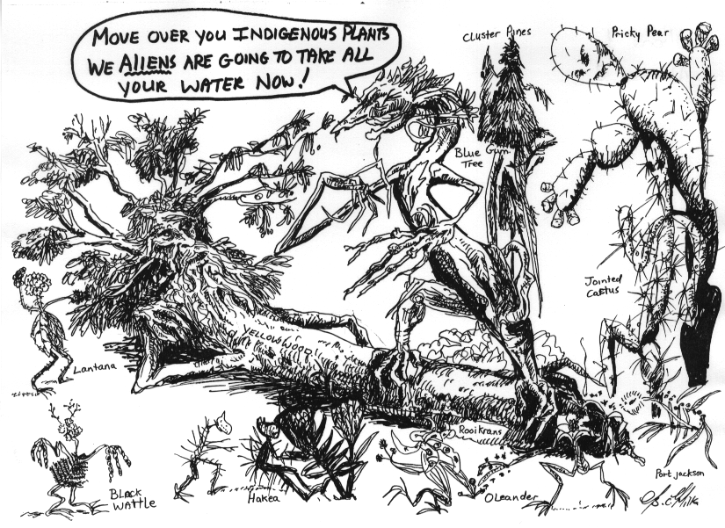
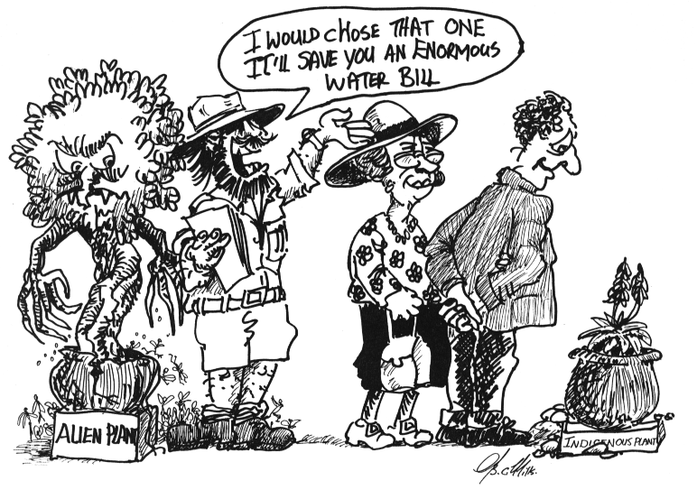
11
12

Drawings by Basil Mills

1. Think about: Alien plants grow and spread very quickly. They invade our natural areas and push out indigenous plants. Alien plants often use up a lot of water. It costs money to provide water for thirsty plants.
Do you want to use up extra water on plants that can damage the environment?
2. Think about: Indigenous plants come from our own country. Most indigenous plants are easy to grow, and do not need much water. South Africa has a wide variety of beautiful indigenous plants.
Would you like to do less work in your garden, and spend less money on water, with lovely indigenous plants?

For more info: Nature Conservation 046-622 7216; Albany Working for Water 046-636 1449; or visit the website http://www.dwaf.gov.za/wfw/problem.asp (has useful Weedy Web Links, WFW Resources, etc). Albany branch of the Botanical Society of SA – secretary Michelle Hatherly (tel: 046-636.1370, email: garnet@imaginet.co.za). Visit their website: http://www.botanicalsociety.org.za/ & also the NBI at: http://www.nbi.co.za/
Good reference books: Pitta Joffe “Gardener’s Guide to Indigenous Plants”, Pitta Joffe (2001) “Creative Gardening with Indigenous Plants”, & Ernst van Jaarsveld (2002) “Wonderful Waterwise Gardening”.

