Wise Buying Series: Produced in collaboration with the Rhodes University Environmental Education & Sustainability Unit
Welcome to our Wise Buying Series! This is the final of eight short and informative pieces that will help you think about the choices you can make when shopping. Each series has been accompanied by an entertaining Basil Mills illustration (originally produced for the 2003 Sasol SciFest). Enjoy!

How will you carry your shopping?
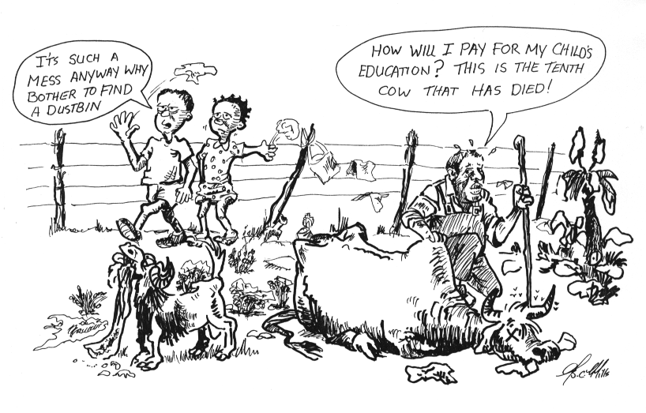
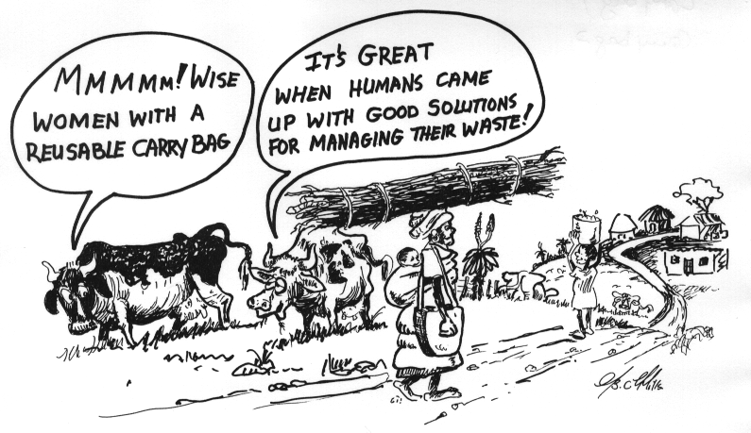
15
5
16

Drawings by Basil Mills

1. Think about: A plastic bag can blow away and cause ugly litter. As former minister of Environmental Affairs and Tourism, Vali Moosa, said, “Plastic bags touch the lives of each and every South African, be they rich or poor … plastic bags are competing with the Protea as our national flower!” As litter piles up, we get pests and diseases. If animals swallow plastic, they can die – and this can affect farmers’ livelihoods.
Do we want to contribute to the country’s health & economic problems by asking for plastic bags?
2. Think about: As former Minister of Environmental Affairs and Tourism, Vali Moosa, said, “We have to roll up our sleeves and clean up our country. These regulations on plastic bags are the start of a broader look at waste management. Simply put, we as a nation have to start to recover a higher percentage of our waste, lest we drown in our own garbage.”
There are many good alternatives to plastic bags, including cloth bags and baskets. Cloth bags can be used again and again. They do not pile up as non-biodegradable waste. They will not blow around and cause problems.
Don’t you want to contribute to the country’s health & economy by using smarter alternatives for your shopping??

For more info: Speak to major retailers in town. Dial the Plastic Bag Hotline: 0800 203 622. Visit the websites: http://www.environment.gov.za/ (click on “New plastic bag regulations”), http://www.panda.org.za/article.php?id=194 , http://www.plasticbag.com/environmental/pop.html , http://www.iol.co.za (& search for “plastic bag”), http://www.indiatogether.org/opinions/suggestions.htm

