WELCOME TO a new destination in travel

We are delighted to welcome you to our world of Corporate Travel.

Our aim is to provide stress free travel and incorporate an element of fun and relaxation...
Remember our promise to you:
- The best deal each and every time, including web-based fares;
- Corporate Specials;
- 24 Hour Service; 083 626 1184
- Reporting according to your needs;
- Corporate Travel Tips;
- Holiday Specials;
- Personal Service;

Your Travel Consultants are: Team Leader Jasmine Abbas, Consultant Nazlie Jossie and Lyndyll Peters

Club Travel Corporate Contact number: 021 427 1900

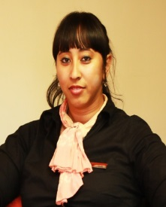 |  | 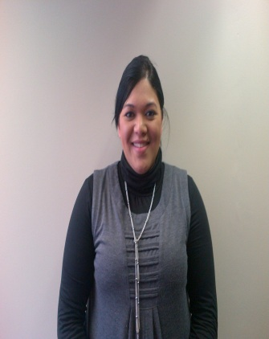
Consultant:  Nazlie Jossie  Nazlie@clubtravel.co.za | Team leader /Consultant: Jasmine Abbas  Jasmine@clubtravel.co.za | Consultant:  Lyndyll Peters  Lyndyll@clubtravel.co.za

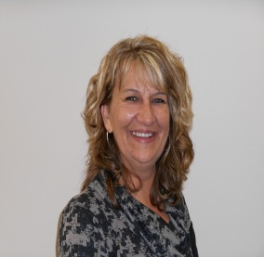 | 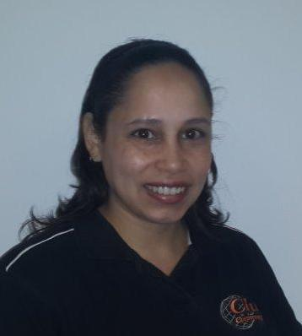
National Corporate Manager: Sharon Nash  sharonnash@clubtravel.co.za  Mobile Number: 073 6900 078 | Corporate Floor Manager:  Lee –Ann Page  Lee-anne@clubtravel.co.za  082 694 7708 | Key Account Manager:  Tahierah Johaadien  Tahierah@clubtravel.co.za  071 354 9338
Thank you for joining Club Travel Corporate. We know it will be a rewarding experience.

