Projects with Prevec
Transformation of Karoo and/or Cape Supergroup rocks into kaolinitic clays in the Grahamstown Formation, Makhanda area.
Materials: collected (locally)
Purpose of study: To develop diagnostic tools for the identification of the protolith, and the extent and style of kaolinitisation at a given site, of Makhanda kaolinite deposits.
Tens of metres of folded units of the uppermost Cape Supergroup (mudstones of the Lake Mentz Group), and the lowermost unit of the Karoo Supergroup (the Dwyka tillite) have been transformed into kaolinitic equivalents known as the Grahamstown Formation by extensive leaching at the end of the Cretaceous Period. The progressive conversion process is mainly expressed through the breakdown of alkali feldspars in the protoliths into progressively more mineralogically and stoichiometrically simple clay minerals, from feldspars to smectites to illites to kandites (kaolinite), relating to mobility of silica and alkali metals in relatively oxidizing and acidic aqueous fluids. Locally variable contents and/or oxidation states of iron and of carbonate influence the colour and mechanical properties of the resultant clay ores (yes, ores: they are economically mined here in town). Preliminary analyses indicate systematic variations in clay mineralogy and rock chemistry; interpretation and additional more nuanced analysis by XRD and XRF are needed.
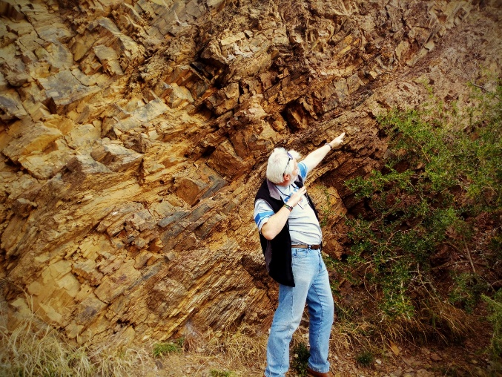 | 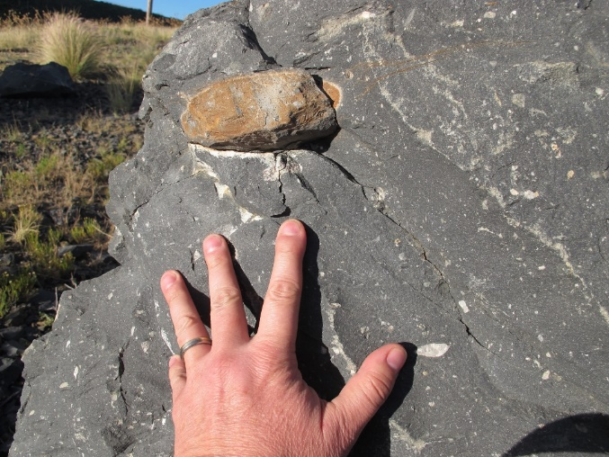
Above, tilted mudstones of the Lake Mentz Fm, Witteberg Group, Cape Supergroup, and below, after pervasive kaolinitisation (Strowan Mine). | Above, glacial tillites of the Dwyka Fm, Karoo Supergroup. Below, the same unit after partial kaolinitisation (N2 Bypass).
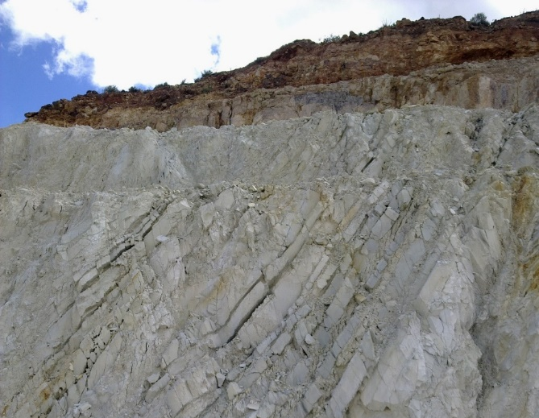 | 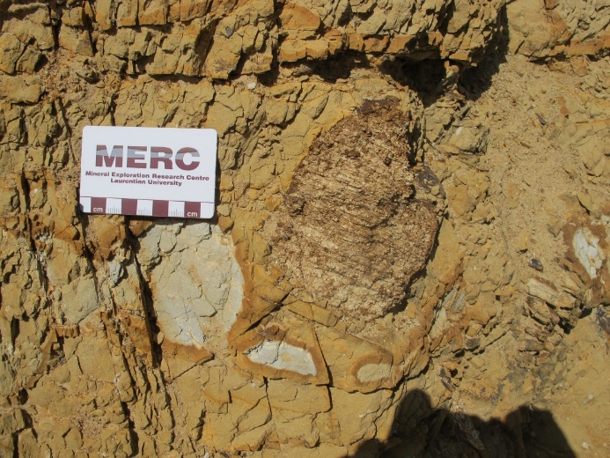

Projects with Prevec
Transformation of Karoo and/or Cape Supergroup rocks into silcrete associated with the Grahamstown Formation, Makhanda area.
Materials: to be collected (locally)
Purpose of study: To assess the formation process of the thick silcrete layer associated with the Grahamstown peneplain.
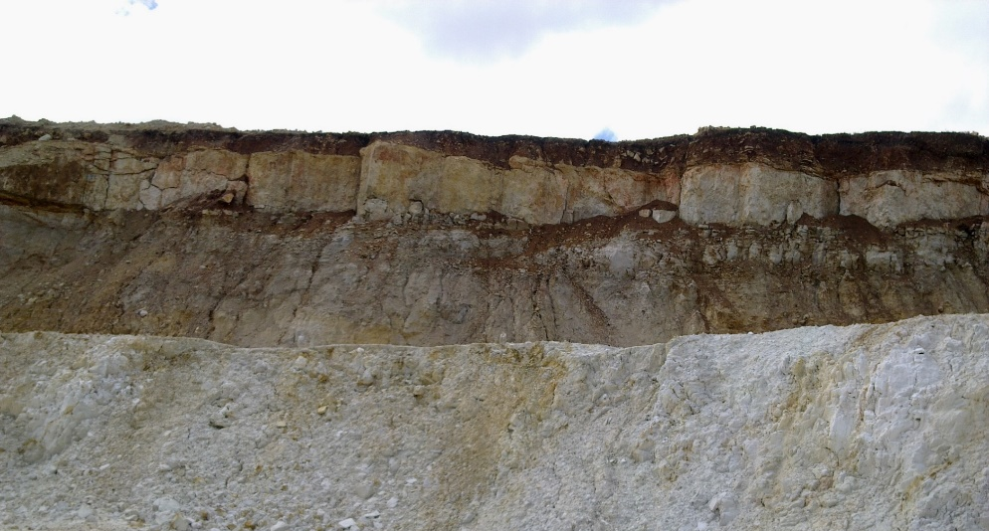 | Ca. 1 m-thick silcrete layer exposed in the Strowan Mine, Makhanda.

Is the silcrete a byproduct of the extensive leaching of silica out of the underlying feldspathic and siliceous rocks during the end-Cretaceous kaolinitisation event that created the clay deposits of the Grahamstown Formation? This would seem, superficially, to be the most obvious explanation. If so, does the nature of the silcrete (composition, density, thickness, porosity) correlate with the footwall rocks (composition, mineralogy, thickness), which comprise the uppermost Cape Supergroup (mudstones of the Lake Mentz Group), and the lowermost unit of the Karoo Supergroup (the Dwyka tillite)? For example, does a thicker silcrete suggest a thicker, and more pervasively altered, kaolinite unit underlying it? (If so, this becomes a kaolinite ore exploration vector). Are there multiple layers of silcrete? Why? If indeed that genetic relationship exists between the silcretes and the underlying clays, then why are the silcretes not directly contiguous with the underlying clays (see photo above)? What was the change in the chemical environment that was required to change from silica dissolution in the footwall to silica precipitation in the silcrete horizon?
Projects with Prevec
Assessment of the silicate layer between the MG1 and the MG2 chromitite ‘reefs’, western lobe of the Bushveld Complex; one chromitite’s hangingwall is the next one’s footwall.
Materials: to be collected from drill core sequence available in the Geology Dept. Some thin sections and polished sections may be available (MG1 HW).
Purpose of study:
To assess the nature of the floor and the roof associated with successive chromitite layers. The sequence of a few metres between the MG (Middle Group) chromitites in drill core from Glencore’s Waterval Mine in the western lobe of the Bushveld Complex offers the prospect of a detailed evaluation of chemical and mineralogical changes across superficially relatively homogeneous noritic rocks. However, genetic models for the formation of chromitite layers should require some chemical contrast between the rocks and minerals immediately underlying a chromitite, the silicates within a chromitite, and the rocks and minerals immediately overlying a chromitite. Even a complete absence of a difference, while boring, would require an explanation, such as the in situ crystallization of chromite in an otherwise unaffected rock (in which case, how do we suddenly precipitate wildly non-cotectic proportions of chromite), or secondary re-equilibration of the silicate compositions (i.e., they were actually originally different, but now they’re not). Petrographic examination of the mineral textures and their compositions (evidence of zoning? Absence of zoning? Variable zoning in different coexisting minerals?) ought to reveal evidence of such a process.
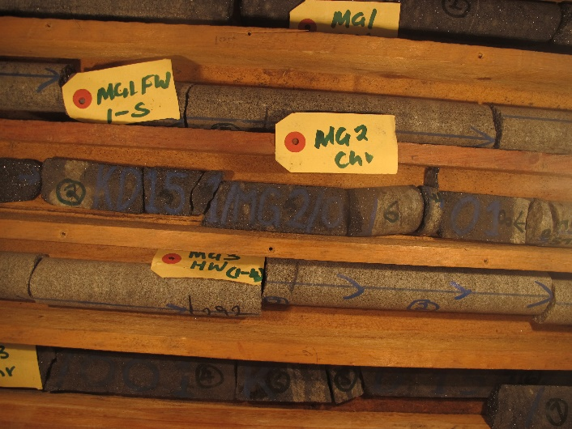 | The interval between the MG1 chromitite (top row) and the MG2 (bottom row). Is this a) a homogeneous noritic pyroxenite into which chromite-rich layers have been introduced (either by in situ precipitation of chromite caused by sudden changes in pressure, oxygen fugacity, or changes in the compositional position of the cotectic curve), or b) a sequence of progressive intrusions of chromite-saturated ultramafic magmas, where the chromite then settles to the floor of each new pulse. Or something else?

Projects with Prevec
First appearance of cumulus plagioclase feldspar in the stratigraphy of the Bushveld Complex: so what?
Materials: to be collected from drill core sequence available in the Geology Dept. Some thin sections and polished thin sections may already be available (MG3 FW).
Purpose of study:
Between the emplacement of the MG (Middle Group) 2 chromitite and the MG3 chromitite a few metres above it, plagioclase feldspar changes from a late, interstitial (intercumulus) mineral to a primocryst (so called ‘cumulus plagioclase’), resulting in the appearance of leucocratic (leuconorite to anorthositic) rocks ‘for the first time’ (i.e., assuming that the rocks have formed in chronological order from the bottom upwards, which may not be strictly true in detail).
Research questions or findings include the characterization of these rocks (i.e., compositional, as well as textural differences between primocryst feldspars and interstitial feldspars in the same or underlying rocks), their representation in ternary phase diagram space in terms of the evolving composition of the parent magma, and their consistency with various proposed parental magmas for Upper Critical Zone rocks (of which these would represent the earliest pulses, overlying the Lower Critical Zone just a few metres below, which has an entirely different, olivine-saturated composition).
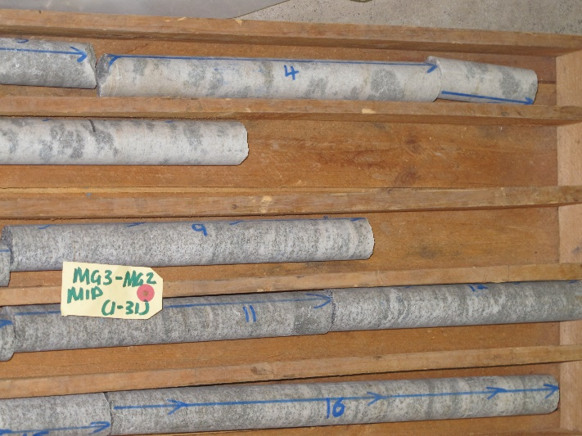 | Leuconoritic (or mottled anorthositic) rocks, in the top two rows at left, appear for the first time in the stratigraphy of the Bushveld as manifestations of cumulus (primocryst) plagioclase crystallisation in the rocks between the MG2 and MG3 chromitites (not seen in this photo).

Projects with Prevec
Characterisation of a chromitite-norite-anorthositic sequence near the base of the Upper Critical Zone: the MG4 (A-C)
Materials: to be collected from drill core sequence available in the Geology Dept.
Purpose of study:
The MG4 represents the top of a cluster of relatively closely-emplaced chromitite layers near the base of the Upper Critical Zone. The MG4 contains a combination of primocrystic (so called cumulus) plagicoase felspars as well as late, interstitial feldspar, in a matrix of medium to coarse-grained (locally pegmatoidal) orthopyroxenite. A complex relationship between modal mineralogical changes and grain size (which may imply locally higher fluid contents, or it may not…) and texture is evident, and have a potential bearing on the interpretation on the processes that created the anorthositic and chromititic rocks.
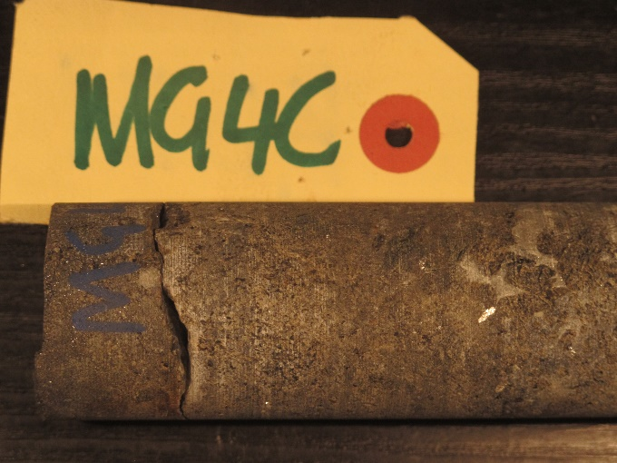 | 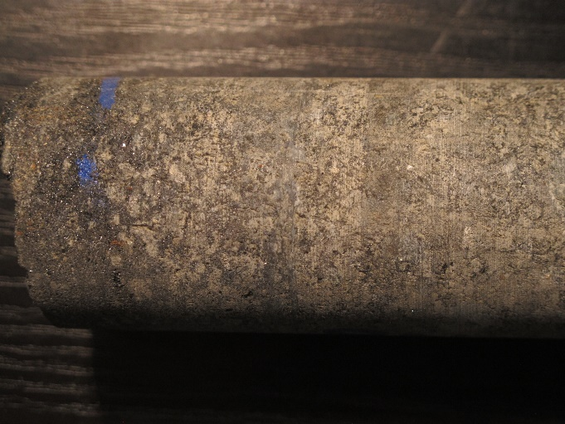
Classically interstititial plagioclase feldspar (presumably) between coarse cumulus enstatite grains from near the the MG4 C chromitite layer. | Variably pegmatoidal enstatites with interstitial finer grained chromite, grading into more massive chromitite of the overlying MG4C layer (to the left, upwards).
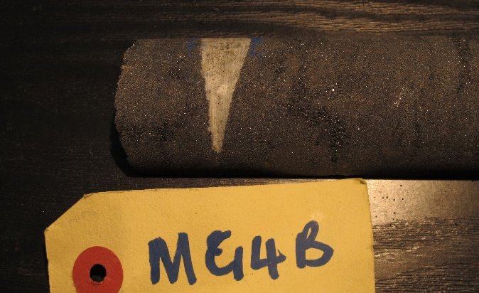
Possible angular unconformity between chromitite layers, expressed in a trapped anorthositic ‘fragment’. Or is it simply an angular xenolith comparable to those shown at right? (I doubt it). | Possible rip-up clasts of anorthositic footwall or hangingwall rocks enclosed within orthpyroxenitic to noritic medium-grained rocks between the MG4A and 4B chromitite.

Projects with Prevec
Low-temperature vein filling associated with tension gashes in deformed Cape Fold Belt rocks, Makhanda area (with cosupervision by an actual structural geologist, Prof. S. Büttner).
Materials: to be collected (locally)
Purpose of study: To assess the formation process of leucocratic vein fills in the Lake Mentz Fm, Witteberg Gp, Cape Supergroup, Makhanda area. What minerals are present, are they (all) syn-deformational (growing as the cracks expanded), or did they crystallise later from fluids migrating along permeable fractures? What was the controlling stress field, in terms of orientation and deformational style, at the time(s) of emplacement? Were there multiple events relating to different fluids and different stress regimes? What information can be obtained on the composition and temperature of the parental fluids? Can we relate this to the regional tectonic and geological history of the area? (Yes, we can.)
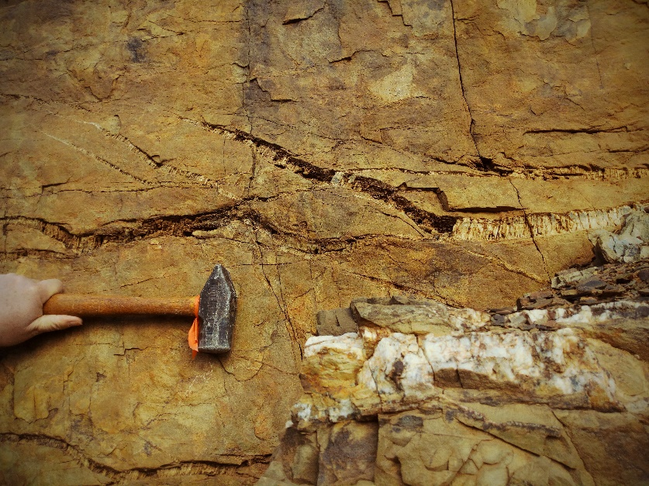 | In upper photo at left, tension gashes contain vertically (fracture perpendicular)-oriented (or orientated) minerals. Below this, massive, apparently joint-surface parallel leucocratic mineral growth. Are these related in time, and/or in terms of parent liquid (hydrothermal aqueous solution) type?
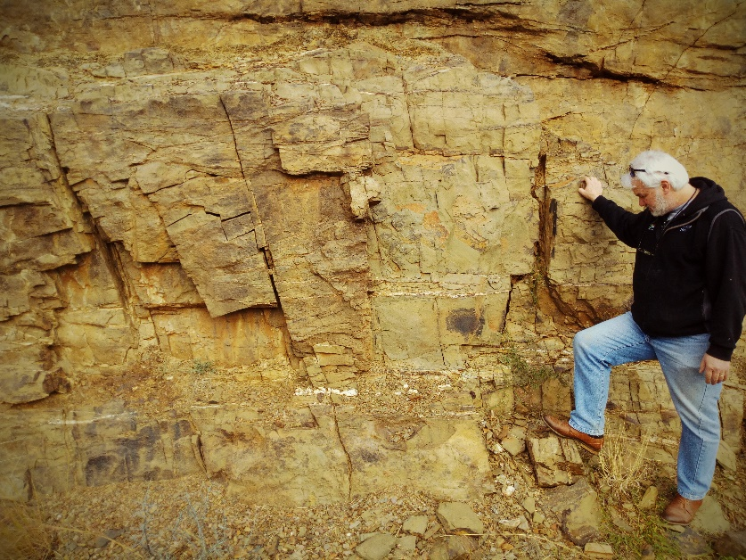 | Layer (bedding?)-parallel stratiform massive textured leucocratic veinlets.

Projects with Prevec
Assimilation and contact metamorphism of carbonate xenolith in Bushveld Marginal Zone norite
Materials: to be collected from the eastern Bushveld (Mpumalanga); depends on possible constraints on travel & travel timing.
Purpose of study:
To evaluate nature of contamination of norite by relatively labile floor rock, and nature of heating, partial melting and devolatilization of xenolith in a mafic magma.
Evaluate changes in chemical composition and mineralogy across contact; are we producing a hybrid rock with potential for spinel or sulphide saturation? Or does the carbonate just wick away into the norite leaving no trace, locally? What is the effect on the xenolith of immersion in a magma, or in fact, is it a ductile, near solid-mush, and can the mineralogical and chemical profile across the xenolith tell us the difference?
Evaluate petrography of samples
Evaluate chemistry of samples, comparing with bulk Malmani dolomite and average Shelter Norite.
