Consolidated Risk Report


  Report Date
  17 October 2012 09:46
  Event Date
  04 October 2012
  Paypoint
  Rhodes University

Demographics

 | Gender
 | Female | Male | Total
Participants | 32 | 53 | 85
Average Age | 45 | 44 | 45

 | 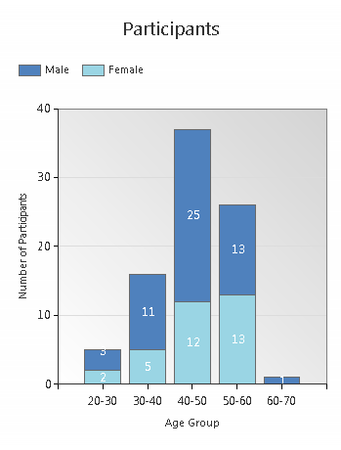 |  | 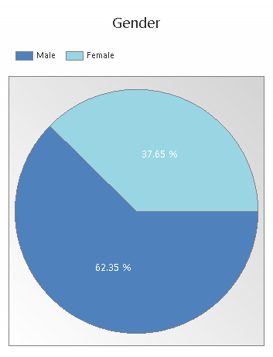

  Smoking
 |  | Gender
 |  | Female | Male | Total
Smoking | Non Smokers | 32 | 47 | 79
Smoking | Smokers | 0 | 6 | 6
Smoking | Total | 32 | 53 | 85

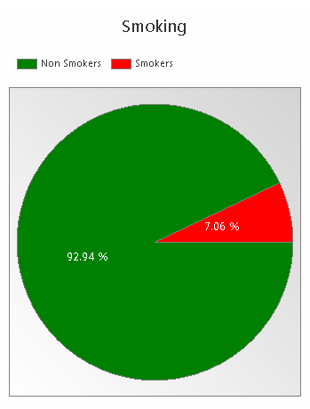 |  |  |  |  |  | 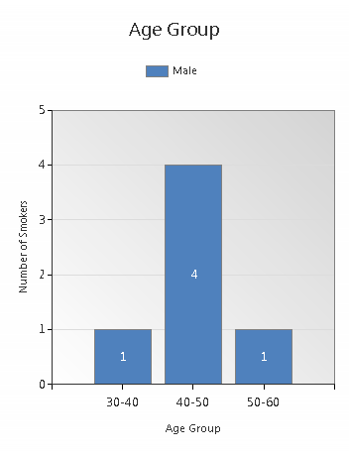
 |  |  |  |  |  |  | 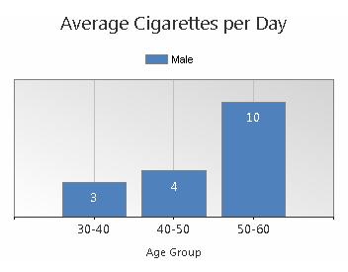
  Smoking greatly increases the probability of Cardiovascular Disease which is the main cause of death due to smoking.
  Cancer risk is increased by smoking and on average reduces life expectancy is reduced by up to 15 years.
  Other diseases related to smoking includes Respiratory Diseases, Non-Insulin-Dependent Diabetes and in older people even vision loss and Alzheimer's
  Reference: MMWR April 12, 2002

Body Mass Index

 |  | Gender
 |  | Female | Male | Total
BMI | Normal | 2 | 26 | 28
BMI | Overweight | 2 | 12 | 14
BMI | Obese I | 14 | 12 | 26
BMI | Obese II | 9 | 2 | 11
BMI | Obese III | 5 | 1 | 6
BMI | Total | 32 | 53 | 85

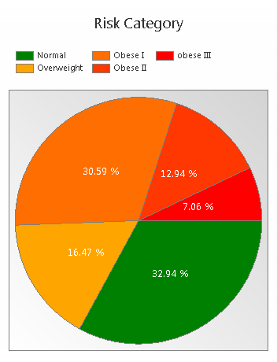
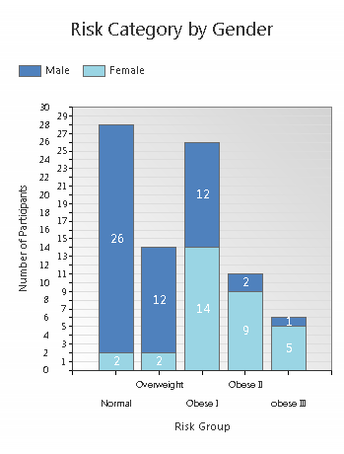

  Waist-hip Ratio
 |  | Gender
 |  | Female | Male | Total
Waist/hip ratio | Desired | 32 | 43 | 75
Waist/hip ratio | At Risk | 0 | 10 | 10
Waist/hip ratio | Total | 32 | 53 | 85

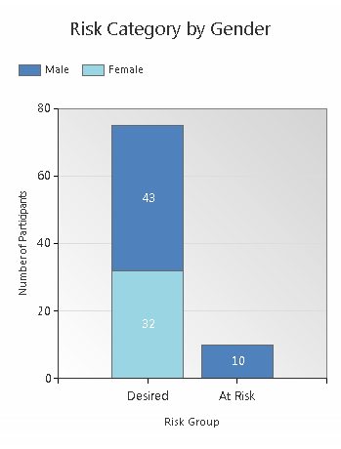 |  |  |  | 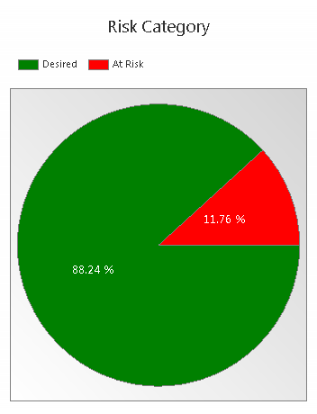
  Waist-Hip Ratio is shown at risk for males with a waist/hip ratio equal or greater than 0.95 and at risk for females with a waist/hip ratio equal or greater than 0.80.

  Blood Pressure
 |  | Gender |  | Treatment
 |  | Female | Male | N/S | N/S | Total
Blood Pressure | Acceptable | 26 | 41 | 66 | 1 | 67
Blood Pressure | Elevated | 6 | 10 | 12 | 4 | 16
Blood Pressure | Severe | 0 | 1 | 1 | 0 | 1
Blood Pressure | Acute | 0 | 1 | 1 | 0 | 1
 |  | 32 | 53 | 80 | 5 | 85

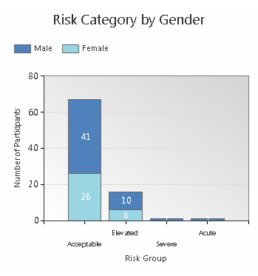 |  |  | 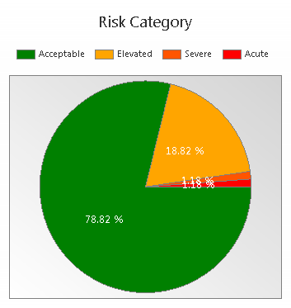
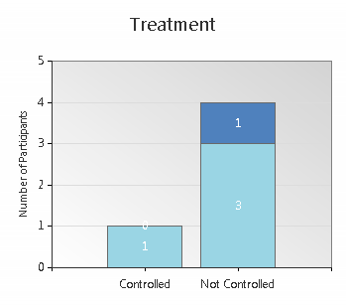
  At risk primary prevention
  Systolic > 139 mmHg or Diastolic > 89 mmHg
  At risk secondary prevention
  Systolic > 119 mmHg or Diastolic > 79 mmHg

Glucose

 |  | Gender |  | Treatment
 |  | Female | Male | N/S | No | Yes | Total
Glucose | Acceptable | 27 | 51 | 74 | 1 | 3 | 78
Glucose | Elevated | 4 | 1 | 3 | 2 | 0 | 5
Glucose | Severe | 1 | 1 | 0 | 0 | 2 | 2
 |  | 32 | 53 | 77 | 3 | 5 | 85

 | 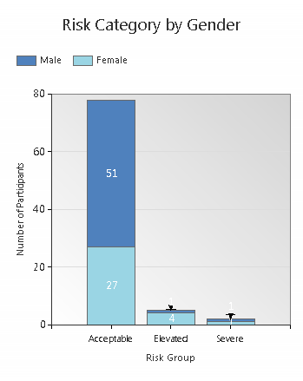 |  |  |  |  | 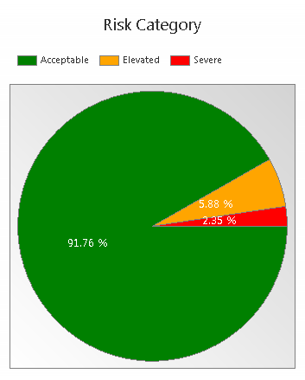
At risk non fasting > 11 mmol/l
At risk fasting >6.9 mmol/l

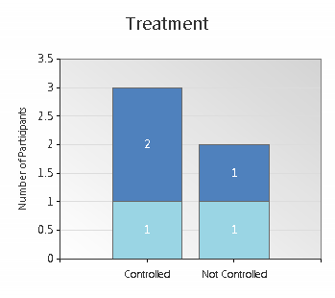

  Cholesterol
 |  | Gender |  | Treatment
 |  | Female | Male | No | Yes | Total
Cholesterol | Acceptable | 13 | 33 | 46 | 0 | 46
Cholesterol | Elevated | 19 | 20 | 36 | 3 | 39
 |  | 32 | 53 | 82 | 3 | 85

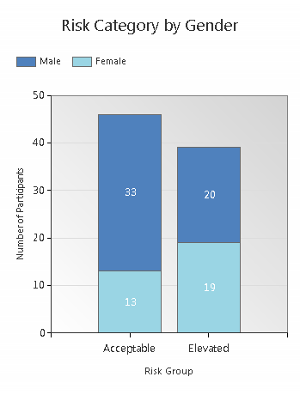 |  |  | 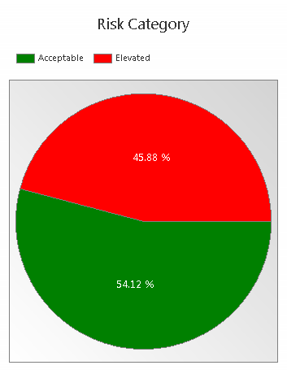
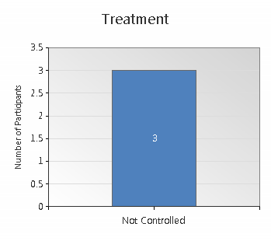
  At risk primary prevention > 5 mmol/l
  At risk secondary prevention > 4.5 mmol/l
  Along with cigarette smoking, high blood pressure, physical inactivity and obesity, high blood cholesterol is one of the five major risk factors for coronary heart disease. If your cholesterol is currently in the desirable range, healthy lifestyle habits may help you improve it even more and prevent it from becoming a risk in the future.

  Depression Risk
 |  | Gender |  | Status
 |  | Female | Male | Undiagnosed | Total
Depression | Acceptable | 22 | 34 | 56 | 56
Depression | Severe | 10 | 19 | 29 | 29
Depression |  | 32 | 53 | 85 | 85

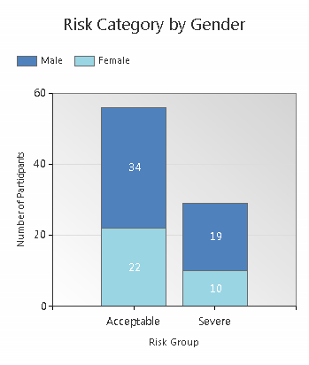 |  |  |  | 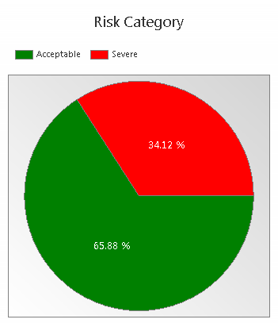
Participants already diagnosed with; or taking medication for Depression is included in the calculation.
Clinical Depression is a psychiatric disorder lasting for more than two weeks that causes great disruption in social functioning, behaviour changes, memory loss, appetite loss and is a major risk factor for suicide.
Reference: Diagnostic and Statistical Manual of Mental Disorders (DSM-IV-TR)

Lifestyle changes and professional help are very effective in treatment and recovery of Depression.

  10 Year Type 2 Diabetes Risk
 |  | Gender
 |  | Female | Male | Total
Type 2 Diabetes | N/A - Diagnosed | 5 | 3 | 8
Type 2 Diabetes | Low (1%) | 5 | 27 | 32
Type 2 Diabetes | Elevated (4%) | 12 | 15 | 27
Type 2 Diabetes | Moderate (16%) | 5 | 6 | 11
Type 2 Diabetes | High (33%) | 4 | 1 | 5
Type 2 Diabetes | Severe (50%) | 1 | 1 | 2
 |  | 32 | 53 | 85

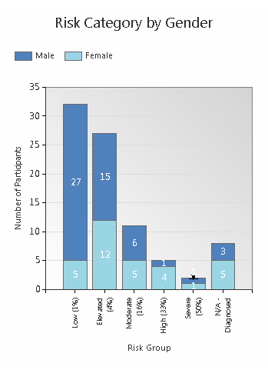 |  |  |  |  | 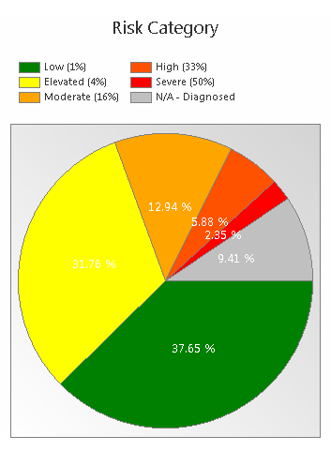
The Type 2 Diabetes Risk is the prediction of a participant's risk to develop type 2 diabetes in the next 10 years. Reference: ESC and EASD Guidelines 2007
Patients already diagnosed with diabetes are not included in the risk calculation, but are shown above in the n/a (not applicable) category.

The calculated risk predictions of the participants are directly related to their lifestyle.
The next step in reducing lifestyle risks and improving wellbeing is to make positive changes to lifestyle habits through participation in a lifestyle management programme.

  5 Year Cardiovascular Event Risk (Gaziano)
 |  | Gender
 |  | Female | Male | Total
Cardiovascular Event Risk | N/A | 14 | 17 | 31
Cardiovascular Event Risk | Low | 6 | 12 | 18
Cardiovascular Event Risk | Elevated | 8 | 16 | 24
Cardiovascular Event Risk | Moderate | 4 | 5 | 9
Cardiovascular Event Risk | High | 0 | 3 | 3
 |  | 32 | 53 | 85

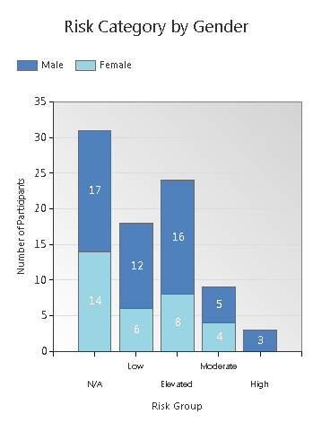 |  |  |  | 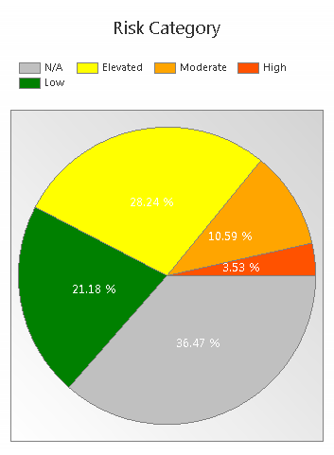
The Cardiovascular Event Risk is the prediction of a participant's risk to have a cardiovascular event in the next 5 years. Reference: Gaziano, TA, Lancet March 2008
The Gaziano risk stratification is limited to the following criteria:
Age between 35 and 74, BMI between 15 and 40, Systolic blood pressure between 111 and 180.
Participants not matching the criteria are shown above in the n/a (not applicable) category.

The calculated risk predictions of the participants are directly related to their lifestyle.
The next step in reducing lifestyle risks and improving wellbeing is to make positive changes to lifestyle habits through participation in a lifestyle management programme.

Summary

 |  |  | Gender |  | Total
 |  |  | Female | Male
Smoking |  | Non Smokers | 32 | 47 | 79 |  | 92.9 %
Smoking |  | Smokers | 0 | 6 | 6 |  | 7.1 %
BMI |  | Normal | 2 | 26 | 28 |  | 32.9 %
BMI |  | Overweight | 2 | 12 | 14 |  | 16.5 %
BMI |  | Obese I | 14 | 12 | 26 |  | 30.6 %
BMI |  | Obese II | 9 | 2 | 11 |  | 12.9 %
BMI |  | obese III | 5 | 1 | 6 |  | 7.1 %
Waist-Hip Ratio |  | Desired | 32 | 43 | 75 |  | 88.2 %
Waist-Hip Ratio |  | At Risk | 0 | 10 | 10 |  | 11.8 %
Blood Pressure |  | Acceptable | 26 | 41 | 67 |  | 78.8 %
Blood Pressure |  | Elevated | 6 | 10 | 16 |  | 18.8 %
Blood Pressure |  | Severe | 0 | 1 | 1 |  | 1.2 %
Blood Pressure |  | Acute | 0 | 1 | 1 |  | 1.2 %
Glucose |  | Acceptable | 27 | 51 | 78 |  | 91.8 %
Glucose |  | Elevated | 4 | 1 | 5 |  | 5.9 %
Glucose |  | Severe | 1 | 1 | 2 |  | 2.4 %
Cholesterol |  | Acceptable | 13 | 33 | 46 |  | 54.1 %
Cholesterol |  | Elevated | 19 | 20 | 39 |  | 45.9 %
Depression |  | Severe | 10 | 19 | 29 |  | 34.1 %
Depression |  | Acceptable | 22 | 34 | 56 |  | 65.9 %
Diabetes |  | na - diagnosed | 5 | 3 | 8 |  | 9.4 %
Diabetes |  | Low (1%) | 5 | 27 | 32 |  | 37.6 %
Diabetes |  | Elevated (4%) | 12 | 15 | 27 |  | 31.8 %
Diabetes |  | Moderate (16%) | 5 | 6 | 11 |  | 12.9 %
Diabetes |  | High (33%) | 4 | 1 | 5 |  | 5.9 %
Diabetes |  | Severe (50%) | 1 | 1 | 2 |  | 2.4 %
Cardio Event |  | N/A | 14 | 17 | 31 |  | 36.5 %
Cardio Event |  | Low | 6 | 12 | 18 |  | 21.2 %
Cardio Event |  | Elevated | 8 | 16 | 24 |  | 28.2 %
Cardio Event |  | Moderate | 4 | 5 | 9 |  | 10.6 %
Cardio Event |  | High | 0 | 3 | 3 |  | 3.5 %
 |  |  | 32 | 53 | 85

