***How it all transpired***

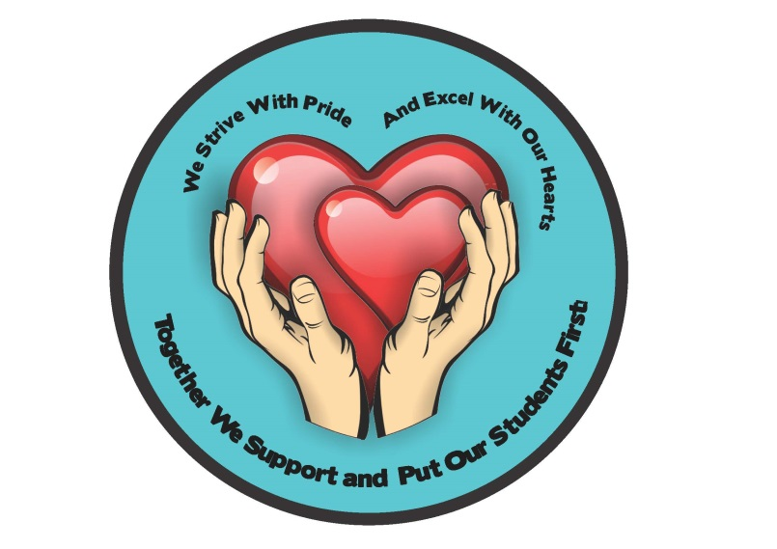

**Housekeeping Services** recognised a phenomenal aspect of formatting it own Vision and Mission Statement, by taking it to the grass route of the division which is the ‘**PEOPLE**’ or it Operational TEAM (STAFF).

The Division consist of various departments which share a common goal to serve and render support services to the University students and academic Departments. Throughout these goals, the division had to seat down and form a platform to point out and remind itself why the need for rendering these services and in the process recognise the importance of the divisions role.

The Division set out a task to its employees to nominate team members in groups, who will represent each and every department within Housekeeping Services, to play a unique role to **contribute their ideas** and thoughts in formulating the Vision and Mission Statement of the Division, that represent the day to day work that the Staff put in to make sure our clients are happy. The main aim of this exercise was to find the **one** common description of the division and be able to identify the Vision and Mission Statement of the division. This would not have been successful without the full participation of staff members of which the nominated groups reported too.

All departments within, ***Housekeeping Services which include, Residential Housekeeping, Central Cleaning Services, Laundry Services, Transit Housing, Janitoring Services, Upholstery and Sewing Services*** were committed in adopting KABAYASHI keys. All these departments were represented by groups nominated by all staff members within the division to voice out their devoted team work and dedication of striving to provide world class support to enable the excellence of the academic projects at Rhodes University.

Throughout these meetings between these groups, week after week, a lot of Values and Cultural diversity were recognised and promoting a culture of sound and professional work ethics and providing a conducive and sustainable environment for learning.

The passion and enthusiasm that came out from the staff members, by recognising the role which they have played in participating in this project, and making history as it is the most inspiring and motivating to be part of such a movement. The whole process brought in a lot of Ideas and thoughts which were shared in order to formulate one **VOICE** as a sign of ***unity***

The same method and ideology was also implemented to have the staff fully involved again through the process of designing the divisions’ **Smiley Badge’**, which would be the in-print and representation of the division and the definition of what the Infrastructure and operations team is all about. We had all the staff to design and draw an art form which best describe the Division. That would be a symbol to commemorate our functions and defines the inner ability of the Division. The smiley badge competition created a buzz within the staff members showing off their art skills and participate in this project, there was a lot off designs brought forward which were in line with the **vision and mission** of the Housekeeping Services lead to the short listing phase. The short listing phase was initiated to choose the best three designs which shined and to best represent the department, then the voting began.

The “Independent Electoral Commission” was implemented to have a smooth voting session for two consecutive days, which allowed all staff members to come in and vote for the best design the felt was best to represent our core functions of the division and close to heart. Each and every staff members from all parts of support services within the division were so excited to be part of this process and confident that the best design was chosen, to interpret the **Unity, diversity, commitment, team work**, **sound and professional work ethics.**

***TOGETHER WE SUPPORT WITH OUR HEARTS TO PUT OUR STUDENTS FIRST***

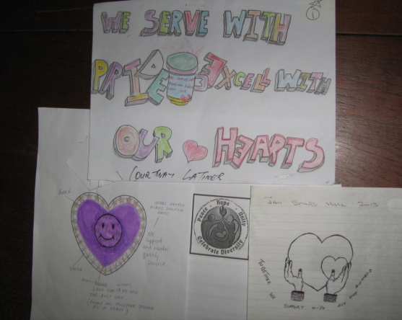

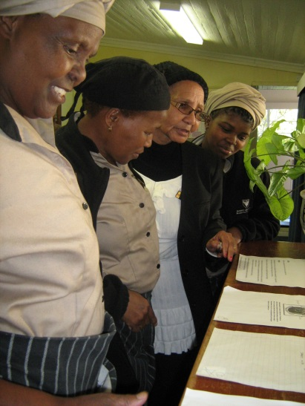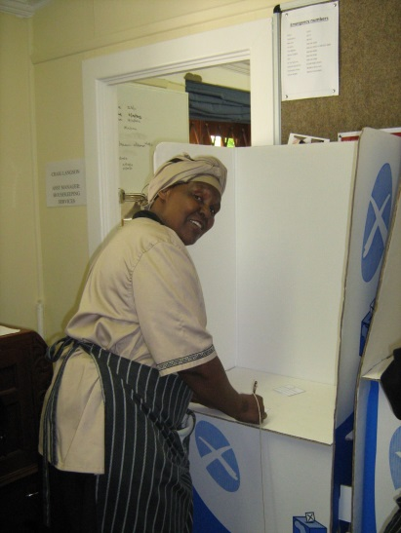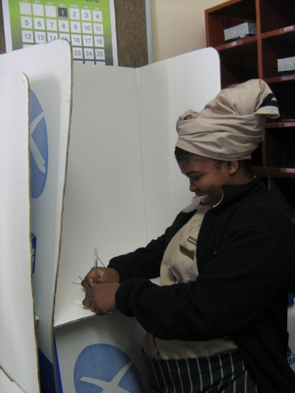

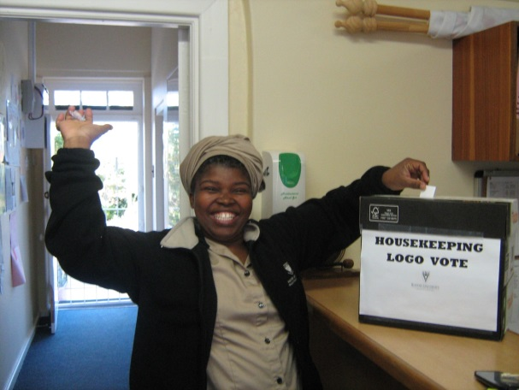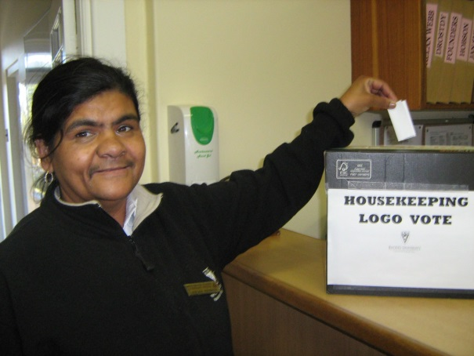

***And the winner is………… Designed by the staff of jan smuts hall.***

***well done!***

