SJMS Research Report: 2001 (condensed from original Rhodes University report)
https://www.ru.ac.za/media/rhodesuniversity/content/research/documents/research%20_report1%20_2001.pdf
PUBLICATIONS IN BOOK/MONOGRAPH FORM
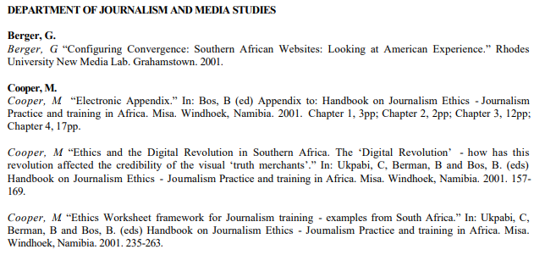
PUBLICATIONS IN RESEARCH JOURNALS IN FULL
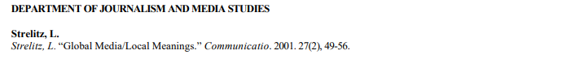
OTHER PUBLICATIONS/ARTICLES IN PERIODICALS INCLUDING BOOK REVIEWS, EDITORS OR JOURNALS AND BOOKS
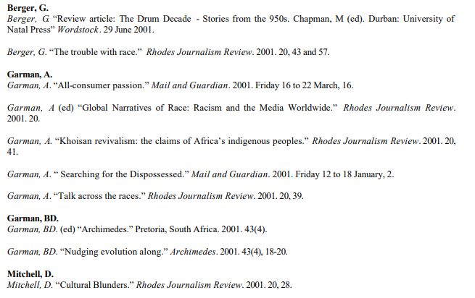
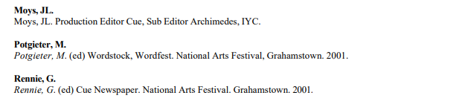
RESEARCH PAPERS PRESENTED AT ACADEMIC/SCIENTIFIC CONFERENCES BUT NOT PUBLISHED IN THE PROCEEDINGS
- Local Conferences (i.e. within South Africa)
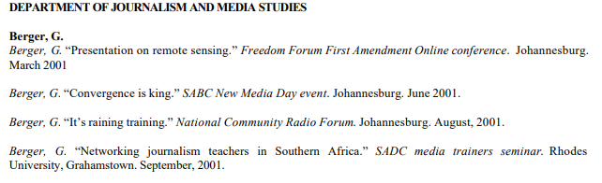
- International Conferences (i.e. outside South Africa)
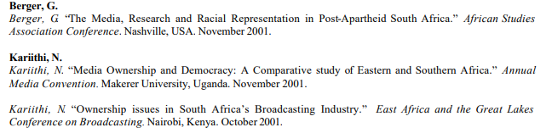
SCIENTIFIC OR SUBJECT CONFERENCES ATTENDED WITHOUT PRESENTING A PAPER
- Local Conferences (i.e. within South Africa)
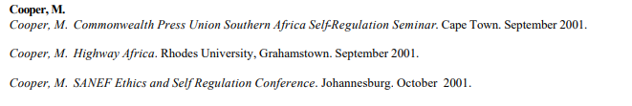
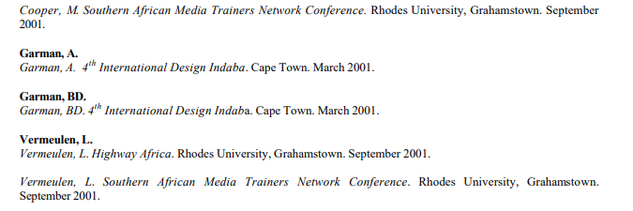
- International Conferences (i.e. outside South Africa)
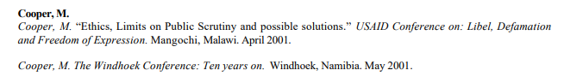
CONCERTS, EXHIBITIONS, PERFORMANCES AND WORKSHOPS
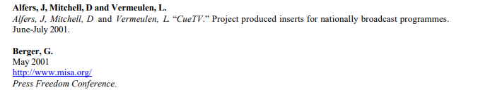
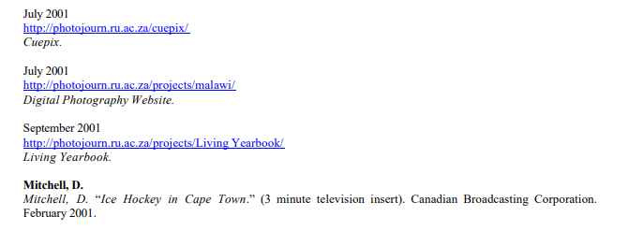
STAFF WHO PROCEEDED OVERSEAS FOR FURTHER STUDY AND/OR RESEARCH

DISTINGUISHED VISITORS TO THE DEPARTMENT
