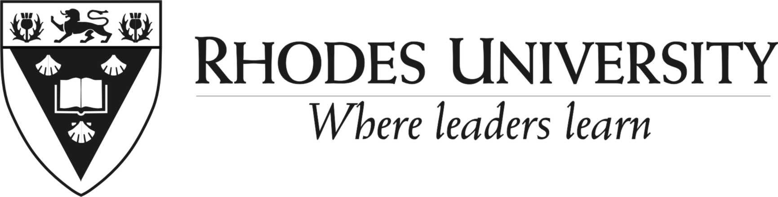

APPLICATION FOR STUDENT EMPLOYMENT IN THE LIBRARY FOR 2023
For purposes of the Employment Equity Act, please indicate if you are a member of the following groups:
Female /Male |  |  |  | African |  |  | Coloured |  |  | Chinese |  |  |  |  | Indian |  |  |  | Disabled
Title |  |  | First Names |  |  |  |  | Preferred Name |  |  |  |  |  |  |  | Surname
Nationality |  |  |  |  |  |  | If you are a foreign national what permits do you hold |  |  |  | Original date of issue |  |  |  |  | ID/Passport Number
Student  Number |  |  |  |  |  |  | Please note: The Department of Labour requires that students with a study permit may not work more than 20 hours per week.
Email Address |  |  |  |  |  |  |  |  |  |  |  | Cell phone
Contact Address
Please note: if your contact details change before you have been informed of the status of your application, please inform the Library at your earliest convenience

Highest qualification:
Are you currently studying at Rhodes? | Yes | No | Current Degree:  1st ,2nd 3rd year, other:
What degree are you registered for in 2022
Which Library job are you applying for?  (Please give a second choice) | 1st choice: |  |  |  | 2nd choice:
Work Experience:
Other qualifications attained:
Skills: Please list the skills and attributes you would like brought to the attention of the Library
Do you have any relatives who are currently employed at Rhodes University?
If so, please state name, relationship and relevant Department/Division/Institute.
Referees: Please provide the names and telephone numbers of 2 referees whom the University may consult:
Are you available for training during O-Week next year (2023)? |  |  |  | Please note that Library jobs involve working throughout the year.
Date form completed: |  |  |  | Do you believe that the customer is always right? |  |  | yes | no
Please note that  The Library reserves the right to check the accuracy of any information provided. Should it become apparent that information provided has been fabricated or deliberately altered; the applicant will forfeit their application. Furthermore, where it is found that a student has provided false information in the course of their application, their employment may be terminated;  It is in your best interests to complete this form as thoroughly as possible. | For Queries contact:  046 6038463 (Main Library)  046 6037250 (Law Library)  To Apply:  Please email your completed application form to j.nene@ru.ac.za  If you do not hear from us by the  30th October 2022, please consider your application unsuccessful. |  |  | Are you computer literate? |  |  | yes | no
 |  |  |  | Are you a Library user? |  |  | yes | no
 |  |  |  | Can you work during office hours? |  |  | yes | no
 |  |  |  | Can you work after office hours? |  |  | yes | no

