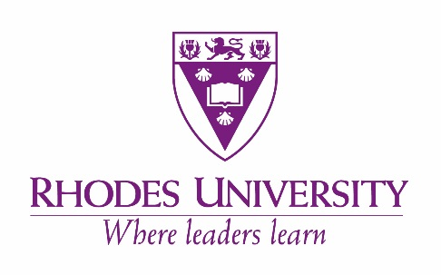

RHODES UNIVERSITY AFRICAN STUDIES CENTRE (RASC)
AFRICAN CLUSTER CENTRE DOCTORAL SCHOLARSHIPS 2020
in:
AFRICAN STUDIES

Sponsored by the German Research Foundation and through its collaboration with the University of Bayreuth, and three other African partners in the African Multiple Cluster system, the RASC seeks to advance the study of Africa and African diaspora by means of cutting edge original empirical research as well as theory-building based on new inter- and transdisciplinary research endeavours.

We welcome Doctoral students who will work closely with their supervisors to produce cutting edge researches that will bring new insights to our cross cutting themes such as: (1) Moralities; (2) Knowledges; (3) Arts and Aesthetics; (4) Mobilities; (5) Affiliations; and (6) Learning.

We are particularly interested in PhD students who will work within the following areas: African history and African politics; African Musicology; Languages and literature, including African Languages, English and Francophone literature (with special reference to multilingualism, African and African diaspora literature, translation and early African literary works); Arts and Aesthetics; African Philosophy as well as Water, environment and climatic change in Africa

Current Doctoral candidates with research projects which explore related themes, and particularly those whose supervisors are in the Cluster System are invited to apply for: a PhD scholarship (one year) in the first instance valued at R120 000 per annum. PhD students under this scholarship are expected to assist the supervisor with some of his/her research work and undertake some limited teaching related duties, where necessary.

Requirement: Applicants must be registered for a PhD at Rhodes University. For the 2020 intake, preference will be given to those candidates whose PhD research proposals have been approved by the Higher Degree Committee and are already doing their fieldwork, or are about to write up the thesis.

Programme Co-Ordinator: Professor Enocent Msindo, Director: RASC,
Rhodes University, Makhanda/Grahamstown, 6139

Applications will be accepted via ROSS, Rhodes’ Online Submission Engine and need to include:
1) a brief research proposal (1000 words) or an accepted research proposal from the Rhodes Higher Degree Committee;
2) CV with academic record; and
3) a recent sample of academic writing

The link to the ROSS application is: https://ru.infoready4.com/#competitionDetail/1799052

Closing Date for Applications: 30 November 2019. Where necessary, candidates may be shortlisted for a brief interview. The scholarship is for 2020.

