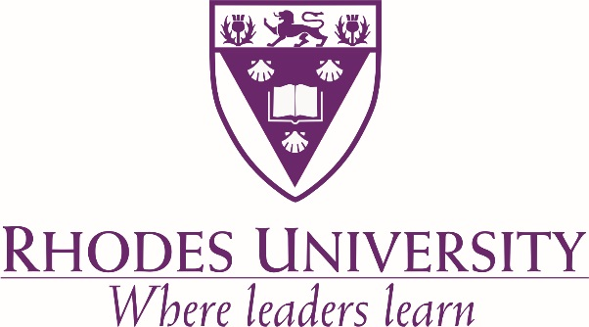

2017

Applications who meet the following criteria are eligible to apply:

South African citizenship;

Previously disadvantaged individuals, particularly females, may apply;

Must prove a financial need;

Area of Research: Environmental sustainability, such that it will make a positive impact on social development in South Africa.

**Rhodes University invites students with a strong academic record**

**(grades 70% and above) with a proven financial need, who intend pursuing**

**full-time Postgraduate studies**

**(Honours, Masters, PHD or Diplomas in all Faculties)**

**in 2016**

**at Rhodes University, to apply for the**

**Imraan & Simisha Elias Sustainability Bursary.**

Period: for one year only. Value of award: R3 000 Closing Date: 10 October 2016

**Closing date: 15 February 2014**

Application procedure:

Submit information on the proposed area of study, a detailed academic CV (including email contact details of three academic referees) and a full academic transcript. The completed application form needs to be emailed back to [pgfunding@ru.ac.za](mailto:pgfunding@ru.ac.za) before the closing date.

THE IMRAAN & SIMISHA ELIAS SUSTAINABILITY BURSARY