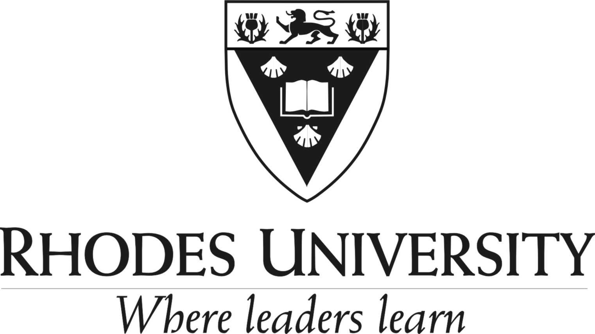

The Ada & Bertie Levenstein Bursary 2026
Closing: 30 July 2025

A generous bequest from the late Elias and Ada Levenstein has provided bursaries for postgraduate students at Rhodes University to study full time towards an Honours, Masters or Doctoral degree in any field of intellectual or creative endeavour at Rhodes University.

Eligibility:
The Ada & Bertie Levenstein Bursaries are tenable only at Rhodes University.

Applicants must be South African citizens under 26 years of age at the start of the first academic year for which they are seeking financial support. Funding for successive years may be granted to a candidate who is 26 or older.

The Ada & Bertie Levenstein Bursaries are open to students in all fields of study at Rhodes University. However, in accordance with the terms of the bequest, preference will be given to applicants “who pursue studies in the field of the sciences”.

Applicants must be able to demonstrate financial need. The academic achievements and merits of the students whose grades are “significantly above the average at university” will be considered. Should attain an average of 65% and above.

Application Process:
Applications will be called for by public advertisement and administered by the Rhodes University Postgraduate Funding: Research Office.

Candidates will be short listed using an application form, CV, academic transcript(s), SA ID document and short letter of motivation. Incomplete applications will be automatically regretted.

Short listed candidates will be assessed by a Committee comprising the Director of Research (Chair), Faculty Deans, Department Heads, and appropriate academic experts at the discretion of the Faculty Deans, and the final assessment may include referees reports or an interview.

Funding:
The Ada & Bertie Levenstein Bursaries will carry an award in the amount of R120 000 for a single year of academic support at Honours level, R120 000 for Masters and R130 000 for Doctoral studies. The value of the scholarship will be revised from time to time by the University with due regard to inflationary cost increases and the growth of the endowed funds. Funding in successive years in the case of Masters and Doctoral support will be contingent on good progress in the current year of funding, and the candidate being on track to complete the degree in the minimum expected time frame.

Expected outcomes:
An Ada & Bertie Levenstein Bursar is expected to complete and submit themselves for examination in all coursework and thesis components of their chosen degree field within the period of support. In addition, the candidate is expected to look carefully into the publication of any novel project work that comes out of the year of academic support, and to publish for the common good any novel research findings of the work undertaken under the support of the scholarship, either during or shortly after the scholarship period, in a scholarly journal.

All publications must acknowledge the financial support of the Ada & Bertie Levenstein Bursary, and must be published under full affiliation to Rhodes University.

