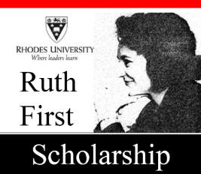

**Ruth First Scholarship 2026**

**Applications are now open for the Ruth First Scholarship for Doctoral or Masters studies at Rhodes University in 2026.**

The Ruth First Scholarship is intended to support candidates whose research is in the spirit of the life and work of Ruth First, whose research poses difficult social questions, and who are interested in linking knowledge and politics and scholarship and action.

**Eligible fields of study are:** politics, sociology, philosophy, anthropology, economics, social policy, democracy studies, development studies, media studies, or studies in cognate disciplines with a strong social and human rights focus. South African and Mozambican black and women candidates are particularly encouraged to apply.

**Value of award: PhD R130 000 per annum or R120 000 per annum for Masters.**

**Closing date:** 30 July 2025

[**Ruth First Booklet**](http://www.ru.ac.za/media/rhodesuniversity/content/research/documents/Ruth_First_Schol_booklet.pdf)

[**Ruth First Scholarship Application Process**](https://www.ru.ac.za/media/rhodesuniversity/content/research/documents/Ruth_First_Scholarship_Application_Process_2023.doc)

**PLEASE NOTE:** Submit a **SINGLE PDF document** clearly marked as your "**surname_RFirst_Schol.pdf"** no later than the closing date to:  [pgfunding@ru.ac.za](mailto:pgfunding@ru.ac.za)

E-mail: [pgfunding@ru.ac.za](mailto:pgfunding@ru.ac.za)   or Jaine Roberts ([j.roberts@ru.ac.za](mailto:j.roberts@ru.ac.za)) for enquiries.  
Tel: 046-603 8536/8755