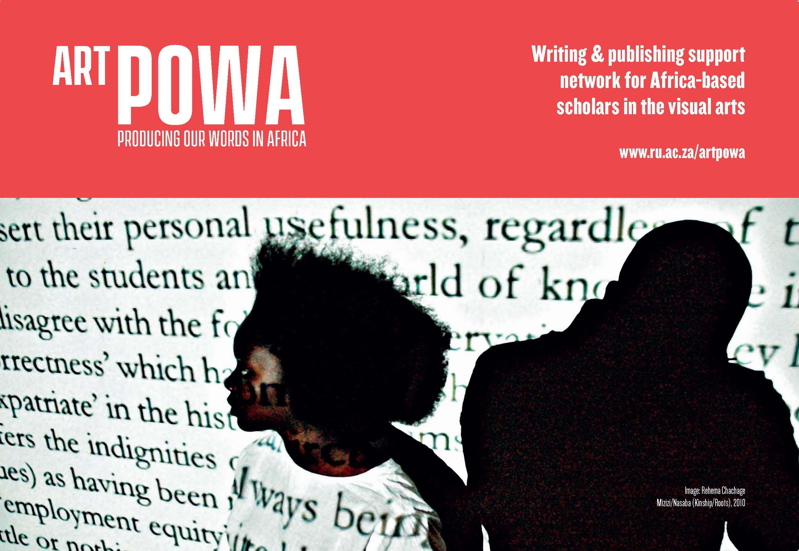

Membership Application Form
Please return to Shirley Kabwato (s.kabwato@ru.ac.za) as a Word document
Date of Application:

Family Name:

Other Name/s:

Contact address:

City of Residence:

Country of Residence:

Telephone:

Email Address:

Current Occupation (if applicable):

Institute of Affiliation (if applicable):

Website/s (if applicable):

Relevant Training/
Education:

Areas of Research Interest:

Publications:  We’d prefer you to list your publications in this document rather than send a separate attachment. | Please provide us with a full list of your relevant publications using the sample format below, and putting the latest dates at the top.  Please provide us with an online link when relevant. (Note that Art POWA complies with all copyright policies. As we develop resources we will include further information about copyright and open access).  Surname, Name. Year. “Article Title”. Journal Title volume (number), p.x-xx.  For example: Simbao, Ruth. 2016. “Infecting the City: Site-situational Performance and Ambulatory Hermeneutics”. Third Text 30 (1-2), p.1-26.  Surname, Name. Year. “Chapter Title”. Book Title volume. Edited by Surname, Initial. and Surname, Initial. p.x-xx.  Simbao, Ruth. 2015. “Walking into Africa in a Chinese Way: Hua Jiming's Mindful Entry as Counterbalance”. Afrique-Asie: Arts, espaces, pratiques. Edited by Malaquais, D. and Khouri, N. p.193-211.
Biography: | Please provide us with a biography (up to 350 words) written in the 3rd person that covers the following information where applicable: Affiliation, position, training/education, awards, research interests, highlights of publishing/curating etc.
Attachment:  (JPEG or TIFF, no PDFs please) | Please attach a recent and good quality portrait of yourself in a vertical format.

We’d be most grateful if you would assist us in building this support network by recommending other colleagues we could contact, and by sharing some journal information with us. Please fill in what you can below.

Recommended writers/scholars: | Name: | Email address:
Recommended Journals: | Journals that are relevant to Art, Culture, Heritage, Museums, Performance etc. but do not focus specifically on Africa | Relevant journals with a particular focus on Africa/African diaspora

CONSENT FORM:

Art POWA respects your right to choose to be affiliated with this writing and publishing support network, and you may ask for your information to be taken down from the website at any time.
Please could you provide us with permission to post information (provided in this form) on our Art POWA website (www.ru.ac.za/artpowa, currently under construction)? Note that we will not post information about “recommended colleagues” without their consent.
Please will you keep us updated whenever you change any of your details, or have a new publication to add? You can do this by emailing Shirley Kabwato (s.kabwato@ru.ac.za) with the subject heading: “Art POWA Updates”.

I, ___________________, give the Art POWA network consent to post the details I have provided on the Art POWA website (www.ru.ac.za/artpowa).

I agree to comply with copyright policies, and will acknowledge the Art POWA website when I reuse resources found on this site for teaching or public use.

___________________ ___________________
Signature Date

