Adding and subtracting
Nicky Roberts
- Adding and subtracting fit together
Whole-part-part diagram | Family of number sentences
12  8 4 | 8 + 4 = 12  4 + 8 = 12  12 – 4 = 8  12 – 8 = 4 | 12 = 8 + 4  12 = 4 + 8  8 = 12 – 4  4 = 12 – 8
- Four types of word problems
DYNAMIC MOVIE OR VIDEO | STATIC OR STILL PHOTO
Change increase  I have 8 apples. I am given some more apples. Now I have 12 apples.  start + change = result | Collection  I have some 12 apples. 8 are green, the rest are red. How many apples are red?  whole = part + part
Change decrease | Compare
I have 12 apples. My brothers and sisters ate some. Now there are 8 apples. How many apples were eaten? | I have 12 apples. You have 8 apples. How many more apples do I have than you?
start - change = result | whole = part + part

- Drawing adding and subtracting pictures
DYNAMIC MOVIE OR VIDEO | STATIC OR STILL PHOTO
7 – 5 = …  Start with 7 and take-away 5:  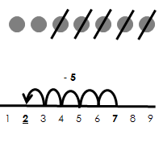  You are left with 2.  You land on 2.  The result is 2.  7 – 5 = 2 | 7 – 5 = … or 5 + … = 7  Compare 7 and 5:  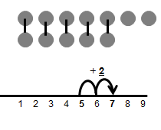  7 is 2 more than 5.  5 is 2 less than 7.  The difference between 5 and 7 is 2.  7 – 5 = 2

