Salute! Playing card game

Originally from Mike Askew

3 children work together as a group
Use a pack of cards with face cards removed
One is nominated as the captain, the other two are sailors.

- Captain gives each sailor one card each placing it face down in front of them - they don’t look at the cards
- Captain says: Salute!
- Sailors salute by lifting their card to their forehead. (So they can’t see their own card, but the other sailor and captain can see their card)
- Captain says: Together it is 11 (he/she must add the two cards)
- Sailors then call out what they have (without looking at their card)

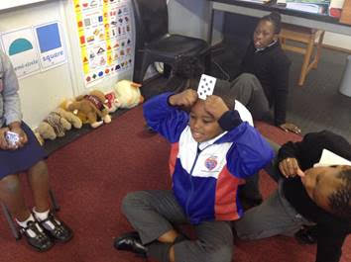
Salute: Sailors salute and put a card on their head. Captain says together it is 11. I can see partner has 3. So I have 8! (without looking at my card)

