SOCIOLOGY OF POPULAR CULTURE

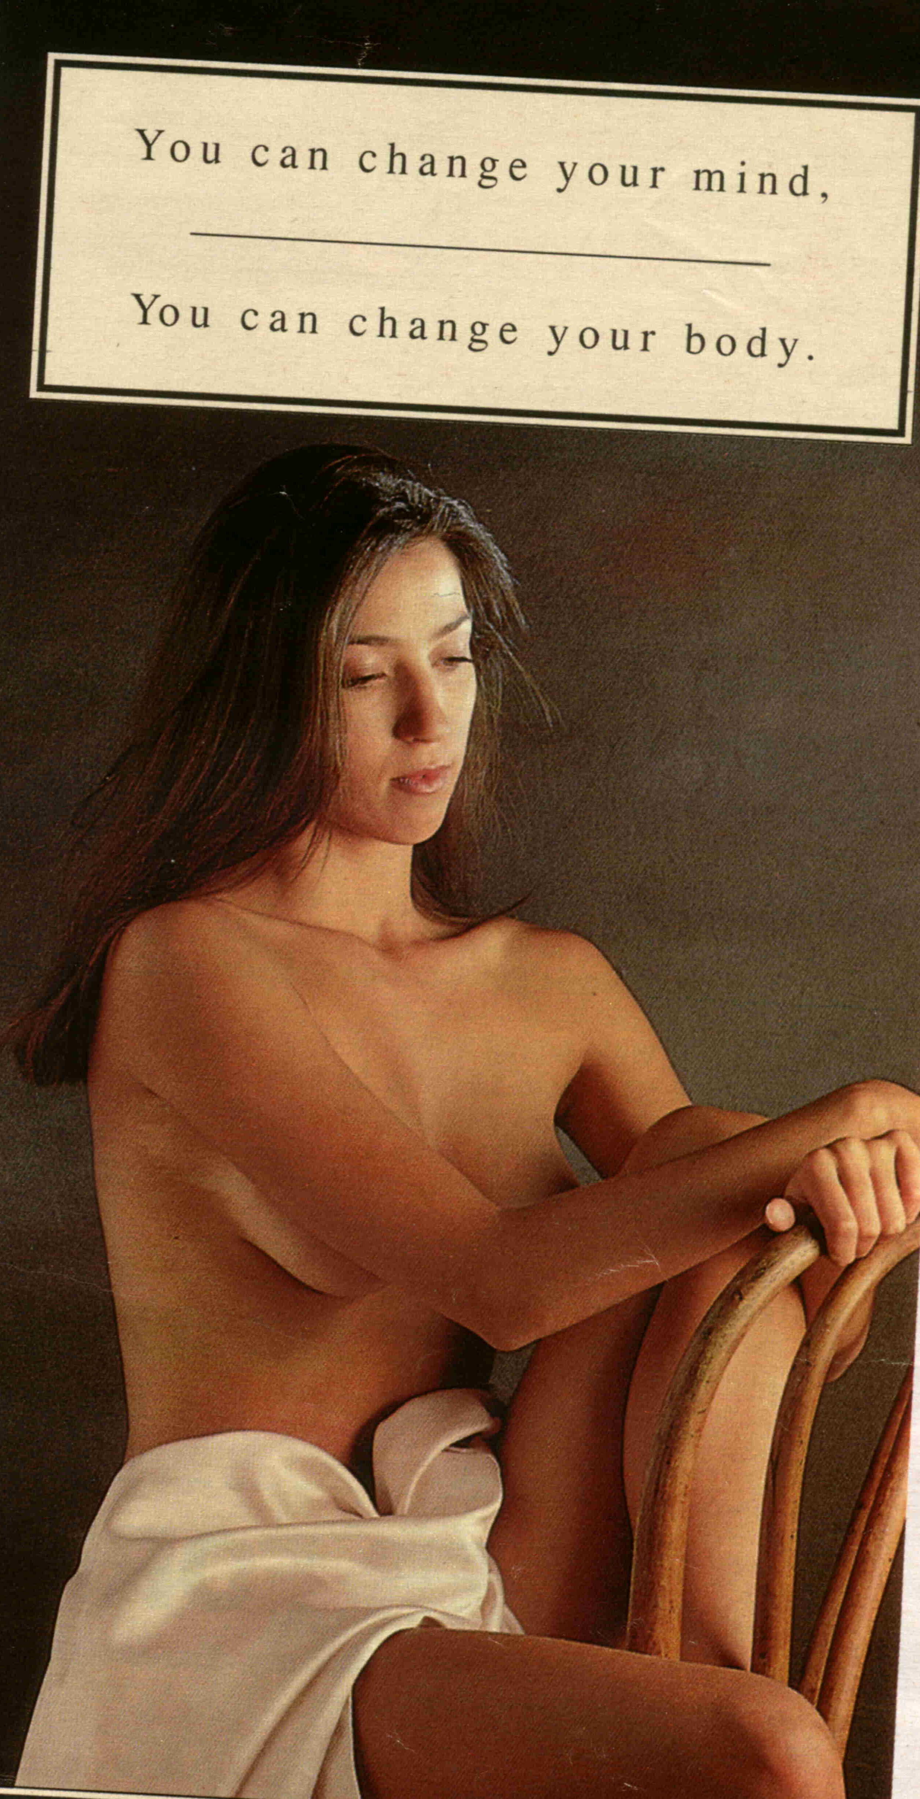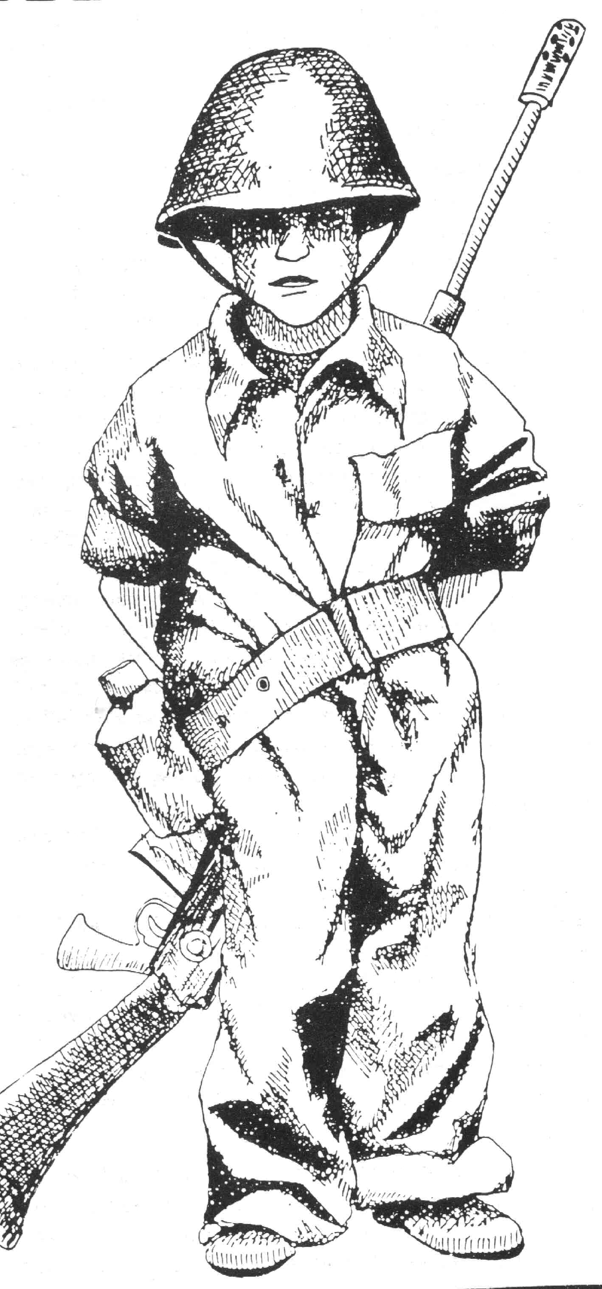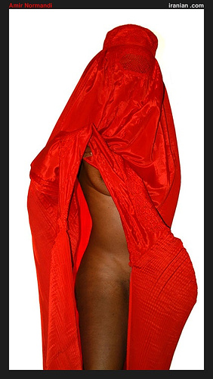

Rhodes University Department of Sociology
General Sociology III
Lecturer: Michael Drewett
2nd Term 2013

A: Introduction

Welcome to this course on the sociology of popular culture. The course will consider various areas of popular culture as a means to exploring social issues in modern day society. The course is divided into five themes, each of which runs for just over a week.

Theme One: Overview of cultural studies theory
We begin the course by considering cultural studies theory (giving special attention to sex, gender, race, ethnicity and class). The overview will be brief, but will act as a starting point to deeper theoretical exploration required when approaching various topical issues during the course. We will consider the evolution of the cultural studies tradition, focusing strongly on more recent post-Gramscian, post-colonial and feminist influences which have had a bearing on the direction of contemporary cultural studies enquiry.

- You will especially need to grasp the ideas of the Frankfurt School, British Cultural Studies and more recent post-Gramscian, post-colonial and feminist influences.

Theme Two: The body in popular culture
Our focus on themes in popular culture begins with an emphasis on bodies as cultural texts, drawing on work within the fields of feminism and post-colonialism. Starting with a consideration of the clothing/nudity binary we explore two conceptual extremes: that cultures make identity or reflect identity. This will provide a useful foundation for considering representations of firstly, masculinity and femininity, and secondly, ‘the west and the rest’, in the media generally. We will especially contemplate attempts to overcome binary approaches to representation.

- You will need to develop an understanding of the cultural significance of human bodies, whether adorned or unadorned. An understanding of Foucault’s notion of the docile body as a cultural text is needed. A grasp of Fanon’s arguments about race, identity and representation in colonial contexts is also essential, together with an overall sense of the feminist and post-colonial arguments influenced by the aforementioned theories. Importantly, you need to grasp the limitations of conceptions based on binary views of sex and race and be able to supersede these with more complex explanations.

Theme Three: The gaze within popular culture
Leading from a focus on the body in popular culture the course narrows the focus on bodies to a study of the gaze. An appropriate starting point for this section is Laura Mulvey’s notion of the male gaze within film narratives. Mulvey’s approach fits broadly into a radical feminist perspective and we consider the merits and problems of her viewpoint, exploring more complex approaches to the gaze, not only in relation to gendered bodies. We develop the notion of the gaze by applying it to the growth of surveillance in modern day society. Michel Foucault’s ideas about surveillance are especially used to inform our ideas about such surveillance trends in our society. We consider dominant modes of masculinity, femininity, sexuality, ethnicity and adornment. We also consider forms of resistance to dominant modes of body representations. We contemplate the extent to which attempts at transgression constitute a threat to the dominant order or are mere alternatives which offer little prospect of change.

- It is important that you have a grasp of what is meant by the ‘male gaze’ and ‘female gaze’ and the difference between the two concepts. You will also need to apply theories of the gaze to race and ethnicity, including the colonial context and in turn apply these to examples within film and advertising. By the end of this section you should also have a grasp of the conformist pressures which exist in our society, how these affect us, and some of the alternatives available to us. You should also have considered why some people embrace these alternatives, and the possibility they hold for a different way of being.

Theme Four: Resistance in Popular Music
Feminists have long criticised the male-oriented and dominated nature of popular music, resulting in most music providing a male soundtrack to people’s lives, most aptly described by some feminists as ‘cock rock’. This section of the course begins by examining the arguments of those who say that popular music is generally sexist, but quickly moves on to more intricate arguments about women musicians’ response to this issue. What has been the history of women musicians’ response to sexism within the industry and has the situation improved? Is there a way women should or should not present themselves? Furthermore, bell hooks has argued that the focus on sexism and misogyny within rap music has tended to be racist. This further complicates our exploration of sexism in music. We end this section by considering the manner in which black male rappers have increasingly become the targets of feminists, the media and moral entrepreneurs when in fact the problem of sexism in the music industry is far more complex. Third World and Black feminist arguments about the western-centric bias of traditional feminists perspectives are drawn upon to add depth to this exploration.

- For this section you will need to have a grasp of the arguments which expose the sexist nature of much of popular music. You will also require knowledge of the social history of men and women in popular music and be able to evaluate responses by women musicians who have confronted sexism within the popular music industry on different levels. You will also need to grasp the intersection of sex, gender, ethnicity and race in arguments about sexism in the music industry. You will need to be able to refer to relevant examples of musicians and their music, videos, performances and other actions to support your argument.

Theme Five: Reinforcing militarized masculinity through popular culture
In this section our focus turns to representations of militarised masculinity and femininity in South African popular culture and media more generally during the apartheid era. We will also refer to global examples to connect the local to the global. We consider the implications of militarization and conscription for theories about gender oppression.

- By the end of this section you need to understand the dynamics surrounding conscription in apartheid-era South Africa and in relation to the United States’ involvement in the Vietnam War. Importantly, you should understand the way in which support for the military was constituted in strong gender terms. You should also be able to demonstrate that opposition to the military often undermined a heterosexist gender binary approach.

B: Lectures and seminars

The course will generally operate on a lecture basis, although sometimes alternatives will be arranged. These will be announced in lectures and by e-mail.

C: Recommended readings

Theme One: Overview of Cultural Studies Theory

Ashcroft, B. and Ahluwalia, P. 1999. Edward Said: The Paradox of Identity. Chapter 3.
London: Routledge.
Barker, C. 2000. Cultural Studies: Theory and Practice. Chapters 1 and 8. London: Sage.
Best, B. 1997. “Over-the counter-culture: retheorizing resistance in popular culture” in
Redhead, S. et. al. (eds) The Clubcultures Reader: Readings in Popular Culture Studies. Oxford: Blackwell.
Gill, R. 2007. Gender and the Media. Chapters 1, 2. Cambridge: Polity Press.
Hall, S. 1992. “The west and the rest: discourse and power” in Hall, S. and Gieben, B.
Formations of Modernity. Cambridge: Polity Press.
Kellner, D. 1995. Media Culture. Chapter 1. London: Routledge.
Kellner, D. 1995. “Cultural studies, multiculturalism and media culture” in Dines, G. and
Humez, J. (eds) Gender, Race and Class in Media: A Reader. California: Sage Publications.
Lewis, J. 2002. Cultural Studies: The Basics. Chapters 3, 4, 6 and 9. London: Sage.
Mama, A. 1997. “Shedding the masks and tearing the veils: cultural studies for a post-
colonial Africa” in Imam, A. et. al. (eds) Engendering African Social Sciences. Dakar: CODESRIA.

McNair, B, 2002. Striptease Culture: Sex, Media and the Democratization of Desire.
Chapter 1. London: Routledge.
Morley, D. et. al. 1998. Spaces of Identity: Global Media, Electronic Landscapes,
and Cultural Boundaries. London: Routledge.
Noyes, J. 2000. “The Place of the Human” in Nuttall, S. and Michael, C. (eds) Senses of
Culture: South African Cultural Studies. Cape Town: Oxford University Press.
Rojek, C. 2007. Cultural Studies. Chapters 1, 3, 4, 5, 6, 7, 10. London: Routledge.
Said, E. 1995. Orientalism. Chapter One. London: Penguin.
Strinati, D. 1995. An Introduction to Theories of Popular Culture. London:
Routledge.
Thornton, R. 2000. “Finding Culture” in Nuttall, S. and Michael, C. (eds) Senses of
Culture: South African Cultural Studies. Cape Town: Oxford University Press.
Turner, G. 1990. British Cultural Studies: An Introduction. Chapters 1 and 2. New York:
Routledge.

Theme Two: The Body in Popular Culture

Appiah, K. 1992. In My Father’s House: Africa in the Philosophy of Culture.
London: Methuen.
Barnard, R. 2000. “Contested Beauty” in Nuttall, S. and Michael, C. (eds) Senses of
Culture: South African Cultural Studies. Cape Town: Oxford University Press.
Bartky, S. 1993. “The feminine body” in Jaggar, A. and Rothenberg, P. (eds) Feminist
Frameworks. New York: McGraw-Hill.
Bartky, S. 1997. “Foucault, femininity and the modernization of patriarchal power” in
Conboy, K. et. al. (eds) Writing on the Body: Female Embodiment and Feminist Theory. New York: Columbia University Press.
Bell, D. and Holliday, R. “Naked as nature intended”. Body and Society. Volume 6
Numbers 3 and 4.
Bordo, S. 1997. “The body and the reproduction of femininity” in Conboy, K. et.
al. (eds.) Writing on the Body: Female Embodiment and Feminist Theory. New York: Columbia.
Buszek, M. 2006. Pin-up Grrrls: Feminism, Sexuality, Popular Culture. Chapters 7 and
8. Durham: Duke University Press.
Cover, R. 2003. “The naked subject: nudity, context and sexualization in contemporary
culture”. Body and Society. Volume 9 Number 3.
Erasmus, Z. 2000. “Hair Politics” in Nuttall, Sarah and Michael, Cheryl-Ann (eds)
Senses of Culture: South African Cultural Studies. Cape Town: Oxford University Press.
Ekins, R and King, D. 2001. “Telling body transgendering stories” in Backett-Milburn,
K. and McKie, L. (eds) Constructing Gendered Bodies. Basingstoke: Palgrave.
Entwistle, J. 2000. The Fashioned Body: Fashion, Dress and Modern Social Theory.
Chapter 1. Cambridge: Polity Press.
Fanon, F. 1967. Black Skin, White Masks. New York: Grove Press.
Gill, R. 2007. Gender and the Media. Chapter 8. Cambridge: Polity Press.
Greenway, J. 1997. “Twenty-first century sex” in Purkis, J. and Bowen, J. (eds) Twenty-
First Century Anarchism. London: Cassell.
Hall, S. 1997. “The spectacle of the ‘other’” in Hall, S. (Ed.) Representation:
Cultural Representations and Signifying Practices. London: Sage.
Hancock, P. et. al. 2000. The Body, Culture and Society. Buckingham: Open University
Press.
Howson, A. 2004. The Body in Society: An Introduction. Chapters 4 and 5. Cambridge:
Polity.
Kanneh, K. 1995. “Feminism and the colonial body” in Ashcroft, B. et. al.
(eds) The Post-Colonial Studies Reader. London: Routledge.
Lewis, J. 2002. Cultural Studies: The Basics. Chapter 9. London: Sage.
Macdonald, M. 1995. Representing Women: Myths of Femininity in the Popular
Media. London: Edward Arnold.
Mama, A. 1997. “Shedding the masks and tearing the veils: Cultural Studies for a
Post-Colonial Africa” in Imam, A. et. al. (eds) Engendering African Social Sciences. Dakar: CODESRIA.
Mayer, V. 2007. “Letting it all hang out: mardi gras performances live and on video”.
TDR Volume 51 Number 2.

McNair, B, 2002. Striptease Culture: Sex, Media and the Democratization of Desire.
(Chapters 9, 10). London: Routledge.
Mereer, K. 1987. “Black hair/style politics”. New Formations. Number 3, Winter.
Parkins, W. 2000. “Protesting like a girl: embodiment, dissent and feminist agency”.
Feminist Theory. Volume 1 Number 1.
Peplau, L. and Gordon, S. 1983. “The intimate relationships of lesbians and gay men” in
Rice Allgeier, E. and McCormick, N. Changing Boundaries: Gender Roles and Sexual Behaviour. California: Mayfield.
Poster, M. 1984. Foucault, Marxism and History. Chapter 4. Cambridge: Polity Press.
Sasson-Levy, O. and Rapoport, T. 2003. “Body, gender, and knowledge in protest
movements” The Israeli case”. Gender and Society. Volume 17 Number 3.
Souweine, I. 2005. “Naked protest and the politics of personalism”. Sarai Reader 2005:
Bare Acts.
Sutton, B. 2007. “Naked protest: memories of bodies and resistance at the World Social
Forums”. Journal of International Women’s Studies. Volume 8 Number 3.
Weitz, R. 2003. “Women and their hair: seeking power through resistance and
accommodation” in Weitz, R. (ed) The Politics of Women’s Bodies Sexuality, Appearance and Behavior. New York: Oxford University Press.
Williamson, J. 1996. “Woman is an island: femininity and colonisation” in Baehr, H.
and Gray, A. (eds) Turning it on. London: Arnold.

Theme Three: The Gaze Within Popular Culture

Albrechtslund, A and Dubbeld, L. 2005. “The plays and arts of surveillance: studying
surveillance as entertainment”. Surveillance and Society. Volume 3 Numbers 2 and 3.
Bartky, S. L. 1990. Femininity and Domination: Studies in the Phenomenology of
Oppression. London: Routledge.
Bell, D. 2009. “Surveillance is sexy”. Surveillance and Society. Volume 6 Number 3.
Blood, S. K. 2005. Body Work: The Social Construction of Women’s Body Image. New
York: Routledge.
Bloom, L. 1999. “Introducing with other eyes: looking at race and gender in visual
culture” in Bloom, L. (ed) With Other Eyes: Looking at Race and Gender in Visual Culture. Minneapolis: University of Minnesota Press.
Bordo, S. 2004. Unbearable Weight: Feminism, Western Culture, and the Body.
California: University of California University Press.
Doane, M. 1997. “Film and the masquerade: theorising the female spectator” in Conboy,
K. et. al. (eds) Writing on the Body: Female Embodiment and Feminist Theory. New York: Columbia University Press.
Fanon, F. 1967. Black Skin, White Masks. New York: Grove Press.
Gamman, L. 1989. “Watching the detectives: the enigma of the female gaze” in
Gamman, L. and Marshment, M. (eds) The Female Gaze: Women as Viewers of Popular Culture. Seattle: The Real Comet Press.
Gill, R. 2007. Gender and the Media. Chapters 3, 6. Cambridge: Polity Press.
Geenway, J & Nadeau, M. 2010. Art & Copy [videorecording]. An Art & Industry and
Granite Pass production. United States: PBS Distributions.
Hall, S. 1992. “The west and the rest: discourse and power” in Hall, S. and Gieben, B.
Formations of Modernity. Cambridge: Polity Press.
Harris, A. & Fine, M. 2004. All About the Girl: Culture, Power, and Identity. New
York: Routledge.
Hollows, J. & Moseley, R. Feminism in Popular Culture. New York: Berg.
Jhally, S. 2010. Killing us Softly 4 [videorecording]: Advertising’s Image of Women.
Northampton, MA: Media Education Foundation.
Knight, B. 2000. “Watch me! Webcams and the public exposure of private lives”. Art
Journal. Volume 59 Number 4.
Koskela, H. 2003. “’Cam era’ – the contemporary urban panopticon”. Surveillance and
Society. Volume 1 Number 3.
Koskela, H. 2004. “Webcams, TV shows and mobile phones: empowering
exhibitionism”. Surveillance and Society. Volume 2 Numbers 2 and 3.
Lehman, P. 2007. “You and voyeurweb: illustrating the shifting representation of the
penis on the internet with user-generated content”. Cinema Journal. Volume 46, Number 4.
Lumby, C. 1997. Bad Girls: The Media, Sex and Feminism in the ’90s. Chapter 1. St.
Leonards: Allen & Unwin.
Macdonald, M. 1995. Representing Women: Myths of Femininity in the Popular
Media. Chapters 2 and 7. London: Edward Arnold.
McNair, B, 2002. Striptease Culture: Sex, Media and the Democratization of Desire.
Chapters 5, 6. London: Routledge.
Modleski, T. 1997. “Cinema and the dark continent” in Conboy, K. et. al. (eds) Writing
on the Body: Female Embodiment and Feminist Theory. New York: Columbia University Press.
Moore, S. 1989. “Here’s looking at you, kid!” in Gamman, L. and Marshment, M. (eds)
The Female Gaze: Women as Viewers of Popular Culture. Seattle: The Real Comet Press.
Mulvey, L. 1975. “Visual pleasure and narrative cinema” in Screen Volume 16 Number
3.
Mulvey, L. 1989. Visual and Other Pleasure. Indiana: University Press.
Stacey, J. 1989. “Desperately seeking difference” in Gamman, L. and Marshment, M.
(eds) The Female Gaze: Women as Viewers of Popular Culture. Seattle: The Real Comet Press.
Van Zoonen, L. 1994. “Spectatorship and gaze” in Feminist Media Studies. London:
Sage.
Whiting, C. 1997. A Taste for Pop: Pop Art, Gender, and Consumer Culture. New
York: Cambridge University Press.
Wolf, N. 1991. The Beauty Myth: How Images of Beauty are Used Against Women.
New York: Morrow.
Young, Robert. 1990. White Mythologies. London: Routledge.
Young, S. 1989. “Feminism and the politics of power: whose gaze is it anyway?” in
Gamman, L. and Marshment, M. (eds) The Female Gaze: Women as Viewers of Popular Culture. Seattle: The Real Comet Press.

Theme Four: Resistance in Popular Music

Bannister, M. 2006. White Boys, White Noise: Masculinities and 1980s Indies Guitar
Rock. London: Ashgate.
Bayton, M. 1998. Frock Rock: Women Performing Rock Music. Chapter One. Oxford:
Oxford University Press.
Buszek, M. 2006. Pin-up Grrrls: Feminism, Sexuality, Popular Culture. Chapters 7 and
8. Durham: Duke University Press.
Case, S. 2002. “The emperor’s new clothes: the naked body and theories of
performance”. Substance. Volume 31 Numbers 2 and 3.
Coates, N. 1997. “(R)Evolution now: Rock and the political potential of gender” in
Whitely, S. (ed) Sexing the Groove: Popular Music and Gender. London: Routledge.
Eileraas, K. 1997. “Witches, bitches & fluids: girl bands performing ugliness as
resistance”. The Drama Review. Volume 41, Number 3.
Emerson, R. 2002. “’Where are my girls at?’ Negotiating black womanhood in music
videos”. Gender and Society. Volume 16 Number 1.
Gaar, G. 1992. She’s a rebel: The History of Women in Rock & Roll. Seattle: Seal
Press.
Haupt, A. 2001. “Black thing: hip-hop nationalism, ‘race’ and gender in Prophets of da
City and Brasse vannie Kaap” in Erasmus, Z. (ed.) Coloured By History: Shaped By Place. Cape Town: Kwela Books.
Haupt, A. 2003. “Hip-hop in the age of empire: Cape Flats style” in Pieterse, E. and
Meintjies, F. (eds) Voices of the Transition: The Politics, Poetics and Practices of Social Change in South Africa. Sandown: Heinemann.
Hooks, B. 1994. Outlaw Culture: Resisting Representations. Chapter 11. New York:
Routledge.
Impey, A. 2001. “Resurrecting the flesh? Reflections on women in kwaito”. AGENDA
No 49.
Iudicello, K. 2002. “‘See, I’ve got my tit out’: women’s performance art and punk rock”
in Brewer, M. (ed). Exclusions in Feminist Thought: Challenging the Boundaries
of Womanhood. Brighton: Sussex Academic Press.
Keyes, C. 2000. “Empowering self, making choices, creating spaces: black female
identity via rap music performance”. Journal of American Folklore. Volume 113.
Kolawole, H. 1996. “Sisters take the rap … but talk back” in Cooper, S. (ed) Girls!
Girls! Girls!: Essays on Women and Music. New York: New York University Press.
Leonard, M. 1997. “‘Rebel girl, you are the queen of my world’: feminism ‘subculture’
and grrrl power” in Whitely, S. (ed) Sexing the Groove: Popular Music and
Gender. London: Routledge.
Mackenny, V. 2001. “Post-apartheid performance art as a site of gender resistance”.
AGENDA. Number 49.
Marcus, S. 2010. Girls to the Front: The True Story of the Riot Grrrl Revolution. New
York: Harper.
McCarthy, K. 2006. “Not pretty girls?: sexuality, spirituality, and gender construction in
women’s rock music” in The Journal of Popular Culture Volume 39, Number 1.
Meltzer, M. 2010. Girl Power: The Nineties Revolution in Music. New York: Faber and
Faber.
O’Brein, L. 2002. She Bop II: The Definitive History of Women I Rock, Pop and
Soul. London: Continuum.
Raha, M. 2005. Cinderella’s Big Score: Women of the Punk and Indie Underground.
Introduction. Emeryville: Seal Press.
Raphael, A. 1994. Grrrls: Viva Rock Divas. “Introduction”. New York: St. Martin’s
Griffin.
Schilt, K. 2003. “’A little too ironic’: the appropriation and packaging of riot grrrl
politics by mainstream female musicians”. Popular Music and Society. Volume 26 Number 1.
Stephens, S. 2000. “Kwaito” in Nuttall, S. and Michael, C. (eds) Senses of Culture:
South African Cultural Studies. Cape Town: Oxford University Press.
Wald, G. 1998. “Just a girl? Rock music, feminism, and the cultural construction of
female youth”. Signs: Journal of Women and Culture in Society. Volume 23 Number 3.
Woldu, G. 2006. “Gender as anomaly: women in rap” in The Resisting Muse: Popular
Music and Social Protest. London: Ashgate.

Theme Five: Reinforcing Militarized Masculinity Through Popular Culture

Cock, J. 1991.Colonels and Cadres: War and Gender in South Africa. Chapters 3 and 6.
Cape Town: Oxford University Press.
Cohn, C. 1993. “War, wimps and women: talking gender and thinking war” in Cooke, M.
and Woollacott, A. (eds) Gendering War Talk. Princeton: Princeton University Press.
Cooke, M. 1993. “Wo-man, retelling the war myth” in Cooke, M. and Woollacott, A.
(eds) Gendering War Talk. Princeton: Princeton University Press.
Cooke, M. and Woollacott, A. 1993. “Introduction” in Cooke, M. and Woollacott, A.
(eds) Gendering War Talk. Princeton: Princeton University Press.
Drewett, M. 2003. “Battling over borders: narratives of resistance to the South African
border war voiced through popular music”. Social Dynamics Volume 29. No 1.
Drewett, M. 2007. “The construction and subversion of gender stereotypes in popular
cultural representations of the border war” in Baines, G. and Vale, P. (eds). Beyond the Border War. Pretoria: UNISA Press.
Enloe,C. 1983. Does Khaki Become You? The Militarization of Women’s Lives.
Chapter 8. Boston: South End Press.
Foucault, M. 1977. Discipline and Punish. London: Penguin.
Hearn, J. 1987. The Gender of Oppression: Men, Masculinity and the Critique of
Marxism. Chapter 5. Sussex: Wheatsheaf.
Hopkins, P. 1992. “Gender treachery: homophobia, masculinity and threatened identities”
in May, L. and Strikwerda, R. (eds) Rethinking Masculinity. Maryland: Littlefield.
Jacobson, R. et. al. “Introduction: states of conflict” in Jacobs, S. 2000. States of
Conflict: Gender, Violence and Resistance. London: Zed Books.
LaFollette, H. 1992. “Real men” in May, L. and Strikwerda, R. (eds) Rethinking
Masculinity. Maryland: Littlefield Adams.
Maitse, T. 2000. “Revealing silences: voices from South Africa” in Jacobs, S. 2000.
States of Conflict: Gender, Violence and Resistance. London: Zed Books.
Morgan, D. 1993. “You too can have a body like mine: reflections on the male body and
masculinities” in Scott, S. and Morgan, D. (eds) Body Matters: Essays on the Sociology of the Body. London: Falmer Press.
Morrell, R. 2001. ‘The times of change: men and masculinity in South Africa’ in Morrell,
R. (Ed) Changing Men in Southern Africa. New York: Zed Books.

D: Term Essay Assignment

There will also be a formal essay which will contribute towards your year mark. Your essay must be between 2000 and 2500 words (excluding appendixes and lyrics if applicable). Essays must be typed and submitted by 15h00 on Tuesday 21st May.

You need to check the essay guidelines in the Department of Sociology Handout Number 1 and especially take note of the regulations concerning plagiarism and attach a signed copy of the stipulated form regarding plagiarism to the front of your essay. All essays MUST be placed in the General Sociology III essay box prior to the above deadline.

Essay Topics

- Critically compare and contrast the Frankfurt School and British Cultural Studies approaches to cultural studies.
- Provide a critical evaluation of the contribution of feminism to cultural studies.
- Provide a theoretically informed and critical discussion of ‘hair’ as an issue in cultural politics.
- To what extent do theories of gendered and postcolonial gazes converge? Provide a critical discussion.
- Michel Foucault argues that visibility is a trap, yet Judy Greenway argues that visibility is crucial to sex/gender activism. How do you resolve this seeming contradiction?
- Critically assess the use of the human body as a form of popular cultural political resistance.
- Provide a critical overview of Laura Mulvey’s theory of the male gaze, paying attention to attempts by later theorists to overcome earlier criticisms.
- Reality television, web cameras and mobile phone and other cameras have created a context in which surveillance and voyeurism have become a form of entertainment and pleasure. Is this problematic? Provide a critical discussion.
- Some feminists would argue that women musicians such as Courtney Love (of Hole), Tribe 8, Rockbitch, Diamanda Galas and Zia McCabe (of the Dandy Warhols) cater for a male gaze when they weave nudity into their stage performances and that male musicians such as Iggy Pop, G G Allen, Flea (of the Red Hot Chilli Peppers) and Half Price do so in order to flaunt their masculinity. Is there a way out of this binary conception of performance? Provide a critical discussion.
- What potential exists for feminist resistance to sexism within popular music? Provide a critical discussion, using examples (such as lyrics, photographs, video, music and historical incidents) to support your answer.
- Provide a critical discussion of the way in which popular music was used to support and resist hegemonic notions of gender and patriotism relating to the Vietnam and South African border wars.

