State and Society/Political Sociology 2013
Department of Sociology
Third Year
Rhodes University
Fourth Term
Course Overview

Instructor: Tarryn Alexander
Phone: (046) 603-8930
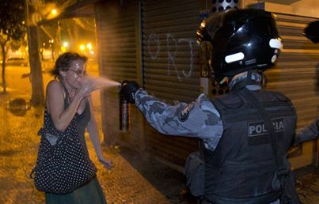
Email: t.alexander@ru.ac.za


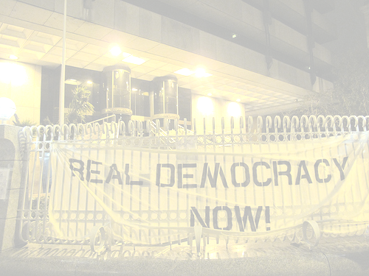
Section One:
Social Movement Theory
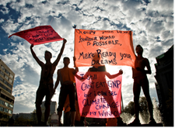


Section Two:
Feminist Theory




Revolution is not 'showing' life to people, but making them live. A revolutionary organization must always remember that its objective is not getting its adherents to listen to convincing talks by expert leaders, but getting them to speak for themselves, in order to achieve, or at least strive toward, an equal degree of participation.
- Guy Debord (1967)

To defy and exceed the system’s insistence that its own limits be taken as the limits of the possible is to rediscover the explosive potential of utopia –
Robinson and Tormey (2009)

The State and Society/Political Sociology course will run from 9 September 2013- 25 October 2013.
This is a course for thinking ‘radical social change’ – as concept, as praxis and ultimately as a question which confronts every person, generation and society about their power to create new social and political realities. Is there such a thing as collective power? Is it possible to harness this power - through thought and action – in order to make a better, freer and more humane society thinkable and liveable?
In this course you are invited to explore ideas of social transformation from the perspectives of social movement theory and feminist theory.

- Prescribed readings for the various themes will be made available prior to lectures on RU Connected / Via e-mail
- Course evaluation will comprise of two short essays for the two main sections of the course as well as an examination on the 19 November.
- The tutorial periods will be used for discussion/revision sessions in class.

- Success in this course will rely on reading and critical thinking.
Course Themes

 | Part One: Movements
1 | Social Movement Theory
2 | Prefigurative Politics
3 | Local and Global Social Movements
 | Part Two: Feminist Theory
4 | What is Feminism?
5 | How is Housework related to Capitalism?
6 | Understanding Sexual Violence
7 | Moving beyond white, middle-class Feminisms. (“Anti-Eurocentric Feminism”)

