STRATEGIC Plan

TOP EIGHT 2020 AND THE PROMOTION OF ACTIVE LIVING

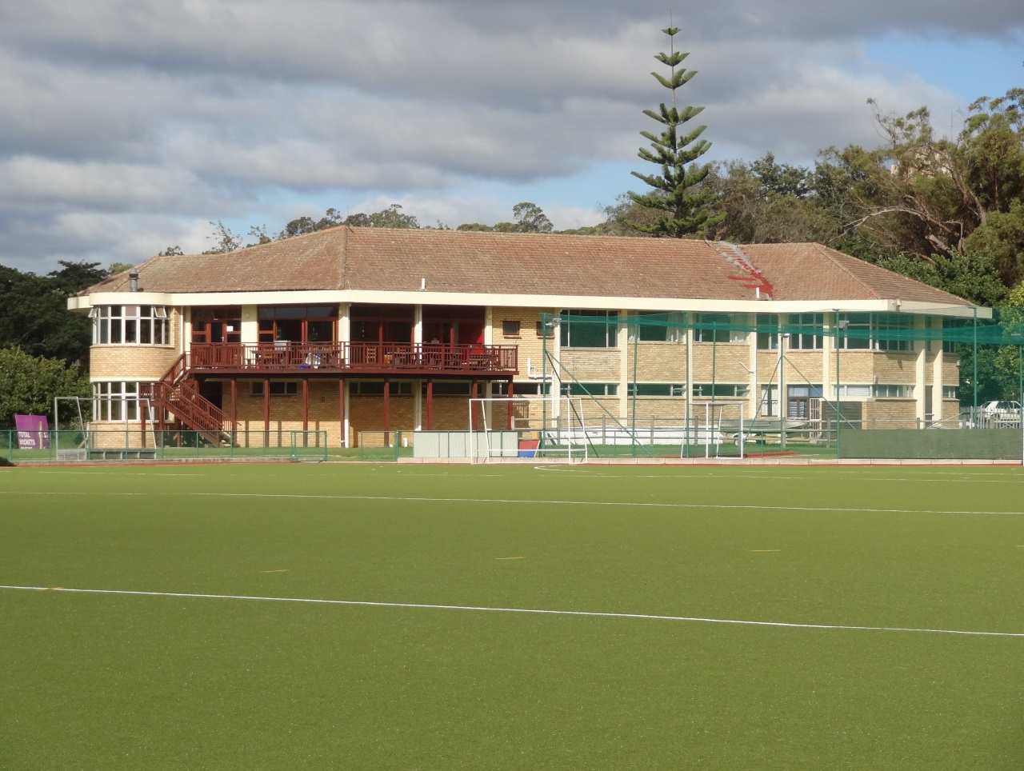

1. INTRODUCTION

TABLE OF CONTENTS

2. BACKGROUND

3. RHODES SPORT VALUES

4. RHODES SPORT VISION

5. RHODES SPORT MISSION

6. RHODES SPORT CONTEXT

7. STRATEGIC OBJECTIVES AND OPERATIONAL PRIORITIES

8. MONITORING AND EVALUATION

ANNEXURE A

- Introduction

Since 1994 there has been an extensive array of initiatives including a radical re-definition of the values, purposes, goals and policies for Higher Education (HE).

Student sport has not been left untouched by these developments. Mergers in some HE institutions have brought about the establishment of “super student teams” and national sports federations have re-drawn their geographical boundaries. The result being that some institutions, and their teams, now belong to “unknown territories”. In addition, the emphasis that Rhodes University places on their core business viz., the academic project, has led to the allocation of minimal funding for sport and has challenged Rhodes Sports. This, with an already ageing infrastructure and limited funds has led Rhodes Sport to look for alternative sources, or third stream funding specifically from the commercial sector. The commercialization of student sport has also led to the introduction of high value sports bursaries at some universities, thereby leaving Rhodes in the difficult position of being unable to attract top sportsmen and women.

Since Rhodes Sport places value on participation and the development of students and as the University is creating an Institutional Development Plan (IDP), this has led to the re-evaluation of what we are, what we do and our relevance to student sport at institutional, district, sector, regional, national and international levels.

- Background - Rhodes Sport
Rhodes University is the smallest university in South Africa. This presents the university with many challenges which impacts its operations – of which sport is not immune. This is, in particular, with respect to the number of fulltime sports administration staff allocated to specific clubs (staff/club ratio). Best practice in university sport in South Africa reveals that there be a maximum of three (3) clubs per sports administrator. At Rhodes University this is currently at approximately ten (10) clubs to every sports administrator.

In the face of this, one of the strengths of Rhodes Sport is its focus on student development. It is among one of the top universities in South Africa with respect to facilitating student involvement in sport at a competitive and/or social/recreation level. All sports clubs are primarily run by students with the assistance of sports administrators that provide insight and guidance into sports administration.

Over the years, Rhodes Sport has offered a range of up to thirty five (35) sporting codes with some sports providing a variety of activities. For example, spear fishing and underwater hockey in the Underwater Club or diving, swimming and water polo in the Aquatics Club, etc. Some of these activities are offered at a competitive level whereas others are only offered at a social and/or recreational level. However, as pressure is placed on Rhodes Sport, with an ever shrinking financial support from the Council budget, this becomes increasingly difficult to sustain. In addition, the changing student demography has shifted slowly to more sports that appear to follow the demographics of the country. As a result, the following sports have ceased to be offered at Rhodes University and include: baseball, gymnastics, diving, Goju Ryu, and cycling. Several clubs such as the rifle, first aid, fly fishing, sailing and surfing clubs are struggling to survive. Despite these changes and challenges, Rhodes Sport has always been able to assist individual athletes from sports that are not officially recognized by the Sports Council. The sustainability of this is, however, questionable.

Rhodes Sport, is faced with sports facilities that are old and barely conform to the required standards for sports participation. These facilities are not able to cope with the increased numbers of students and Grahamstown community users. Our physical resources need to be modernized and upgraded in order to ensure that we meet these increasing demands while, at the same time, meeting Occupational Health and Safety compliance standards. During the exams period our infrastructure is further stretched in that ten (10) of our clubs are prohibited from operating during this period due to the sharing of our facilities. This ongoing overuse of Rhodes Sport facilities is simply not sustainable.

Rhodes Sport has been fortunate to receive external support through Lotto funding but this is sporadic and not continuous. In addition due to our geographic location and distance from major cities, it has been difficult for Rhodes Sport to obtain sponsorships from the commercial sector. South Africa has been downgraded in terms of fiscal rating and thus third stream income generation will become increasingly difficult. It should be noted that since 1999 there has been no infrastructure funding received for sport from Rhodes University.
In terms of support for Rhodes Sport, The Department of Human Kinetics and Ergonomics has facilities and expertise available to assist. Rhodes Sport also benefits from positive input from the Health Suite.

Through the implementation and operationalization of the ‘Top Eight 2020’ and the promotion of active living, Rhodes Sport will be informed by this strategy.

- Rhodes Sport Values

As Rhodes Sports we are committed to the following values; these define our purpose and mission and guide our direction and actions.

Unity in Diversity
Rhodes Sport will reflect and respect diversity in achieving a united commitment to these core values and assist in developing an institutional culture of unity in diversity.

Democracy
Rhodes Sport endeavours to ensure that its governance structures are transparent and accountable.

Discipline:
Rhodes Sport will carry out duties with responsibility, diligence, commitment and passion.

Fair Play and Sportsmanship:
Rhodes Sport insists that all sports should be played to the highest standard of sportsmanship and fair play, treating opponents and team members with integrity and respect.

- Rhodes Sport Vision

Rhodes Sports takes account of its responsibilities in South Africa. The strategy for Rhodes Sport will be informed by the Rhodes IDP.
The vision of Rhodes Sport is the following: By 2020 Rhodes Sport aims to be amongst top eight (8) universities in South Africa in identified sporting codes and contribute to the holistic development of students through participation in sport and active living.

- Rhodes Sport Mission

In pursuing this strategy, Rhodes Sport will be guided by the following mission:

To contribute to the development and wellness of our students by embracing diversity and providing them with the necessary facilities and opportunities to discover and unleash their sporting excellence and leadership potential during their tenure at Rhodes University.

Achievement of the mission entails commitment to:
- Provision of modern and compliant infrastructure and equipment
- Compliance with federation and USSA coaching standards
- Supporting and developing student athletes by providing opportunities for all to participate in student sports activities
- Promoting and facilitating sporting and academic excellence
- Creating and maintaining ethical student leadership opportunities
- Community engagement

Statement of purpose
- To communicate and consult with the Rhodes community in order to more effectively achieve our strategic goals
- To attain visible support for sport at top levels of the University
- To continue to support and enhance sporting participation and excellence
- To continue to celebrate unity through diversity in a stimulating and harmonious environment
- To continue to develop ethical leadership through the provision of opportunities for development at all levels
- To continue to recruit, through our strong academic standing, high flying academic students with sporting abilities

- Rhodes Sports Context

Our strategic plan is informed by the context in which Rhodes University finds itself as a rural university based in Grahamstown, the Eastern Cape - the poorest province in the Country. The inter-residential and internal league sports programmes provide opportunities for students to participate in healthy, active lifestyles as well as creating opportunities for students to participate in sport at a competitive level. However, due to the remote location of Rhodes, extending this to provincial, national and international participation is, in part, hindered. Rhodes Sports will focus on maintaining developing strategic partnerships that will locate the University in the community as a meaningful and responsive entity that makes a significant contribution to the advancement of our society.

- Strategic objectives and operational priorities

GOAL: To be to be amongst the top eight (8) of the twenty six (26) universities in South Africa in identified sporting codes.

STRATEGIC OBJECTIVE | OPERATIONAL PRIORITY
To ensure that athletes from identified sporting codes are appropriately coached, managed and supported with the intention to achieve their full potential | - To categorize sporting codes according to the following categories to ensure appropriate support and management. The categorizations will be as follows and will drive financial, management and research focused initiatives:  - CATEGORY A = those sports which are focused on achieving sporting excellence  - CATEGORY B = those sports categorized as aspiring to excellence  - CATEGORY C = those sports categorized as competitive/social  - To create a differentiated funding model and administrative support according to categorization.  - To identify and appoint adequately qualified coaches and managers dependent on the respective categories.  - To develop and maintain strategic partnerships with the academic leadership, including the Registrar and Deans, in order to recruit high flying academic students with sports abilities. This can be done through the inclusion of a sport section in the University’s application form when they arrive at Rhodes.  - To develop a high performance, research focussed program in the Department of Human Kinetics and Ergonomics to specifically support identified sporting codes and to enable students to reach their full sporting potential.  - To collaborate with academic departments on campus in identifying talented athletes in the relevant sporting codes.  - To further collaborate with academic departments to attract funding which is focused on research-based high performance initiatives.

GOAL: To consciously position Rhodes athletes to achieve sporting excellence through the provision of adequate infrastructure, equipment and support.

STRATEGIC OBJECTIVE | OPERATIONAL PRIORITY
Modern and compliant sports facilities and equipment | - To create a plan for the upgrading of ageing infrastructure to an acceptable level to achieve this goal.  - To design and build an indoor sports centre that meets the requirements of the academic endeavour and our sporting needs.  - To develop a maintenance plan for all sports facilities and ensure that current facilities are maintained to acceptable standards.

GOAL: To contribute to the development and wellness of our students by providing opportunities to participate in sport in well-co-ordinated inter-residence and internal leagues.

STRATEGIC OBJECTIVE | OPERATIONAL PRIORITY
Well-co-ordinated inter-residence and internal leagues | - To develop sport, and active participation in sports, as an integral part of the University.  - To maintain our position in the top 3 of higher education institutions with respect to these programs.  - To develop and facilitate a sustainable inter-residence sports program with the ultimate responsibility lying with the residences.  - To facilitate and develop a sustainable internal league program that works as a feeder that can be used as a strategic recruitment base for recruitment to Rhodes Sport’s clubs.  - Through this, promote active participation in sports as part of a holistic, healthy lifestyle programme.

GOAL: In order to sustain our multiple sporting activities our aim will be to achieve a position of financial strength.

STRATEGIC OBJECTIVE | OPERATIONAL PRIORITY
To ensure that Sports Administration is resourced adequately | - To ensure that Rhodes Sport’s expenditure does not exceed its income in the short and long term.  - To create a sustainable third stream income through hosting tournaments and ensuring that 100% income generated is not lost to residence system.  - To work with Development and Alumni Relations Division, Infrastructure and Operations, and the Registrar’s Division in order to plan the building of an indoor sports centre by 2018.  - To increase contribution towards the Sports Foundation.  - To partner with Alumni Relations to identify fundraising opportunities as part of key reunions in order to feed into Sports Foundation.  - To commission the History of Rhodes Sport in order to identify strategic partners and engage with alumni to build a broader support base for the purposes fundraising and development.  - Efficient resource utilization shall be optimized through the categorization of sports.

GOALS: To promote and introduce opportunities for student involvement in community based activities in sport.

STRATEGIC OBJECTIVE | OPERATIONAL PRIORITY
Active and meaningful community engagement | - To empower communities to be able to develop and implement sustainable sports programs.  - To coordinate and host capacity building programs for sports administrators and coaches.  - Promote a ‘Learn to Swim’ campaign amongst sports clubs.

GOAL: Development of a marketing and communication strategy aimed at profiling Rhodes Sport internally and externally.

STRATEGIC OBJECTIVE | OPERATIONAL PRIORITY
To implement effective communication of the Rhodes Sports Strategy and achievements | - Identify key local, national and international media partners.  - Develop strategic partnerships with journalists and the Journalism Department within Rhodes.  - Actively engage social media (face book, twitter and Instagram).  - Promote a positive perception of Rhodes Sport and leading a healthy, active lifestyle through profiling of athletes, coaches and administrators who have achieved at all levels at Rhodes (including academically).  - Including a link for Rhodes Sport on the Rhodes University’s landing page and intranet.  - Create a Rhodes University sports brand that every Rhodes university student, staff and alumni can associate with.

GOAL: Leadership opportunities for students and championing good governance and fairness within university sport structures both internally and externally.

STRATEGIC OBJECTIVE | OPERATIONAL PRIORITY
To develop ethical leaders | - Identify and develop students, coaches and administrators with potential leadership abilities with a view to develop them into future leaders.  - Provide ongoing mentorship and capacity building programme.  - Partner with Allan Gray Centre for Leadership Ethics.  - Provide opportunities for students with leadership potential to participate in formal courses in respect of administration and coaching.  - Provide ongoing mentorship opportunities for students.

GOAL: Introduction of a High Performance Programme which facilitates the development of our top athletes within identified sporting codes.

STRATEGIC OBJECTIVE | OPERATIONAL PRIORITY
To develop and implement a High Performance Programme | - To identify and support students who have the potential to succeed in identified sporting codes.  - To ensure that there are facilities, equipment and staff in place to support the identified athletes.  - Consolidate partnership with Human Kinetics and Ergonomics and other academic departments with respect to a High Performance program.  - In order to promote participation in sports at the highest level, there is a need for introduction of a high performance program for several sports. In order for this to occur the services of the Health Suite, Human Kinetics and Ergonomics, and other academic departments must be engaged. These partnerships will also give rise to postgraduate research opportunities.

GOAL: To adequately staff Rhodes Sport.

STRATEGIC OBJECTIVE | OPERATIONAL PRIORITY
Recruit, develop and nurture the potential of Rhodes Sport staff with a view to maximize long term retention | - Align staff development priorities with the IDP and Rhodes Sport’s ‘Top Eight 2020’.  - Recognition and appreciation for high performing behaviour.  - Development opportunities designed to retain and nurture Rhodes Sport’s staff in order to enhance efficiency and accountability.  - Encourage service excellence.

- MONITORING AND EVALUATION

These strategies will be reviewed on annual basis.

ANNEXURE A

INTERGRATED PLANNING CYCLE

Item and Task Due Date

- Sports Council Strategic Planning Subcommittee
Finalization of the draft strategic plan 01 – 02 September 2014

- Sports Administration
Input into the draft 06 September 2014

- Student Sports Council Executive TBC
Input into the draft

- Sports Council Executive 16 September 2014
Input into the draft

- Acting Vice-Chancellor October 2014

